Particle Behaviour Simulator

Contents:

Section 1: Analysis 1

Introduction: 1

Computational methods: 2

Abstraction: 2

Decomposition: 2

Concurrence: 2

Selection: 2

Iteration: 3

Modelling: 3

Stakeholders: 3

Interview 1 – Sixth Form Campion Art student 4

Interview 2 – Y13 Game developer at Havering college 5

Review of the Interview stage: 6

Research of existing solutions: 6

Tom Mohr’s Particle Life: 6

Conway’s Game of Life: 7

Clusters by Ventrella: 8

Essential features: 9

Particle interaction physics: 10

Optimised code for increased performance and frame rate: 10

Vibrant Particle colours: 10

Easy to use and accessible Interface: 10

Multiple input and customisation options (In real time): 10

Hardware and Software requirements: 11

Hardware: 11

Software: 13

Success criteria: 14

Simulation mechanics: 14

Visually Interesting: 14

Smooth frame rate and performance: 14

Usability and Accessibility of features: 14

Curated from feedback based on the end users: 14

Section 2: Design: 15

Problem decomposition: 15

Structure of the solution: 17

Game loop: 26

Physics and Mechanics 27

What will be used for iterative testing? 30

Accessibility Features: 33

Section 3: Development: 38

1ST Solution 38

Review of first solution: 41

Second Solution: 46

How will my data be tested? 46

Matrix Generation 51

Game header file: 52

Main file 54

My game.cpp global variables and header inclusions: 56

Initialising the game and SDL systems: 57

Particle Initialisation 58

Update function: 60

Render function: 63

Cleanup function: 64

Physics interaction 65

Components 65

Entity Component system (ECS) 65

Particle Component 70

Transform Component 70

Physics Component 73

Box Collider 77

Sprite Component 80

Usability features: 82

Handle Events Function: 82

Review of second solution: 87

Iterative test data: 93

Testing User Interface: 106

Section 5 post-development test data: - does it meet criteria 108

Test #1: 108

Test #2: 109

Test #3: 111

Test #4: 113

Test #5: 114

Test #6: 114

Test #7: 116

Test #8: 117

Evaluation: 120

Did I produce an adequate physics system which can handle collisions and interactions between particles? 120

Is my project visually interesting to observe and watch for my end users? 121

Does the program perform well and run smoothly? 122

Have I provided enough accessibility and usability features? 123

Have I taken my end users feedback into consideration when developing this project, and have I reviewed this feedback at the end of each stage in my development project? 124

Maintenance and limitations: 125

# Section 1: Analysis

## Introduction:

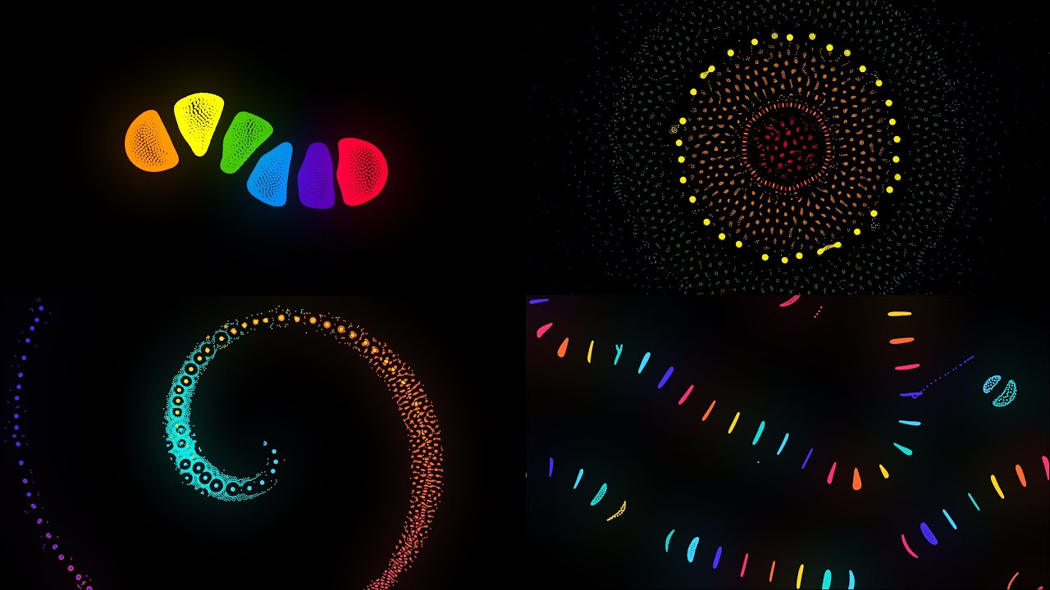

I am making a particle life simulator where the user is able to adjust values of mass and forces of attraction between the particles, as well as how many particles there are and how many different classes, to make complex behaviours emerge. It would all take place on one screen, where you are able to modify the behaviours in real time. The end user for this project ranges from students interested in emergent behaviours, to game developers looking for unique and organic movements to replace simple finite state machines for enemies in their games, to a generative tool for Artists.

This idea of being able to generate intricate systems and behaviours using simple rulesets is a captivating concept that occurs many times in nature, such as the flocking of birds, or atomic interactions. My goal is to make a program that is easy to use and understand, while showing the beauty of this concept, allowing for many uses.

## Computational methods:

### Abstraction:

This project will be able to simulate complex behaviours and phenomena found in nature and at the atomic level, while remaining interactive and enjoyable to use.

### Decomposition:

Due to the complexity of the project requiring multiple systems needed to run the simulation, it is optimal to use decomposition to break the project into 3 main parts, all which will work in conjuncture to give the final product:

1. the SDL graphics library,
2. the Entity Component System (ECS)
3. the physics and maths behind the interactions of the particles

### Concurrence:

Depending on the number of particles being processed, it might cause performance issues to be processing each interaction one at a time, while also keeping track of the positions and velocities of every particle. Therefore, using concurrence via multi-threading is a good approach to be used to maintain performance and speed of the program.

### Selection:

To provide the most interactivity and customisation for the end users (students, game developers, artists), selection will be used to allow the user to adjust the attraction forces in the attraction matrix, as well as edit the number and mass of each class of particle, to achieve different results to the user’s liking.

### Iteration:

This project requires potentially millions of variables to be updated every second, adjusting positions, calculating and changing velocities, rendering the particles and altering the particle’s masses and attraction forces. Therefore, iteration is suitable to use as the same set of rules will be applied and processed several times a second to properly simulate the behaviours of the particles.

### Modelling:

It will be representing complex behaviours and movements from a series of simple interactions between each particle type.

## Stakeholders:

My application is aimed towards a range of end users as stated above, including (but not limited to) artists, students and game developers.

For students, my application will meet their needs as an interactive tool to explore real world behaviours with varying complexity, looking into systems and why they function as they do.

For game developers, it will provide a generative tool for shader effects, enemy movement patterns and much more, giving their games a more unique feel to play.

For artists, similarly to the game developers, it will provide an adjustable generator for artistic inspiration and will allow them to create stand out pieces, which differ from other derivative work.

It will be a simple to use tool, existing all on one screen, so will not require a steep learning curve to get in the way of studies, game dev or creating art.

Two rounds of interview were conducted for the artists and game developer category of end users mentioned above.

### Interview 1 – Sixth Form Campion Art student

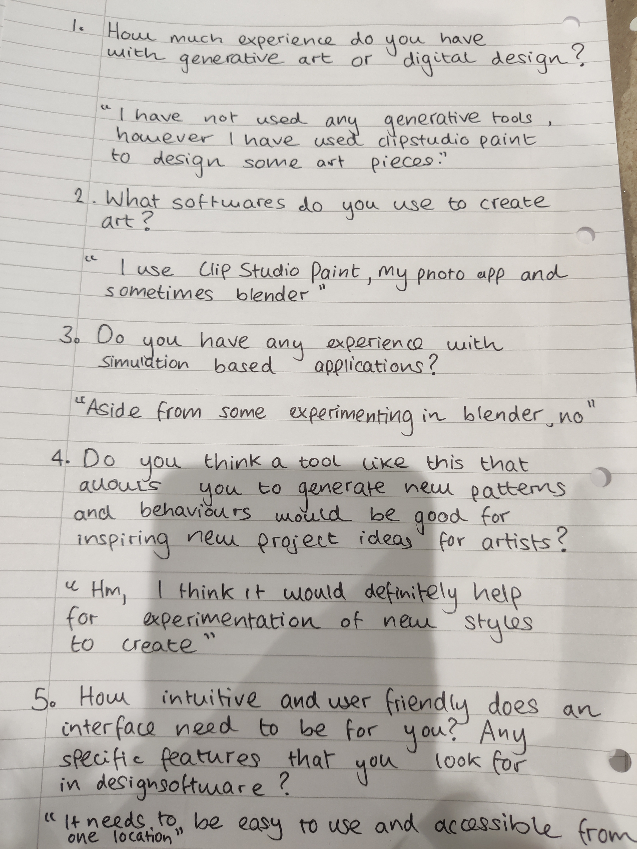

As can be seen from the interview, the person being interviewed has no experience with generative tools, though does have experience with art programs such as clip studio paint.

### Interview 2 – Y13 Game developer at Havering college

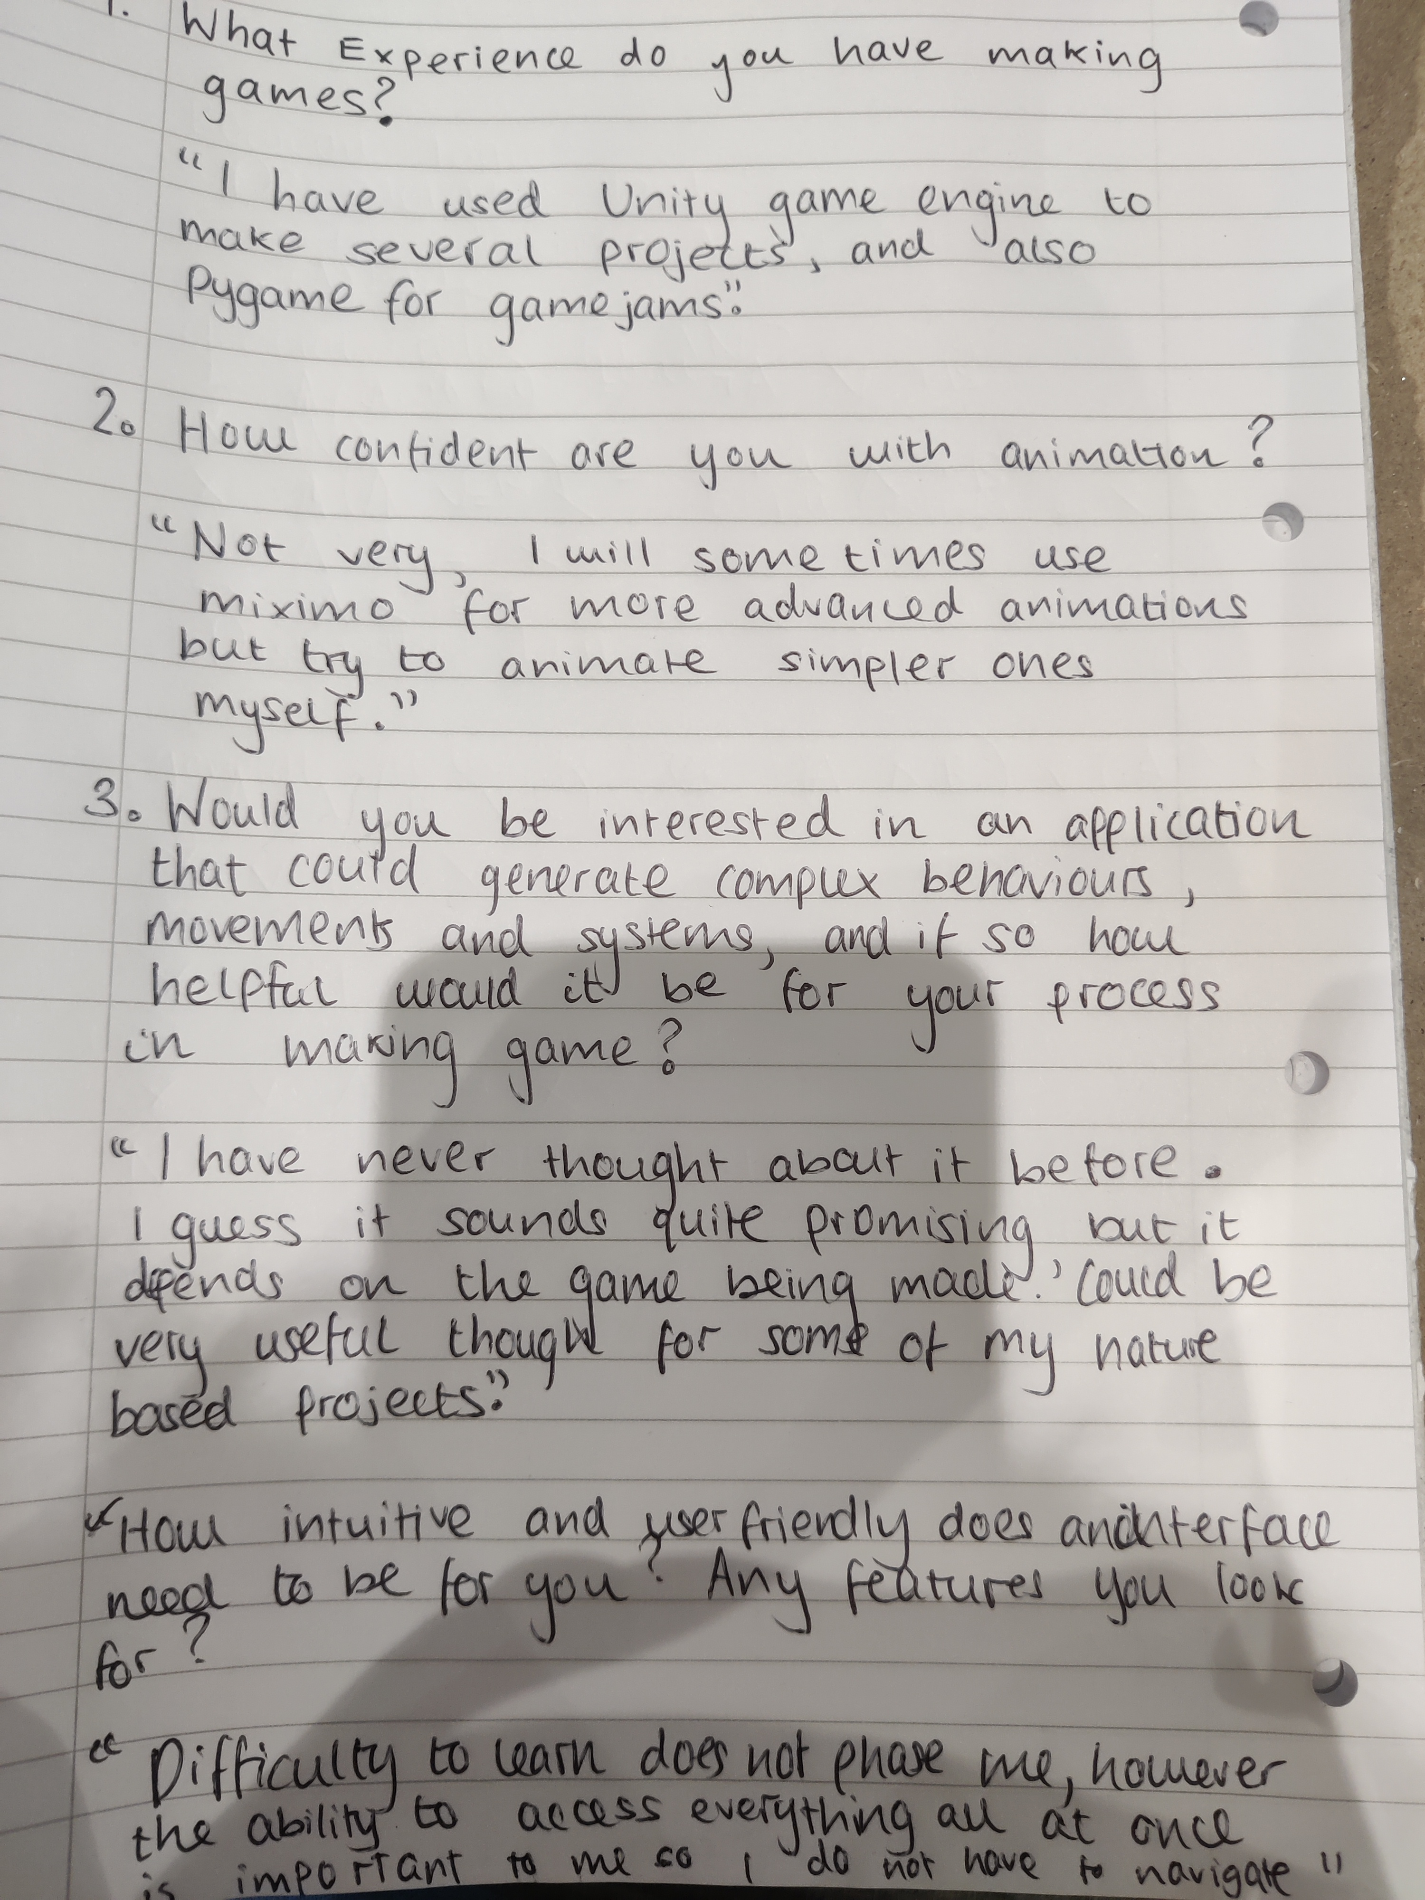

Break down and discuss more

## Review of the Interview stage:

### Review of Interview 1:

The student appears to have limited experience with generative tools and simulators, however, does understand how to use software such as blender and clip studio paint. They do believe that this software could potentially be a useful tool towards the creation of art though, which means my project shows promise. The strongly emphasised the importance of an easy-to-use interface, which is what I will aim to do by making it as straight forward and simple to use as possible. I will try to make the interface as intuitive as possible, as well as the ability to be able to access everything at once to limit the need for a navigation system.

### Review of Interview 2:

The second person to be interviewed also thought that my project could have some useful applications to game development, especially for more organic based movement. As with the first person to be interviewed their main concern for the program to be useful is the ability to have access to all the controls and shortcuts from one place. Given that this feedback has been given back twice now I will make it one of my main aims for the development of this project. Post these interviews I can conclude that my project is suitable for the chosen end users.

## Research of existing solutions:

### Tom Mohr’s Particle Life:

The most similar project I can find to what my end result will be is Particle Life Simulator:

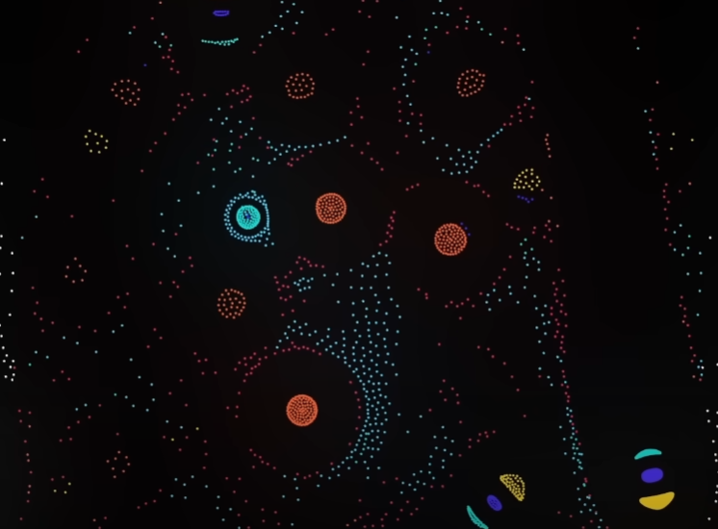

It is a fascinating simulation to watch, with distinct classes of particles, all of which interact differently to form complex behaviours as shown above.

It is similar to my project, and I will be adapting a lot of the core ideas and concepts to do with the maths and physics involved as I would like my particles to function in a similar way. However, Mohr has allocated a mass of 1 for every particle, which limits the number of behaviours that can be represented, while my simulator has the ability to alter mass allowing more creative freedom for my end users. I also considered having the ability to change size of the particle but felt it was unnecessary because the particles clump together anyway depending on their values.

Unlike Mohr’s simulator, mine will be done in C++ as I believe this will provide better performance, rather than JavaScript which is traditionally slower. This will allow for more particles to be processed per simulation and give a wider result of systems to be created. Several other languages were considered but C++ is renowned as one of the best for performance, and I am already familiar with the sdl2 graphics library. My project will also be more user focused and interactive to use, something that I feel Mohr’s simulator is lacking.

### Conway’s Game of Life:

Another project that holds some similarities to mine is Conway’s Game of Life. It is a cellular automaton invented by Jon Conway in 1970. Famous for being a “zero” player game it is based on a simple set of rules which determine if cells live, reproduce or die. This too also demonstrates how complex patterns can emerge from simple rulesets.

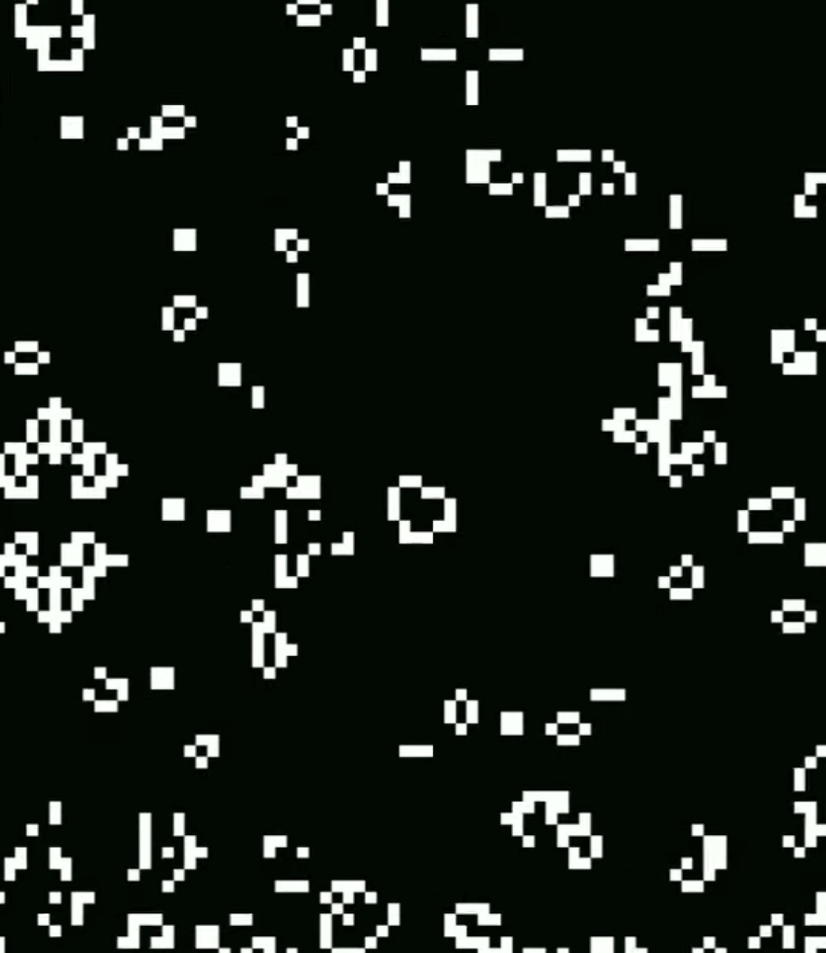

I will be adapting the user control and inputs, pattern customisation and editing and the efficiency of the project. I will implement the features to start and stop the simulation, as well as change the speed at which it runs, however I would also like to add the ability to pan in and out, as this will allow the user to view more of the particles in action which is beneficial for observing patterns which take up more space to fully realise, another solution would be to have the particles be small and the screen to be big to start with, but this might not always be useful to users who want smaller scale behaviours and patterns.

I will not be adopting the grid-based design though as though makes it more manageable in terms of processing, I feel it would be too restrictive on the capabilities of the simulation.

### Clusters by Ventrella:

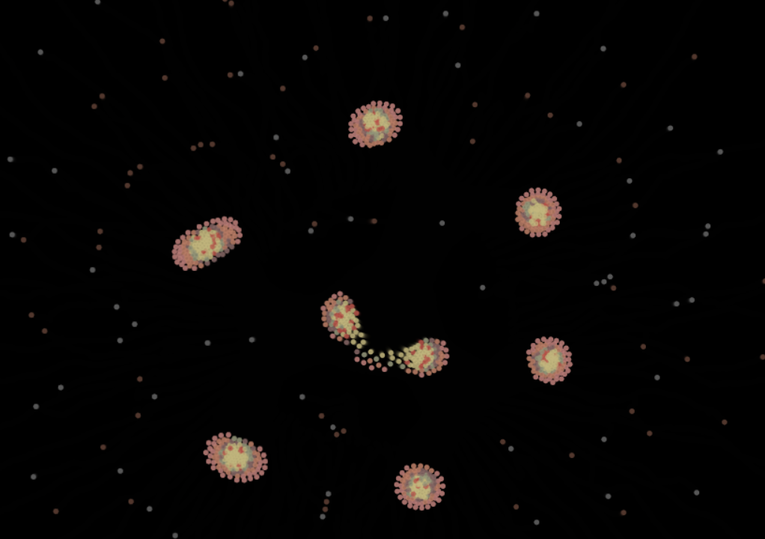

Another very similar project is Cluster by Ventrella. It has several presets for simple logic to determine how particles interact with each other, which allows for demonstrating some very cool behaviours, for example mitosis (as shown above), formation of planets and the Red Menace Effect.

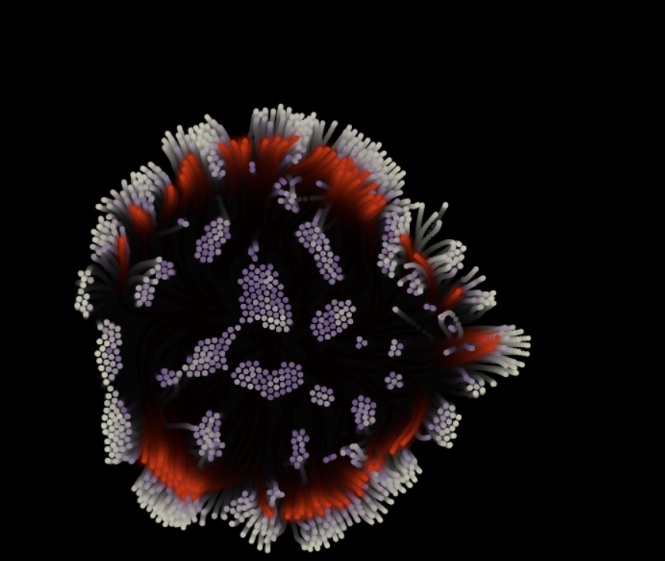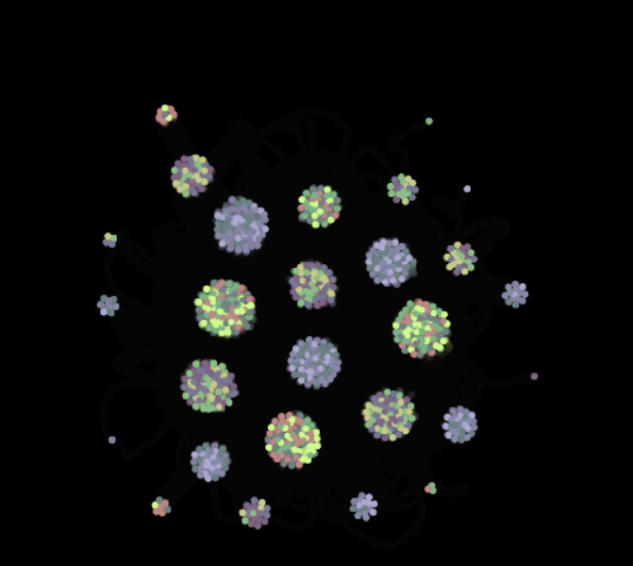

Much like Particle Life, I will be taking inspiration from the interaction physics but adopting the preset features for this project. This will allow me to have pre-determined values for showing off effects that users can build on and adapt, allowing for easier use of the program with some basic defaults available. I will be choosing some different presets to this, which will likely be determined through some questionnaires from my end users to ensure its viability.

Another approach could have been not having presets in the program itself, and instead a source of presets in an external file coupled with the program to be pasted in, but this integrated approach will be more cohesive, easier and quicker to use.

I am not adopting the desaturated colours however, as vibrant and engaging visuals are required if artists are one of the end user categories. I could also try programming in a colour wheel to select each colour, though I do not want to over-scope the project and have already added several features - this is something that could definitely be a future improvement or adaptation to this project.

## Essential features:

### Particle interaction physics:

The project must have a robust physics system for the particles to be able to interact with each other and simulate different behaviours. It is needed for my end users so they can observe the movements and systems created, which would not be possible without this feature.

### Optimised code for increased performance and frame rate:

Having a stable frame rate and the ability to process more particles on screen at a time is a necessary feature to push the use cases of my application, allowing end users to experiment with larger and more complex behaviours which can assimilate to more creative design.

### Vibrant Particle colours:

To be visually interesting for my stakeholders I need vibrant particle colours, which is why I have decided to keep each of my particle colours different, instead of having different shades of the same colour. This will give a better visual contrast and make the project more vibrant overall

### Easy to use and accessible Interface:

An interface that is easy to use and understand is required as not all stakeholders have technical backgrounds, so I want to keep it simplistic whilst still leaving lots of options for my clients. This will allow them to more quickly learn how to use the software and create behaviours more quickly.

### 

### Multiple input and customisation options (In real time):

#### *Matrix value regeneration:*

To be customisable for my stakeholders, I need the user to be able to generate new matrices while running the program. This is an essential feature to the intractability of my application. This will allow users to try multiple matrices and see which ones they find interesting.

#### *Ability to set number of particles:*

This is an important feature as stakeholders may want larger or smaller systems depending on their objective. This feature will allow them to adjust the size of the simulation instantly without having to restart the program.

## Hardware and Software requirements:

### Hardware:

1. Processor (CPU):

* Minimum: Dual core processor, 2.0 GHz or higher
* Recommended: Quad core processor (such as an Intel core i5 or above), that can ideally support multithreading support
* Explanation: multiple particle interactions and calculations must be calculated, and especially at higher frame rates this will get CPU intensive, so a fairly modern and capable CPU will be needed

1. Memory (RAM):

* Minimum: 4GB
* Recommended: 8GB
* Explanation: multiple tasks will need to be juggled by the computer, such as rendering, handling physics and real time adjustments, therefore more memory will be needed

1. Graphics (GPU):

* Minimum: Integrated graphics
* Recommended: An older dedicated GPU such as the GTX 1050
* Explanation: not necessary to have a dedicated GPU, however will increase rendering performance for the application

1. Storage:

* Minimum: 200MB of free storage

* Explanation: the application is not resource intensive in terms of assets and other presets, so does not need to much storage to be installed

1. Display:

* Minimum: 720p
* Recommended: 1080p +
* Explanation: Higher resolution allows for a clearer view of the particles, bettering the user experience and also is important for the uses of my target end users

1. Input and other peripherals:

* Minimum: Keyboard and Mouse
* Explanation: Basic set of input devices to navigate the user interface and modify values

### Software:

1. Operating System:

* Windows 10 (64-bit) or higher
* Explanation: the application will be compiled for a 64-bit operating system for better memory management and handling, as we are dealing with a high number of particles

1. Compiler:

* GCC (g++) Latest version (as of 2024) to ensure complete compatibility
* Explanation: Most readily available, and has useful modern c++ features

1. Libraries and other Dependencies:

* SDL2 and SDL2main – the core SDL features for graphics, input and window
* SDL2_image: needed for using images as textures
* SDL2_ttf: needed for rendering text and fonts for the user interface

## Success criteria:

### Simulation mechanics:

The physics engine must be adequate enough to handle collisions and interactions between particles, being able to accurately simulate behaviours that occur in the real world. To measure this, I will try and replicate a series of phenomena once the system has been built to see how accurate the simulator is to the real world.

### 

### Visually Interesting:

My application must be appealing to view, as one of the key target end users is artists, which is why I will measure the success of this criteria by getting Art students at my school to fill out a questionnaire on how appealing they think the colours are in several screenshots I will upload. This is a hard criterion to measure as it is subjective; I am aiming to offset this by gathering enough data to form a general opinion.

### Smooth frame rate and performance:

The performance and frame rate (which goes along with it) must be optimal to allow a fairly high upper limit of particles to be able to be shown on screen. This feature is extremely important as it is a key feature for all 3 of my target end users. I will be able to measure this using some analytic tools on how processor intensive it is.

### Usability and Accessibility of features:

As expressed in the interviews and Questionnaires, the program must be easy to use, and all of the tools should be accessible on the same page to promote fast creative processes. I will run a small test group, where I can gain feedback for what is good, bad or might need fixing if there are issues.

### Curated from feedback based on the end users:

This program would be a failure if it was of no use to any of my end users, which is why getting feedback and criticism is instrumental to the project. I will use the same test group to gain feedback on the user interface and what can be improved.

# Section 2: Design:

### Problem decomposition:

This project is complex so has to be broken down using decomposition.

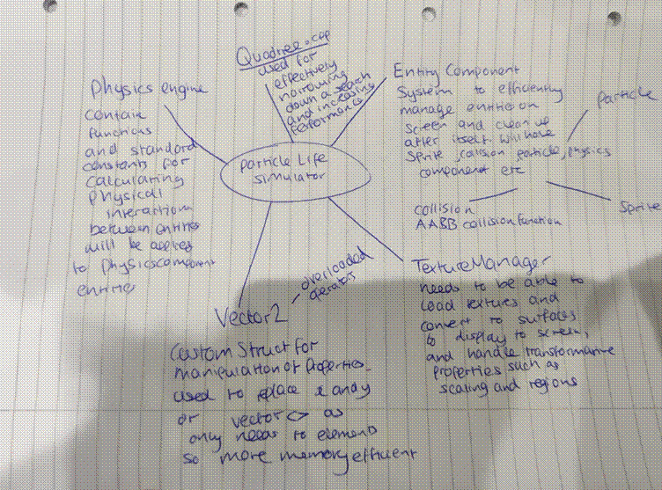

I have decomposed the project into 5 main areas:

1. Physics engine
2. Vector2 class
3. Entity component system
4. Texture and sprite manager
5. Quadtree.

I have broken the project down by virtue of the key parts I will have to develop for my project to function. Each part is vital to the project and the success criteria would almost certainly not be met without the inclusion of each into my project. All these areas will be explained in more depth further along this documentation however here is a brief overview of each one beforehand:

My physics system will be responsible for updating the positions of my entities every frame. It needs to be concise and accurate to maintain the simulation. I will need to resolve for several potential issues, such as energy and velocity build up, and delta time calculations.

My entity component system is key to efficiently managing all my entities and game objects at any given time, while keeping the project modular and easy to build upon in the long run. This will work by having an entity (essentially just a container), which will have several different components attached to it which determines how the entity will behave. In my instance, my entities will all have sprite and physics components as I want them to be visible and interact with each other in accordance with my physics system explained above. There are other methodologies I could have followed to achieve the same results.

My Vector2 structure will be used heavily throughout my project and is one of the primary data structures that will be used. It needs to be able to handle several different operators such aa +, - , / and *, as well as other functions for obtaining the magnitude of a Vector2 and finding the normalised unit vector of the Vector2. It will be used in almost every file, including but not limited to my physics component, my transform component, my game.cpp and most likely my sprite component.

My texture manager will need to be able to appropriately render textures to the screen as surfaces and have error catching implemented to make my program more robust, so if there are missing textures the program does not crash.

My quadtrees justification will be described down below in my second solution of my development section.

### Structure of the solution:

UML diagram made in Luidchart:

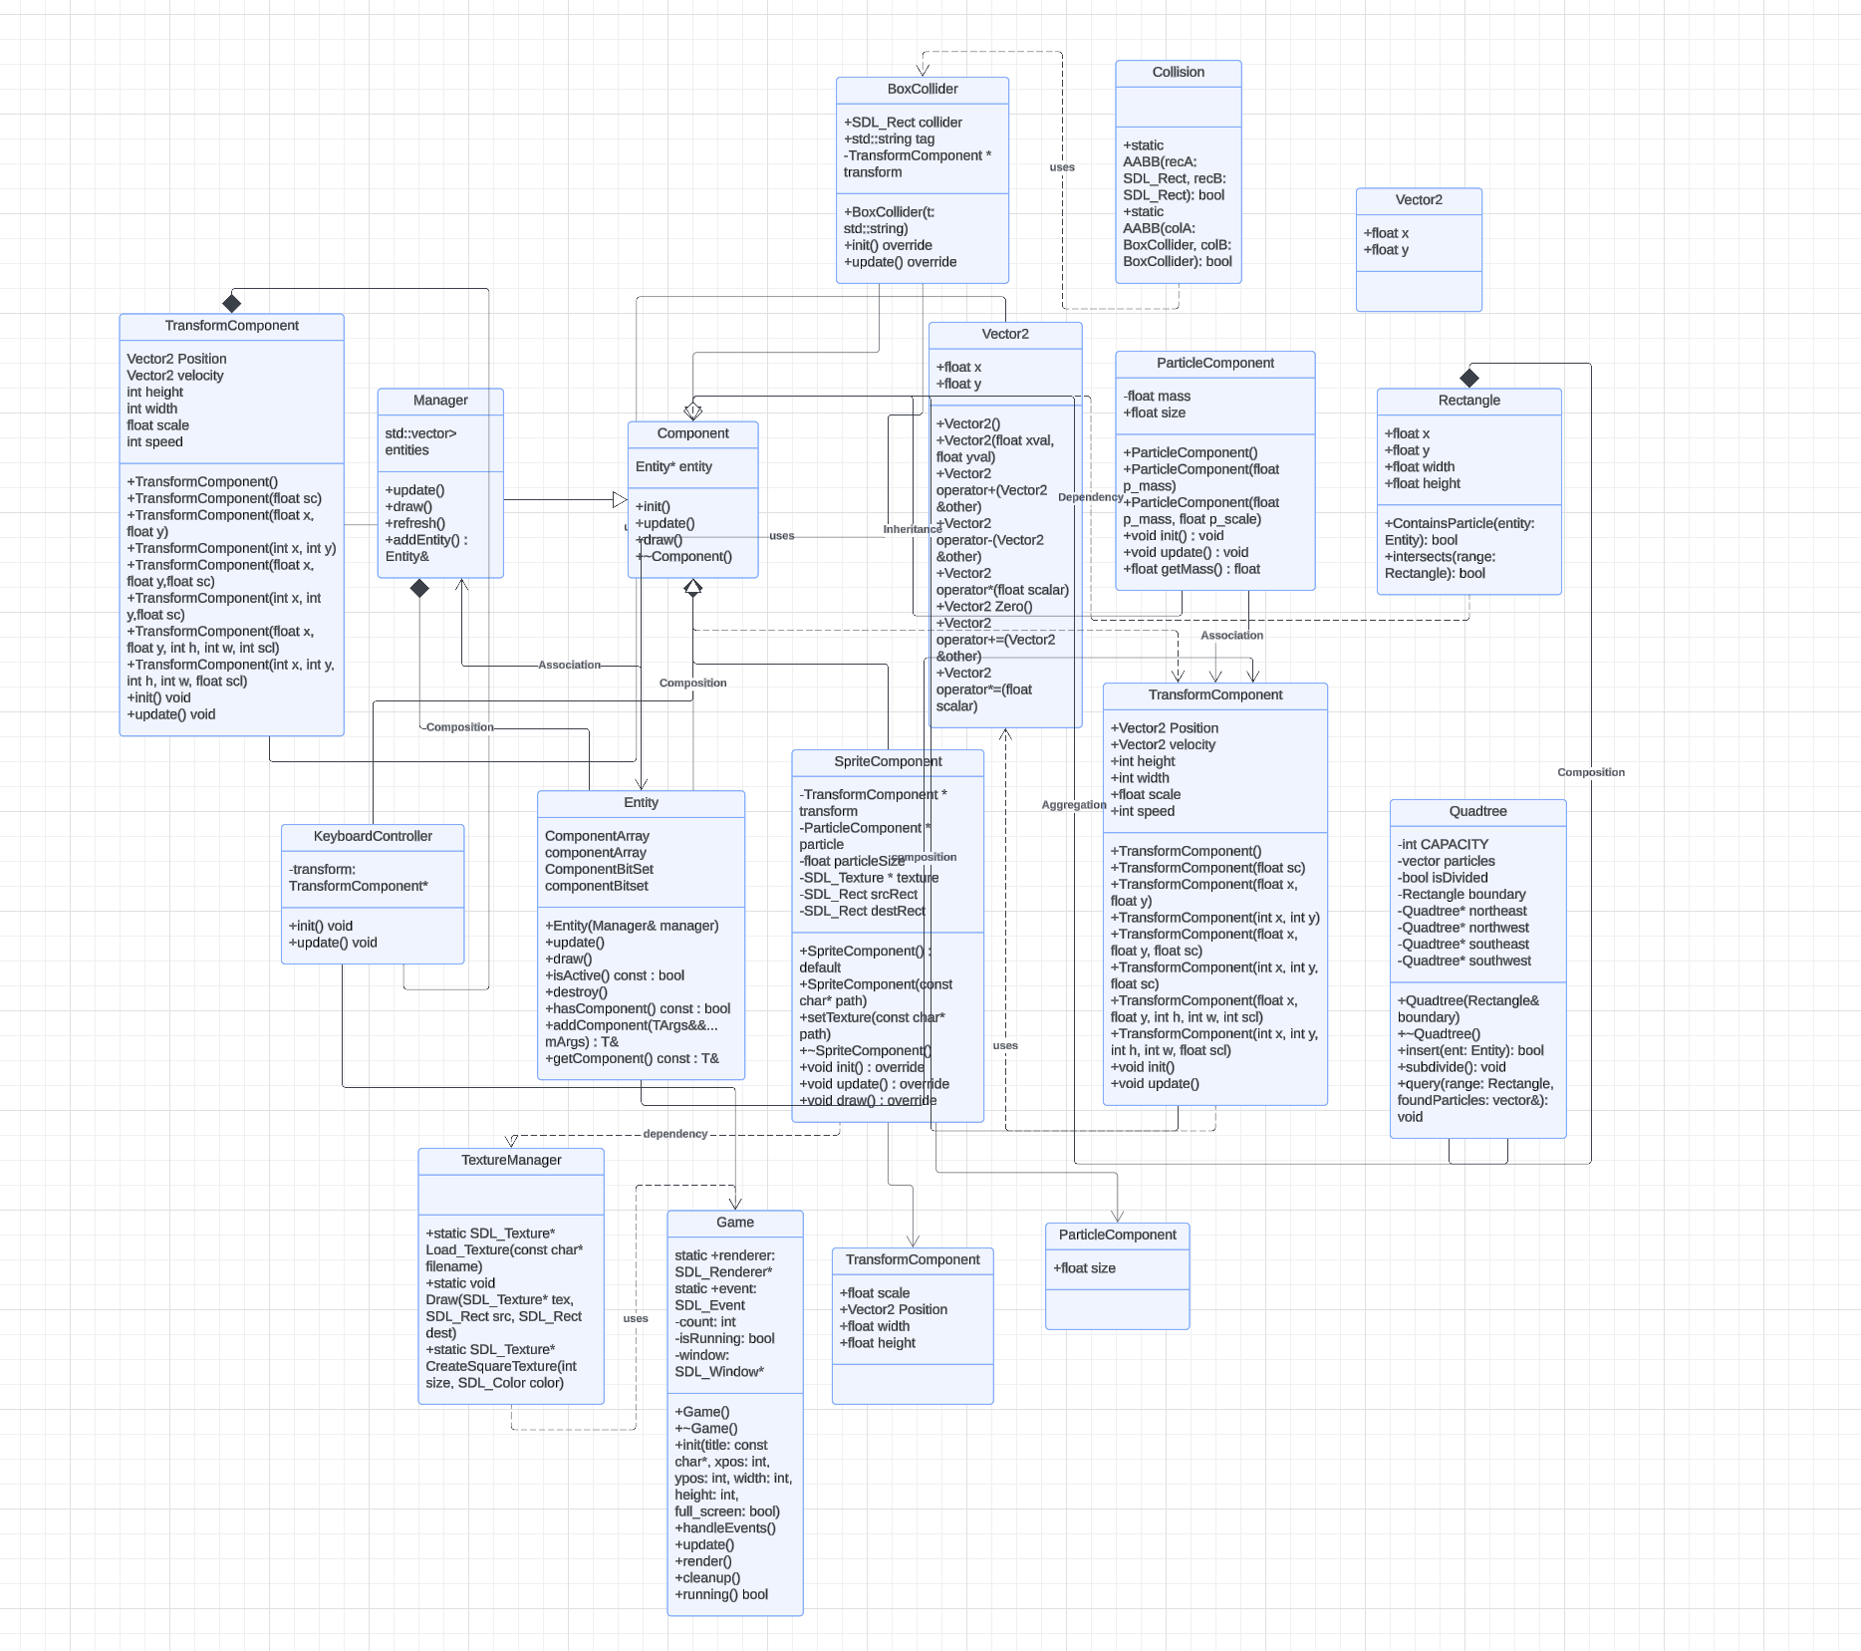

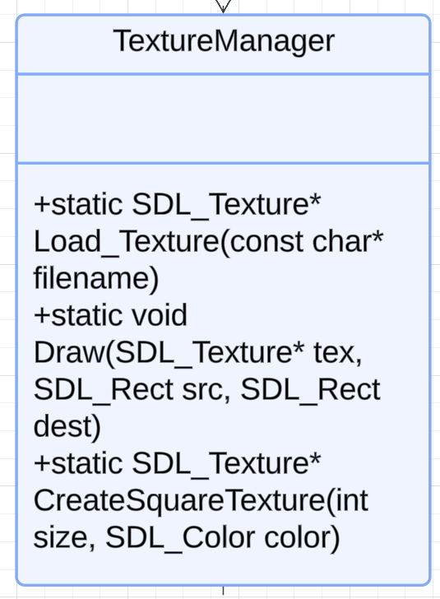

This will allow me to load textures and render to a surface in my window. It has a draw, load texture and create square texture method, and this will allow me to manage and create textures, while not being too overly complicated to use.

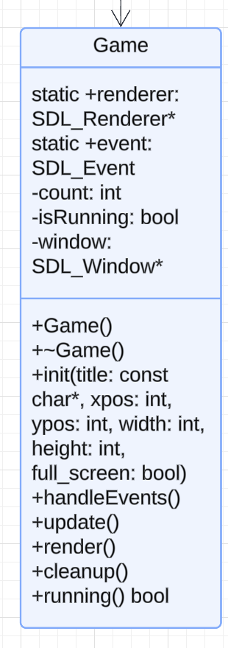

Standard methods for maintaining the application and game loop. Has a Game constructor and destructor for cleaning up at the end. Also has an update render and cleanup function.

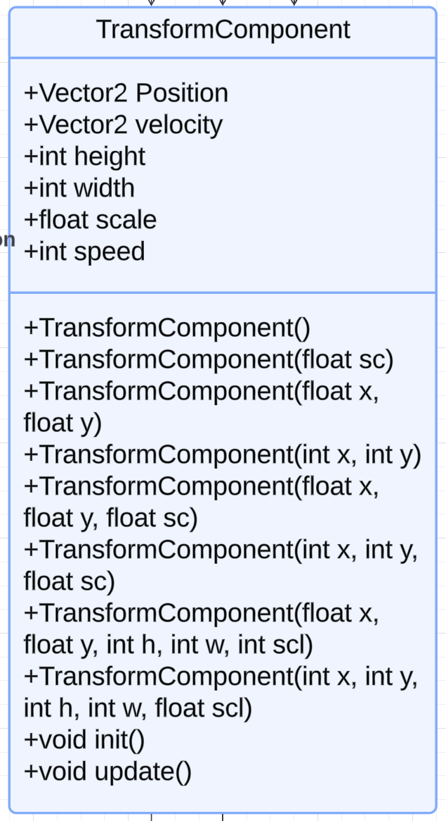

While quite simple, I have implemented several overloaded constructor methods to allow flexibility for creating particles. I could have alternatively stuck with a uniform method, however since some of my stakeholders will be programmer so thought that it would allow for some easy modification in case of any different coding practices or habits that might be needed to be accommodated.

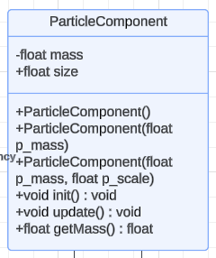

This ended up being redundant and just merged into the physics component class as all my entities are treated as a particle, where the force acts at one point for now.

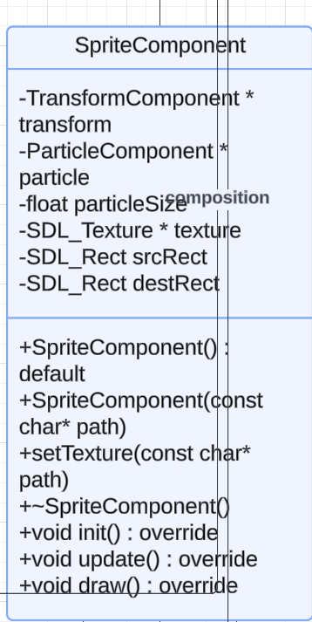

Simple component which allows me to interface with the transform component and texture manager to render my particles to my screen. The Sprite Component is dependent on the transform component.

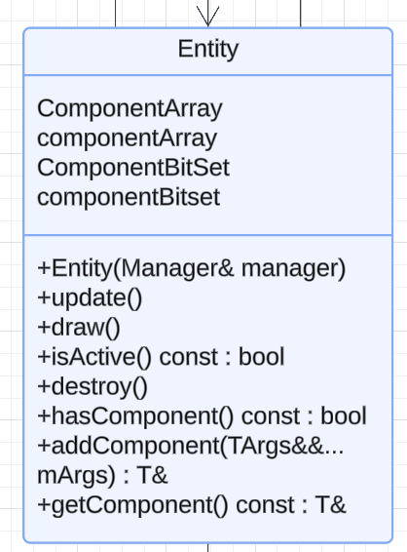

A basic template to attach all the components too. A bit bland on its own but very important and makes the whole project run. It is responsible for telling all its components to run its own methods. I could have alternatively used something other than an ECS, however I felt that this was the most modular and well-suited approach I could take for this project, and it also isolates and helps with debugging and maintenance.

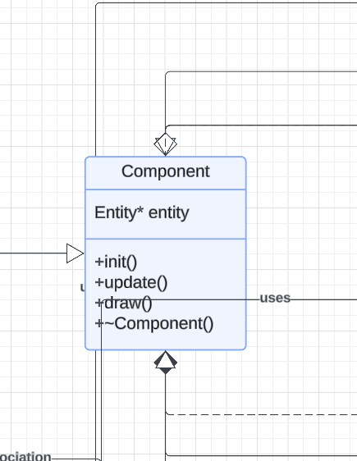

The soul of the components, the entity is used by nearly every single other class or component of my project and forms the backbone for my project to be able to efficiently run. Encapsulating all my game objects as entities allows me to process them in my manager accordingly and uniformly.

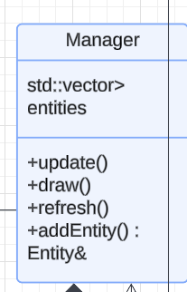

As the name suggests, the manager class is responsible for telling all the entities to call their own methods, such as updating and deleting when the application is closed

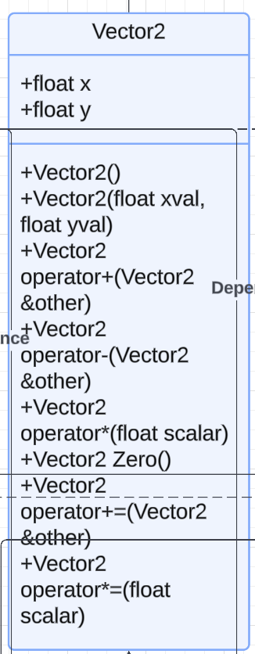

This is the data structure on which my transform component runs. I could have alternatively used the c++ standard vector, however That can dynamically hold more than 2 elements, and essentially functions as a dynamic linked list, whereas this data structure has its specific components and overloaded operators to deal with my simulation, and the methods are clearly in the project and easy to understand.

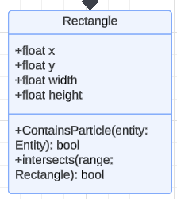

Basic data structure for my collision class to use. I could have alternatively made a circle data structure, however given the size of the particles and the scope of the project, I decided to stick with A rectangle structure to avoid further complications when it comes to debugging

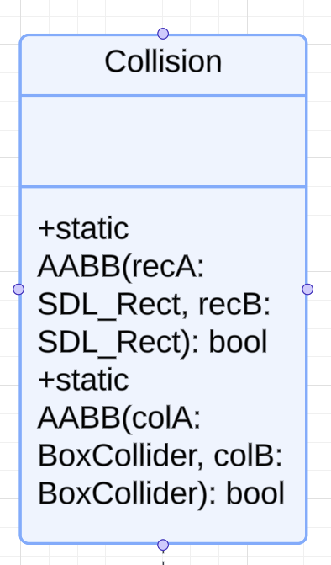

Standard Axis Aligned bounding boxes collision method to detect if two particles have collided. I could have alternatively used another collision method to better suit the shape of the particles, however as mentioned above due to the size of the particles being insignificant and the scope of the project I decided against it.

### Game loop:

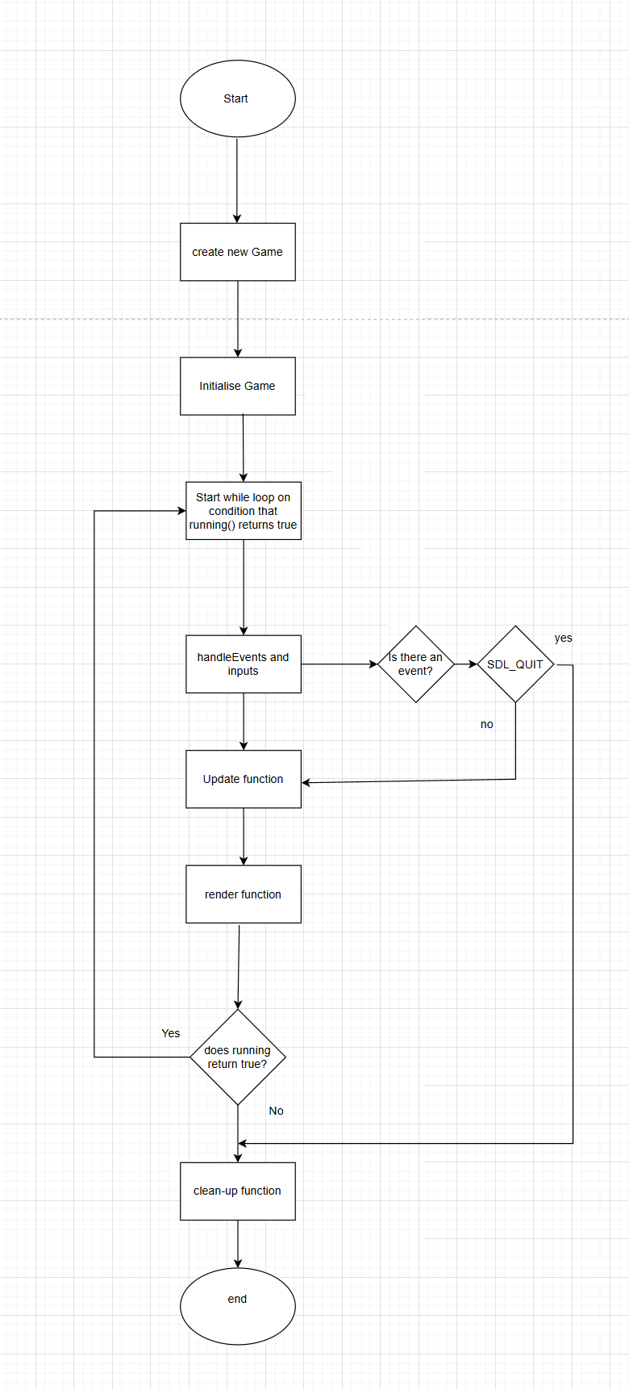

### Physics and Mechanics

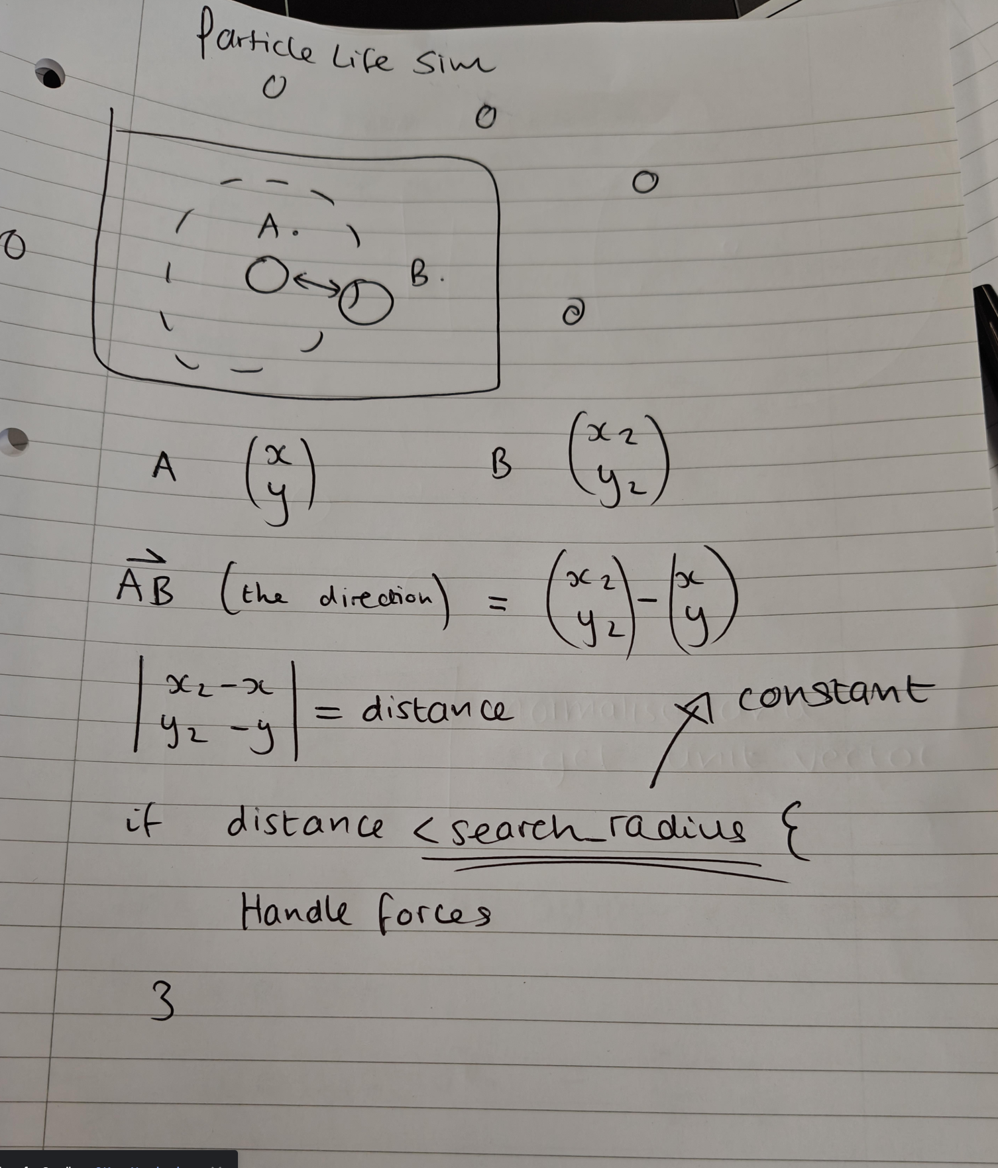

To be able to simulate realistic physics for my stakeholders, I first need to calculate how I am going to handle the interactions between them. Though I have decided to make my physics system from scratch, I could have alternatively used a different framework, or even a game engine. However, with a game engine I would lose the optimisation and streamlined nature of my application, and an external framework would require another thing to learn and use, so it just seemed much easier to create my own with my own knowledge. This has the added benefit of it being easy for me to modify and adjust as I see fit. Another benefit of making it myself is there is no need to try link these external libraries, which will likely solve a lot of debugging issues later down the line in development and testing.

Using my Vector2 class which I have made, we can store the Particle’s positions as these vectors, and to obtain the Vector from one particle to another, we simply minus A from B. This gives us the direction we need to be able to apply the force, however, to find the unit vector (where the magnitude equals one), we need to divide our Vector AB by the magnitude/length of the vector AB. By having the unit vector and the magnitude of the original vector, this tells us a standard direction and the distance between the two particles, which is very useful. We can check the distance against the search radius to determine if the particles are in range or not.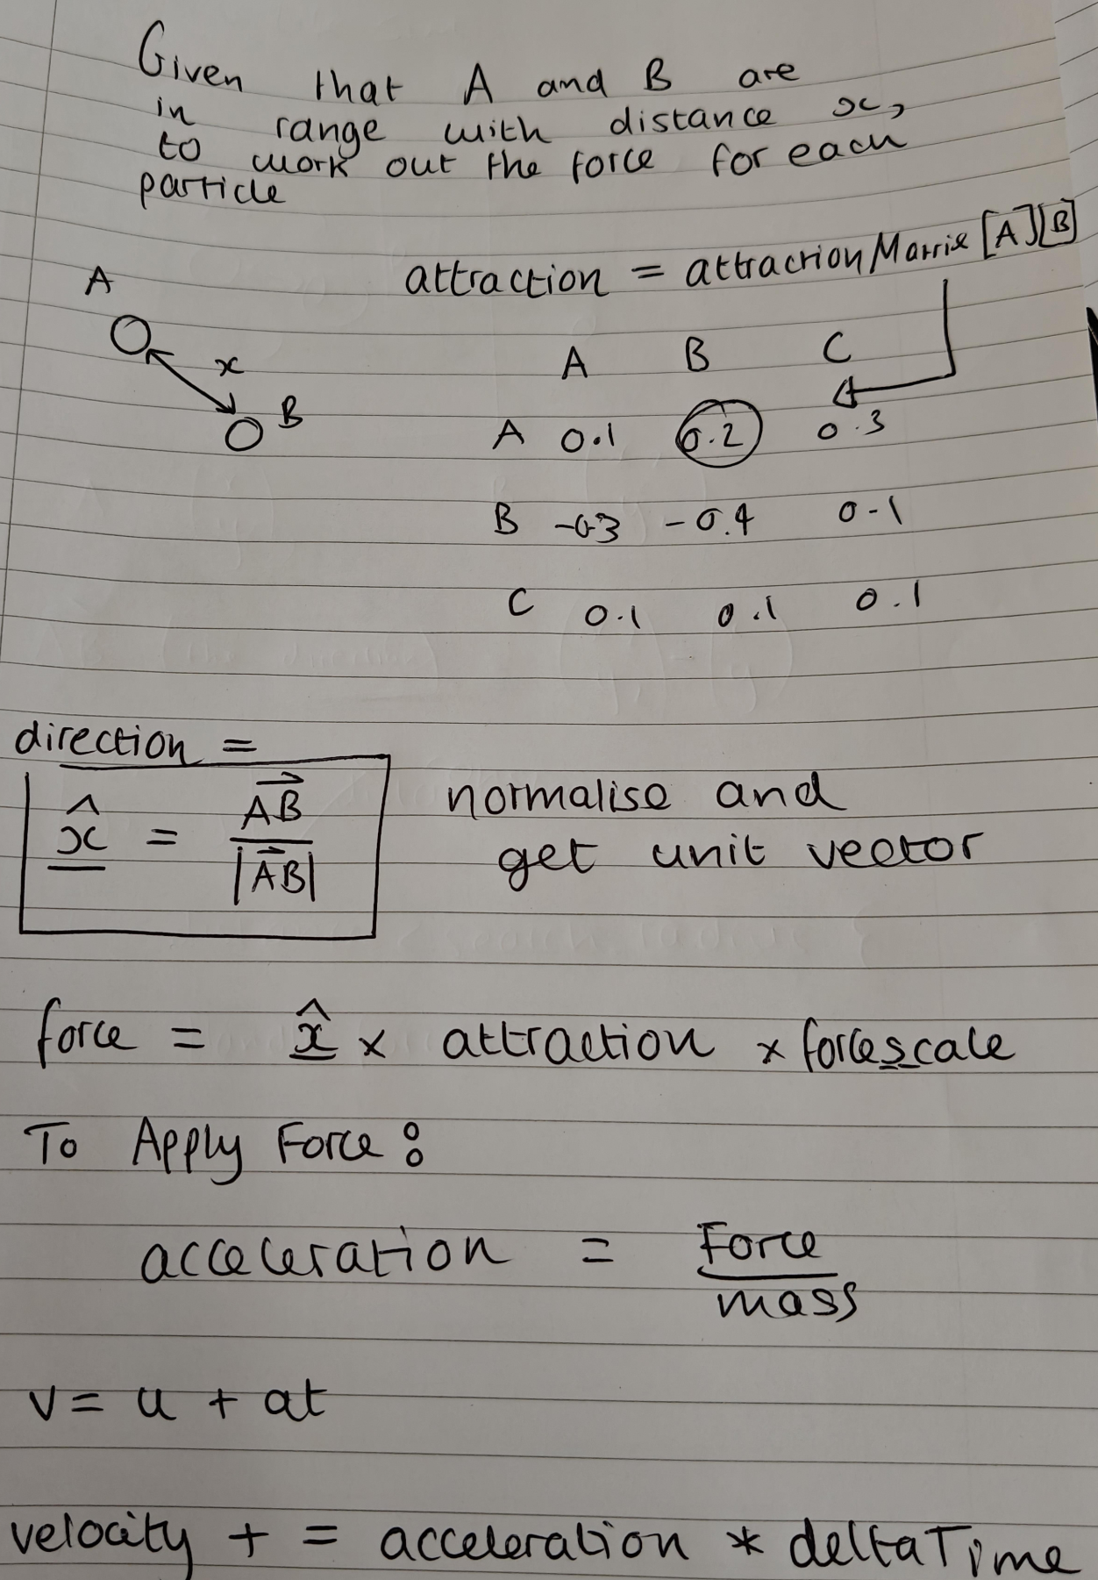

To calculate the force we need to apply, we obtain the attraction value from the attraction matrix by using the colour types of particle A and B. This attraction value is a scalar, however force is a vector, so we multiply the attraction by the unit vector of force to obtain the total force that should be applied. This is an extremely simplified force function and will be improved upon later in development. We then use the equations of motion to apply this force in my physics component and use the time since our last frame (delta Time) as our rime variable.

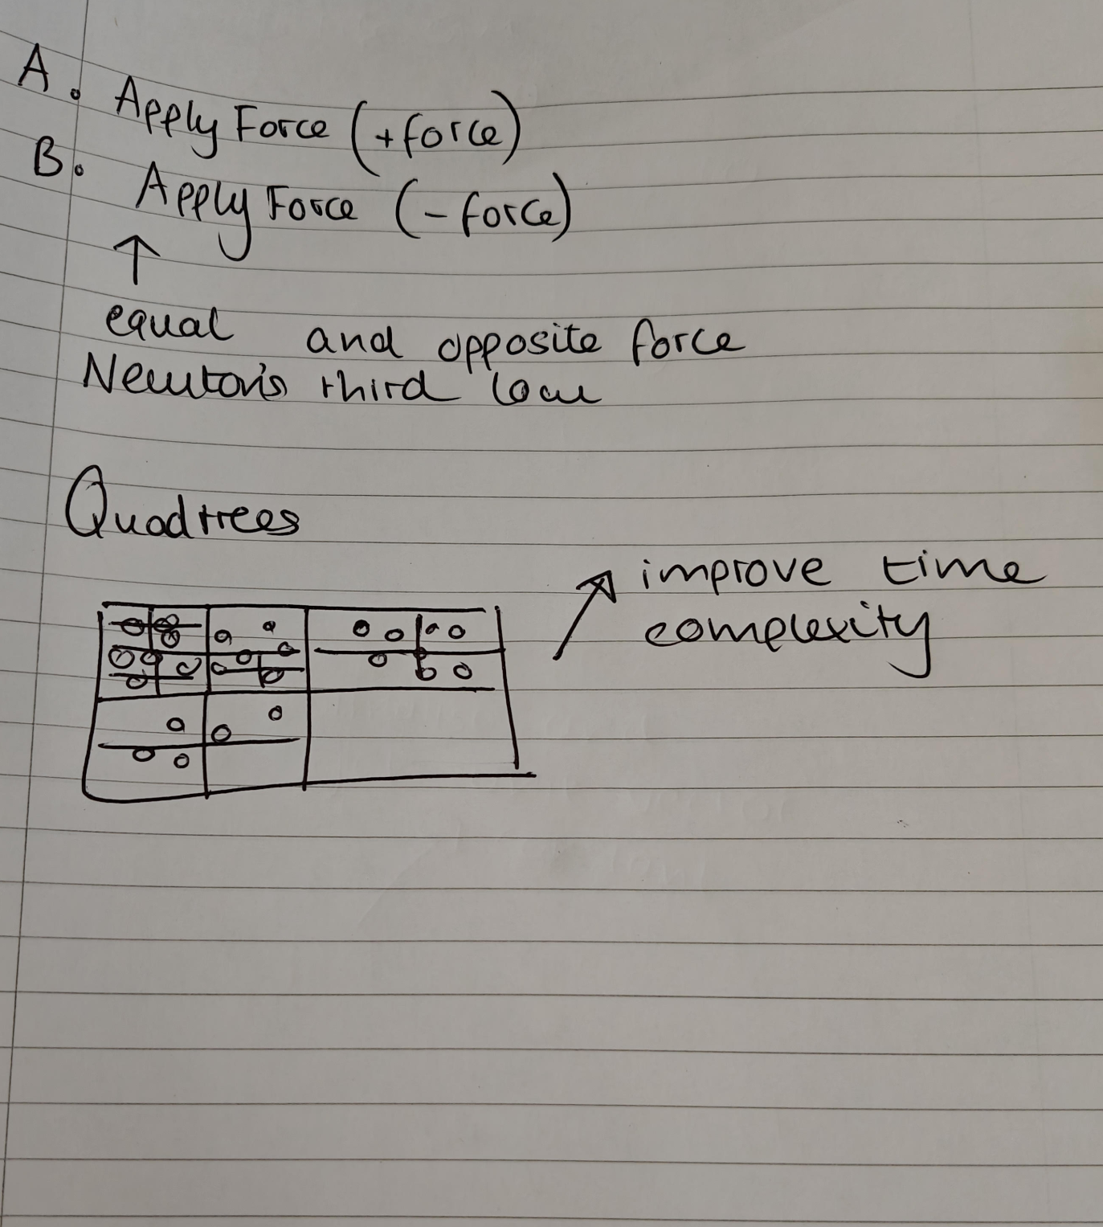

The according to newtons 3rd law, every reaction has an equal and opposite reaction, so we must apply the force to A, and the force to B in the negative direction.

### What will be used for iterative testing?

After considering the scope and purpose of my project, I have decided which variables will be used for my iterative testing stage. While more may also be adjusted and tested along the way, these variables are the key components which will create the simulation for my stakeholders, and due to time constraints, I need to pick the most notably important variables. For instance, I could test the variables in my texture manager however since it is a small rudimentary file there is less need than testing the core logic and interactions for my application.

|  |  |  |
| --- | --- | --- |
| Variable | Type | Purpose and testing |
| SEARCH_SCALE | float | Is used to determine how far particles can search around them for other particles. Will be used in testing to ensure that the distance is not too far so that particles on opposite sides of the screen interact, and that particles do not have to be overlapping to react with each other |
| MAX_SPEED | float | Will be used to clamp the particles to stop velocity build up. Will be tested to ensure particles do not go too fast and escape bounds of the screen or cause too chaotic behaviours. |
| Delta Time | float | Time since last frame, however, will set to a constant for simplicity as size of float is negligible at this level. |
| Friction Half Life | float | Used in the calculation to work out the friction facto, will be tested and updated to ensure particles are able to calm down and not gains peed infinitely |
| Friction factor | float | Is used to calculate the modifier to a particles velocity every frame to ensure they do not infinitely accelerate |
| matrix | Vector<vector<double>> | Used to store the attraction matrix, will be tested using different random distributions and intervals to generate between to get desired behaviours |
| manager | Manager | Is used to make sure all the entities are running well. Will be tested with logs to console to make sure it is calling everything it needs to. |
| q | Quadtree | The quadtree which will improve efficiency of the program and increase capacity for more particles. Will be tested to make sure the correct regions are being searched |
| Is Running | Boolean | This is used to check if the game is still running and if not to break out of the game loop. Will make sure there are no edge cases where the game cannot stop running |
| particle | Entity | The main object of the simulation. Will be tested to make sure physics and interactions will be handled properly, and that the correct behaviours are being displayed for my stakeholders. |
| position | Vector2 | The position of the entities. Will be tested to make sure the velocity is being applied correctly |
| velocity | Vector2 | The speed of the entities, will be tested to make sure there are no extreme values or edge cases |
| Attraction value | float | Plays a factor in determining the force between two particles. Will be adjusted in the matrix generation to ensure that the desired behaviours are reached for my stakeholders. |

### Accessibility Features:

To make my project usable, I will implement several features for my project. While I am unsure if I will meet all my initial success criteria due to time constraints, I will make my program as usable as possible, by first starting with a keyboard-based macro input system as opposed to a user interface. This will allow me to continue developing on my project for more desirable features for my clients and stakeholders, and I can always change to a GUI based approach if enough time is given.

What makes my program accessible?

To make my program easy to use and accessible I will first attach a README file with instructions of all the shortcuts that can be used.

#### Accessibility Shortcuts:

All the shortcuts have been chosen for the convenience for the client/ stakeholder and will be justified below the table

|  |  |
| --- | --- |
| Shortcut key | purpose |
| h | “help” - will output in terminal this list of commands that can be used |
| r | “reset” - will perform “p”, “m” and “f” all in one to restart the simulation |
| p | “Reset particle position” - will clear out all the particles and spawn new ones |
| m | “Regenerate matrix” - will generate a new attraction matrix |
| f | “freeze” - will set all the particle's velocity to 0 |
| up | “Increase velocity modifier” |
| down | “Decrease velocity modifier |
| Shift up | “Increase Force modifier” |
| Shift down | “Decrease force modifier” |

* “h” is needed for new users who do not know how to use the shortcuts yet. Alternatively, I could have just kept them in the README file, however not all my target audience may know to find and read that
* “r” is needed so my clients and stakeholders do not need to close the program and rerun it to try get another. It could have been a different key however I thought I should stick with the first letter of each instruction for the shortcut to make it easier to remember.
* “p” I justified putting this in, because some of my stakeholders might like the behaviours from the current attraction matrix yet want to restart the simulation from the beginning with the same matrix.
* “f” I justified this shortcut because in case of the particles starting to move too rapidly and disrupting any behaviours, my clients can soft reset their velocity to manually calm down the behaviours of the particles
* “up” and “down” keys are being implemented for stakeholders that want faster moving behaviours which are more dynamic, or stakeholders that want smoother, slower behaviours. I could have used the mouse wheel for this, but I was unsure of how to add this in, so this seemed easier.
* “Shift up and down” - alternatively I could have used separate keys however because the up and down keys are already established, I thought it would make it easier to user for my clients.

Upon further review, I have changed the up and down keys to increasing and decreasing the particle population. I feel this will give my stakeholders more control over the simulation as opposed to velocity and the force modifier, which are interlinked and act in the same process. I have chosen to replace velocity and not force modifier because my physics system uses application of forces to calculate the velocity, so changing the force is much less direct than forcefully changing the velocity and will result in less peculiar behaviour.

New Interface:

|  |  |
| --- | --- |
| Shortcut key | purpose |
| h | “help” - will output in terminal this list of commands that can be used |
| r | “reset” - will perform “p”, “m” and “f” all in one to restart the simulation |
| p | “Reset particle position” - will clear out all the particles and spawn new ones |
| m | “Regenerate matrix” - will generate a new attraction matrix |
| f | “freeze” - will set all the particle's velocity to 0 |
| up | “Increase population” |
| down | “Decrease population |
| Shift up | “Increase Force modifier” |
| Shift down | “Decrease force modifier” |

Due to time constraints, I cannot refine this new shortcut for the user to have more control of how much they would like to increase and decrease the population by, so instead I will settle for 50 as I believe this is a good mid ground for users. 100 may be too big a leap in terms of population however anything less than 50 will not have any major effects on the behaviour of the particles. Alternatively, I could have nested another condition using the numpad to set the amounts in which the up and down keys would decrease/increase the population ( e.g. 1 would set increase to 10) , however I felt that would be overcomplicating the system and would be hard to clearly explain over outputted terminal text. The default population size will be 500 to start from as from collecting data from my stakeholders via Microsoft forms that appears to be the most desired number.

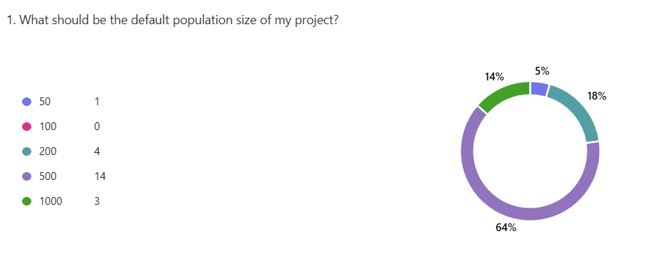

#### Rough sketch for basis of how interface will function and look:

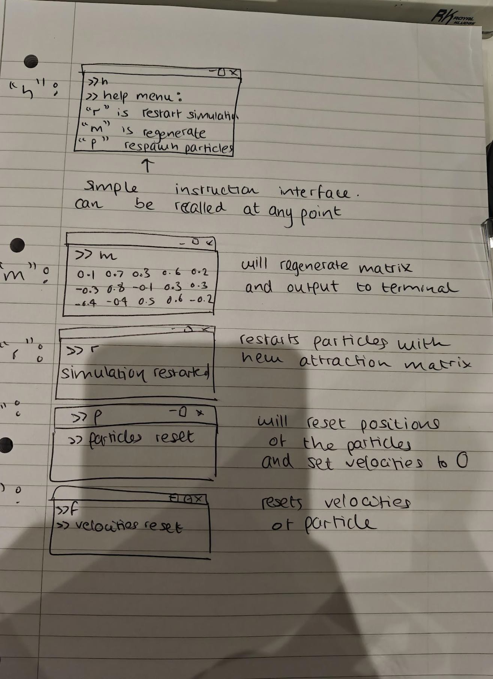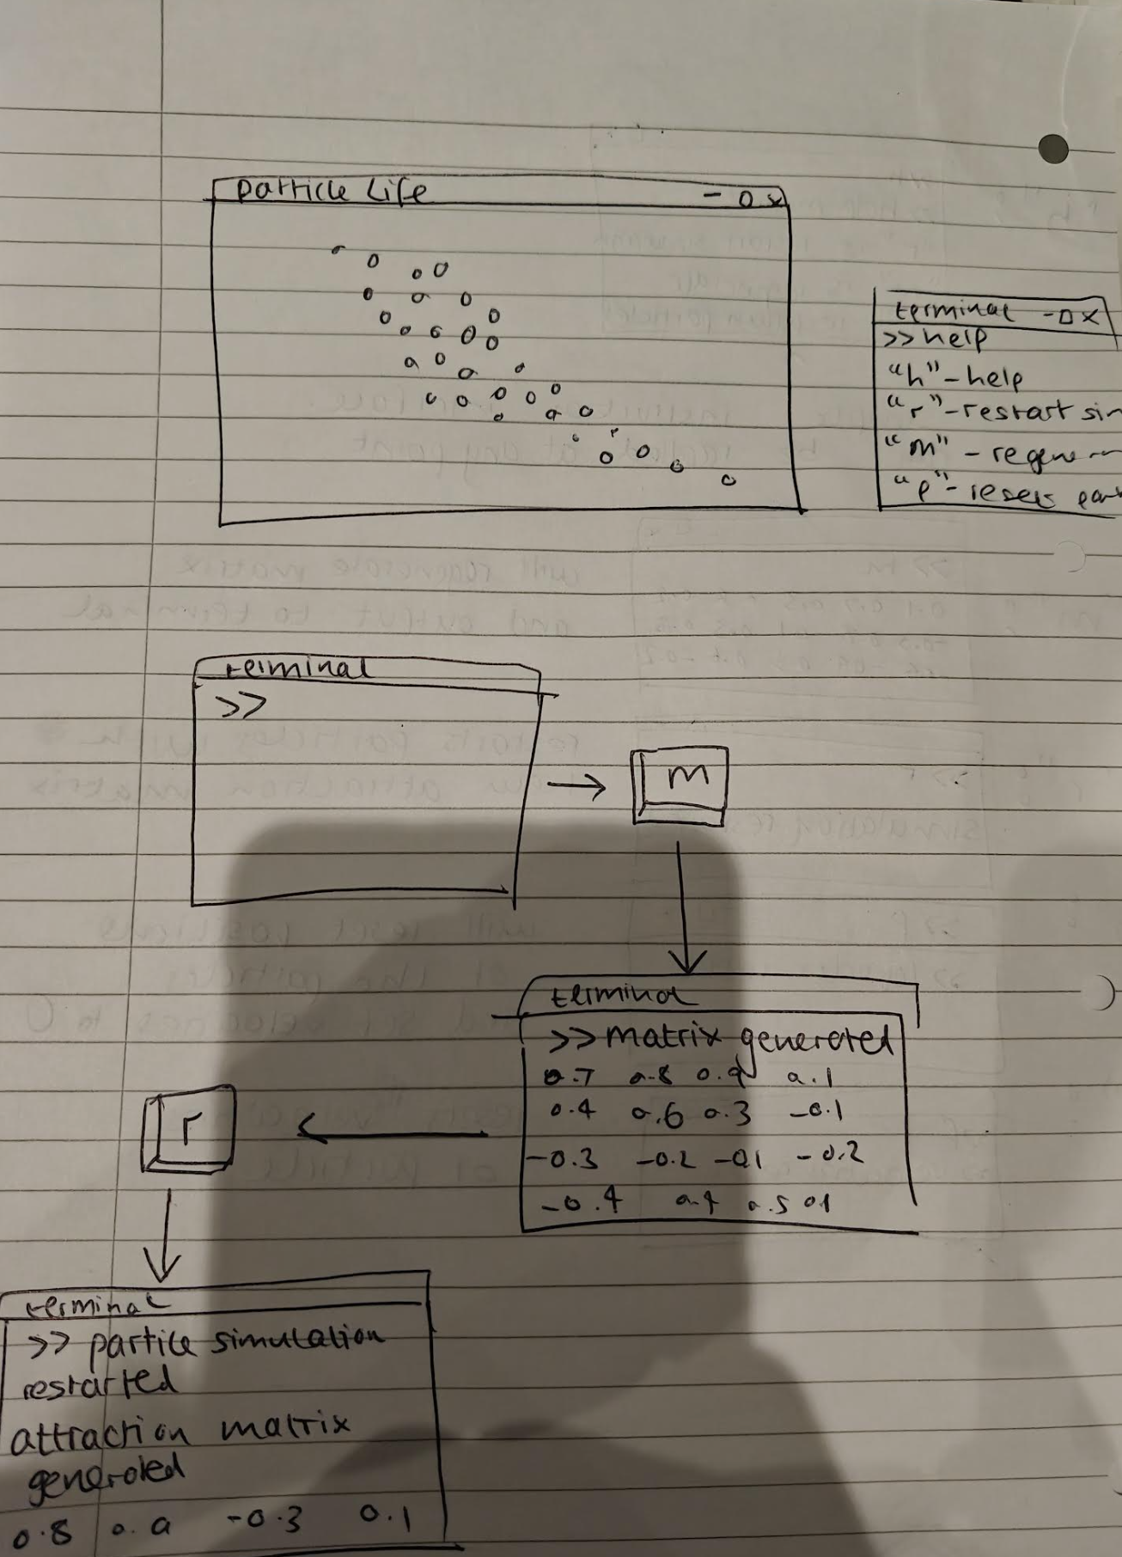

This will allow my users to access these commands without anything obstructing the screen at any given time. Alternatively, I could have had a secondary screen run alongside the application however I am unfamiliar with threading in c++ and felt this was the easiest way to move forward due to time constraints. I am not going to clear the terminal in between inputs so the player can go back and look at what matrices they thought were interesting in the case they want to try it again later. Really the only disadvantage to this system is the fact that players can not directly input values, they can only increase, decrease or generate random new values.

# Section 3: Development:

## 1ST Solution

To first bring this idea to life, I initially made a very simple prototype using pygame. There were no complex behaviours, I just wanted a feel for what the game was going to look like. This quick draft took around 30 minutes and I programmed a simple behaviour between different types of particles:

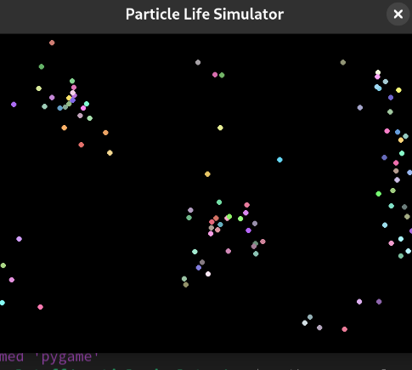

It was a good start but felt lacking in scope compared to my initial success criteria I had set. It was fairly limited in terms of particle population, as larger populations ended up slowing down the program quite a lot. And the physics were poorly made with.

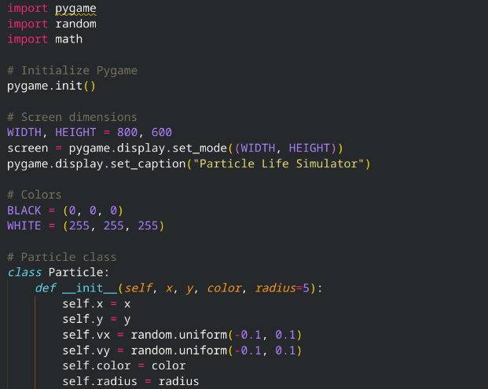

After setting up some boiler-plate for my pygame window, I made a simple Particle class, with position, colour, velocity and radius attributes.

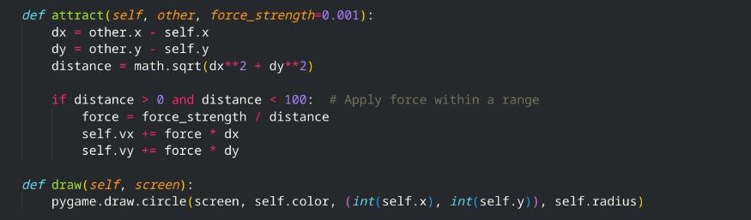

For my attract method, while technically velocity = initial velocity + acceleration* time,

Because of newtons second law (f=ma), if the mass is constant at 1 f=a, so we can just calculate using += force * dx (or dy). Alternatively, I could have implemented varying masses in, however given this is a first prototype I felt it was unnecessary.

My draw method is fairly simple, it just renders a circle to the screen with the attributes of said particle4 such as colour, position and radius.

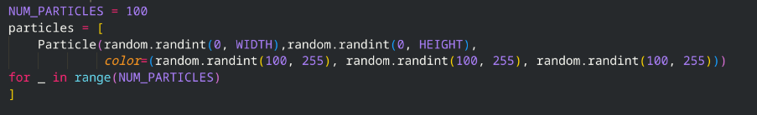

My loop for generating my particles needed a bit of formatting to fit into one screenshot, however this is just a simple python list comprehension, where an instance of a new particle is being inserted as each element, using randomised values.

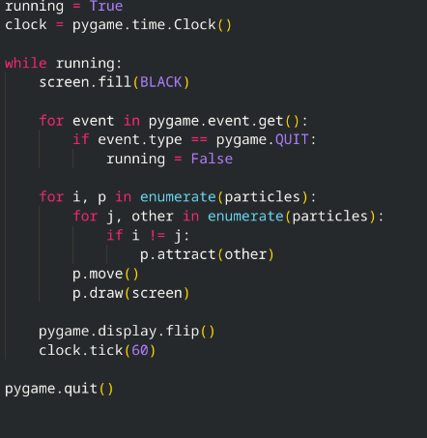

This simple game loop allows the simulation to run. I have a running variable which is a Boolean, and when set to false will break out of the while loop, and my clock is a Pygame clock which limits the fps of my project to 60 frames per second.

At the start of each loop, my screen is filled to black to override the previous frame, and I check for events (in this case the only event would be the quit event, which sets running to false). I then enumerate through my particles list and check to see if they are the same object or not. If not, I apply my attract function and then use my move function to change the particles position. I then flip the display, updating it and rendering the particles onto the screen and set clock tick of 60.

This was a great prototype; however, it was only 70 lines of code and lacks a lot of features as mentioned before. I want something more optimised and potential bearing, which leads me onto my next prototype.

This is next solution is based off what will be seen in the design section and is much more modular and well structured. I have developed an Entity component system and made my own sprite and texture manager. Funnily enough, this is using pygame as well, sort of. Pygame is a wrapped version of SDL2 for python. So, under the hood, the graphic framework is the same.

### Review of first solution:

I will be gathering Feeback from my end users to understand what good and what needs is improving about my project.

I will gather information on:

* If the users found the project visually interesting
* What features they would like to see added regarding functionality
* Their overall rating of the solution based on the initial success criteria
* What usability features are most important to them

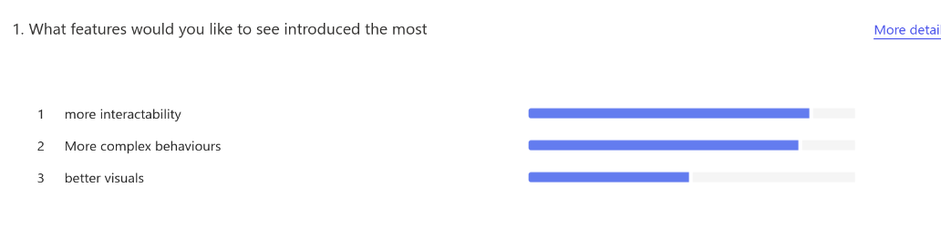

As can be seen from the results, usability/intractability and the behaviour of the particles themselves outvote the need for better visuals. If better visuals had gotten more votes, I would have considered introducing shaders using SDL, however due to time constraints, unfamiliarity with shaders and overall less demand from my end users compared to the other features, I will not be implementing a shader system.

I will be alerting the colours to be more saturated and I will leave the visuals at that for now, however if given extra time this is something I would consider adding this. Intractability and the behaviour of the particles is evidently much more important to my end users, which is why I will focus on implementing these features in my second solution, using more realistic physics and mechanics calculations and adding in an interface for my users to be able to control the application with.

Not wanting to over scope the project I had to make a choice between improving the behaviours of the particles and having a simpler interface system or not getting to spend much time modifying how the particles interact but have a fully fleshed out Gui for my end users.



I created another miniature form for my end users to fill out to gain some insight towards the consensus for what the focus of development should be on. After gathering the responses, I ended up with these results:

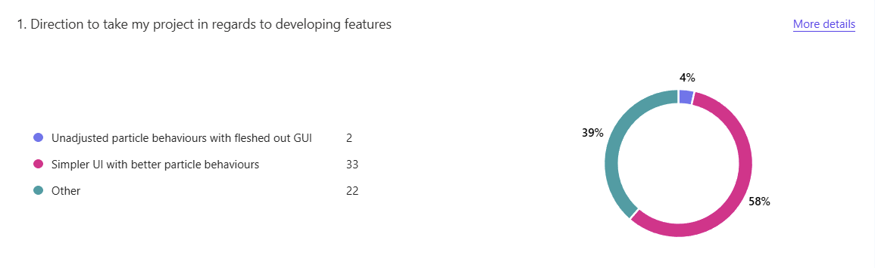Which allowed me to come to the decision that I will be focusing on the interaction logic between the particles and provide a simple and easy to use terminal-based control system for my end users.

My next question I collected data on can be considered not as helpful as the rest, though it works in providing a general opinion of my project so far. At its core it is supposed to be interesting to watch and observe, and luckily as can be seen from the figure below Over 80 percent of the end users who took the survey found it to be visually interesting. While I will still aim to improve on this, this allows me to be less concerned with this section knowing that it has already been met at a base requirement.

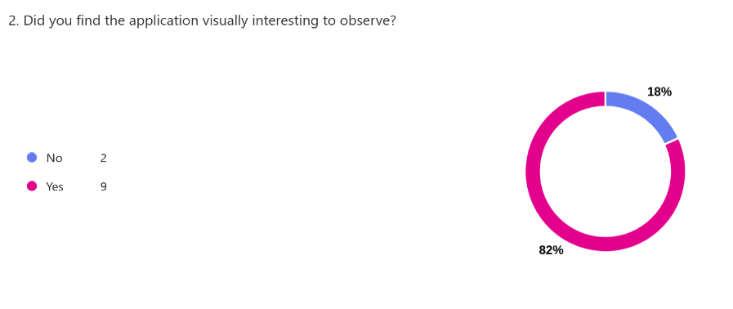

On average, my rating for how well my first solution delivers based on my success criteria is 2.91 which is about what I expected it to be given the short amount of time it was developed in and the case that it was not developed with the idea of being an end product in mind.

I could have added in a text-based field for this question to gain more clarity on what they think has been met and what has not, however it is easy to see when comparing this solution to my success criteria as I can compare what has and has not been included.

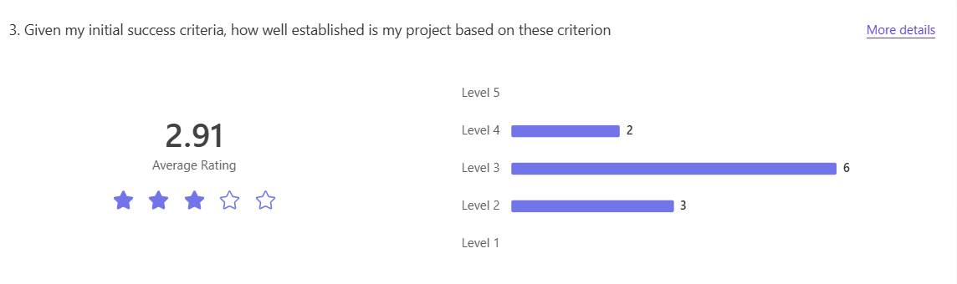

For my interface, I wanted to know what the most desired usability features would be, so I put together the top mechanics I could think off my head and put them in my survey. Surprisingly, the ability to change the colour of particles was rated the lowest, which is strange considering some of my end users will be artists. This could potentially be due to the fact this survey was done with my computing class, meaning that these results are slightly skewed, which I will try to rectify by having a wider range of my end users participate for my second solution review.

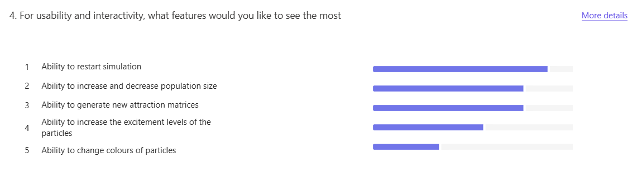

As can be seen, the ability to restart the simulation and the ability to increase and decrease the population size of the projects and the most desired by my end users, which is what I will be focusing on as a priority. I will also add in the ability to generate new attraction matrices and the ability to change the excitement levels of the particles, by either altering the velocities of the particles of themselves or by adding a modifier to the force being applied to the particles. This is a decision i will have to make further along the line of the development of my second solution as my physics has not been programmed yet.

Overall, considering the scope of this first solution as a prototype I am happy with the positive Feeback I have received. While the 2.91 stars out of 5 may seem quite low, this is being rated based on how well it meets my initial criteria for success, not necessarily the enjoyability and usefulness of the project (even though there will be some correlation most likely).

I am looking to make my project more modular and easier to maintain for my second solution, which I will achieve by adhering more to the solution established in my design section. I will focus on providing a robust user interface as well as making sure the particle interaction logic is more refined and realistic in movement compared to the prototyped first solution.

### Picking a colour set:

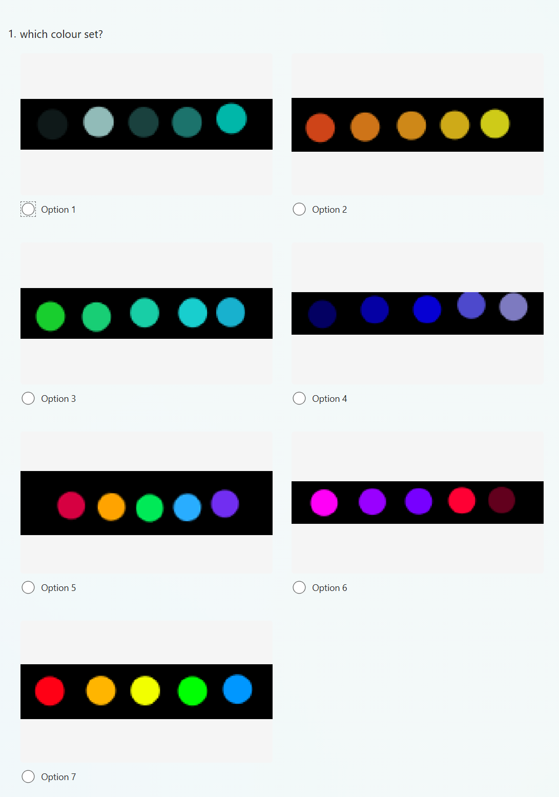

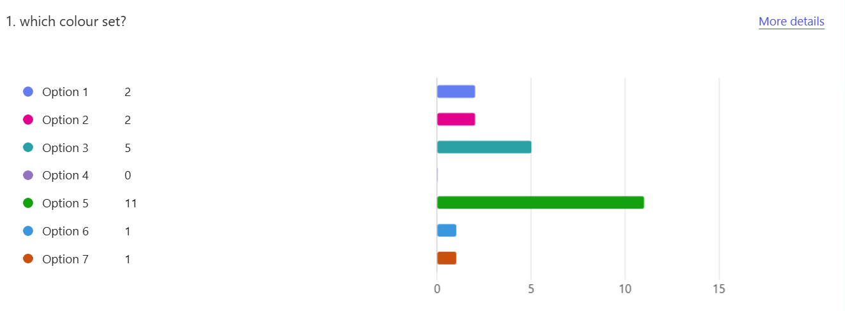

As can be seen from this survey from my end users, the option 5 colour set is the most desired out of the several options I created, which is why it will be used going forward

## Second Solution:

### How will my data be tested?

Most of my variables that will be tested will be tested on an observational basis, meaning that I will be testing them based on how my particles interact and how they behave. Unlike some other projects such as Blackjack, it is hard to get any useful data on outputting a variable such as velocity which is updated 60 times a second.

The chosen variables that have been put into the list are the core variables I believe that are the most impactful to the game. This table is very similar to the one in my design section, where I have justified each piece of data, though this is describing how it will be tested and what I will be observing from its changes.

|  |  |  |
| --- | --- | --- |
| Variable | type | How will it be tested |
| SEARCH_SCALE | float | Will be adjusted and observed to see which values create an equilibrium effect so that the particles can eventually reach a stable state. If there is not enough interaction, this will be increased, and if there is too much from particles long distances away it will be decreased. |
| MAX_SPEED | float | Will be adjusted based on the excitement levels of the particles. If it is observed that the particle shave too much energy and cannot form properly it will be lowered, however if the opposite is true and the lack of energy is causing no formations it will be increased. |
| Delta time | float | This will be observed and tested based on how quickly the particles are interacting with each other. By lowering the delta time, we are getting a smaller time slice each frame, which will allow us to see emerging behaviours much better. If they are interacting too quickly to be able to see these behaviours it will be lowered, however if it gets to the point of it taking too long for behaviours to form it will be increased. |
| Friction Factor | float | Observed and will be increased or decreased based on the connection between particles. If the particles do not have enough friction to form together this variable will be increased however if the friction is too high and the simulations halts, then it will decrease. |
| matrix | Vector<Vector<double>> | Will be observed to test if the corresponding values match the behaviours of the particles. For instance, if the matrix has all negative values however particles are being attracted towards each other that means something is wrong in my force logic. |
| velocity | Vector2 | Will be tested to see if there are any edge cases and if the values are spiking at any points they should not be. If some of the particles are zooming around too much at high speeds that means my MAX_SPEED value has not been applied properly and is causing some errors |
| q | Quadtree | Will be tested using smaller populations fo particles to see if ithey have been inserted correctly into the quadtree, for this the particles will remain static so I can clearly see if they have been inserted into the tree correctly depending on their place |
| Attraction value | float | Will be tested by seeing how strongly the particles are pulling each other and will be increased or decreased based on how the particles behavee, for instance if the attraction values are too weak and the particles are not forming together then my force function need modifying |

Quadtrees:  
  
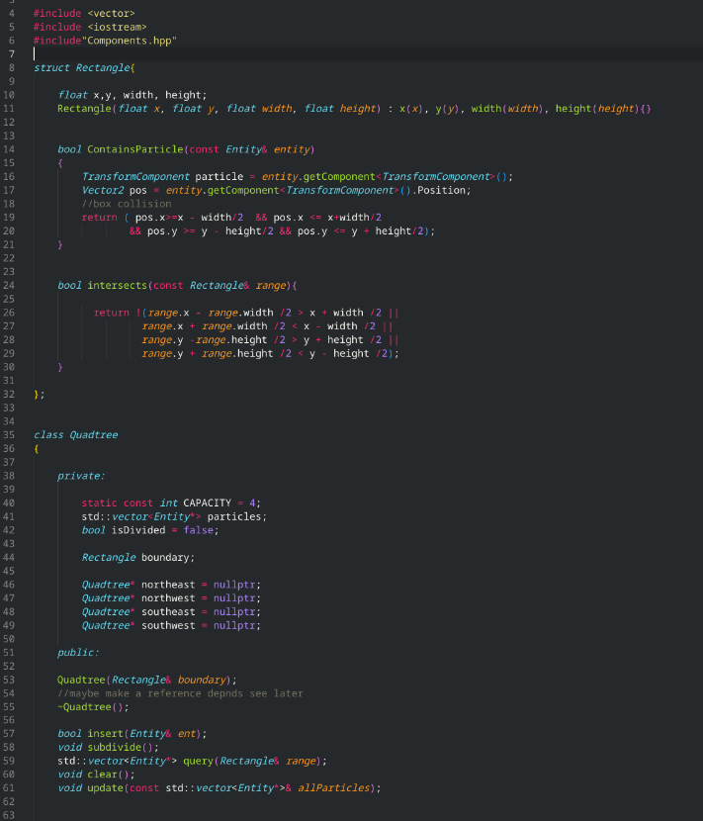

To be able to simulate visually interesting behaviours between these for my stakeholders, hundreds if not thousands of particles will be need to be rendered to the screen and have their physics managed, x times a second (variable depending on the chosen frame rate). If I were to use a linear approach, for every particle, a linear search on the particles array would need to be done, where their transform component is accessed and their distance in relation to the current particle being processed is calculated using Pythagoras to see if it is within a certain radius of the current particle to interact with it.

After this is done, each particle close enough would be added to another array, where their direction vectors relative to the current particle is calculated by subtracting their position vectors that were obtained from their transform component, and then have the impulse calculated for the particle to react to the simulated forces. If we were to try render 1000 particles at 60 frames per second, this would cause major performance issues, especially with not all my stakeholders having high end specs on their devices. To maintain my hardware requirements, I researched for a more optimised approach, and came across red-black tree traversals, and K-D trees, however given the dynamic nature of my application I opted for a Quadtree data structure. This tree data structure will allow me to recursively search through my particles more efficiently, allowing me to traverse down the tree into the region they are in, greatly narrowing the search.

How it works:  
  
The tree starts by performing a linear search on the particle array of particles, to determine if the tree needs to subdivide or not. To decide this, we have a preset region capacity, which if exceeded indicates that a region has too many particles in, and then subdivides again. As in the name, “Quad - tree”, the tree then subdivides into equal regions, where this linear search is then performed on each region to see if that region needs to subdivide again. This is more efficient than a grid system, because if there is a cluster of particles in one region, and none in the rest of the screen, a grid system would still have a grid over the entire screen to search through, with uniform cells, where as a quadtree would be able to produce larger regions , with less sub divides for areas with less particles in, and more subdivides, resulting in smaller regions for areas with a more dense population of particles.

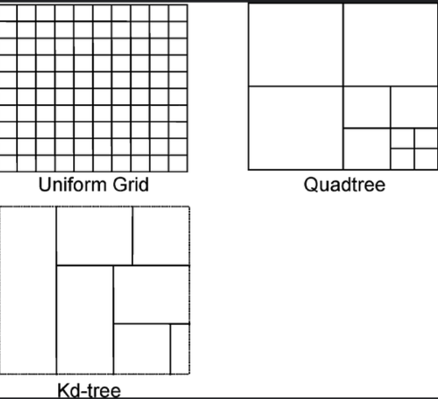

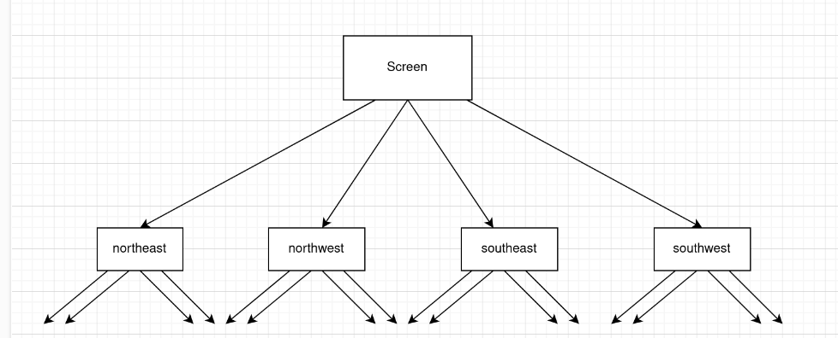

### Matrix Generation

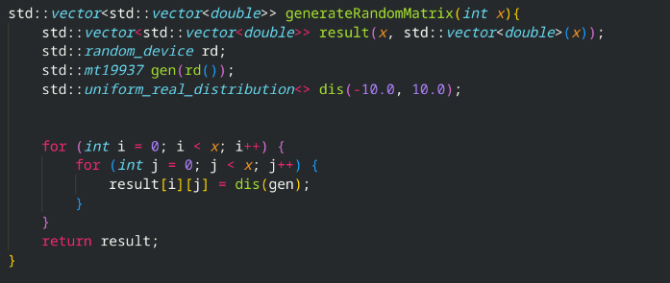

To be able to generate a wide range of experimental and variable results for my users, I need to be able to generate an attraction matrix with random values, as a starting point. To allow for a dynamic size, and automatic memory management, in case of more colours needed to be used, therefore a larger matrix size, I have used the standard vectors from c++ to store my values for my matrix.

While not feasible to generate true random numbers, we can use a pseudo random number generator (in this case I have chosen the Mersenne Twister 19937 generator), and after setting a seed for us to generate on, and setting boundary values to generate between, we can apply this to our matrix of size n*n. I could have also used manual creation, however this option is much less limited for my stakeholders

Matrix generation logic:

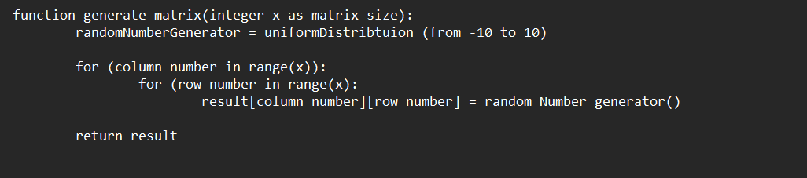

### Game header file:

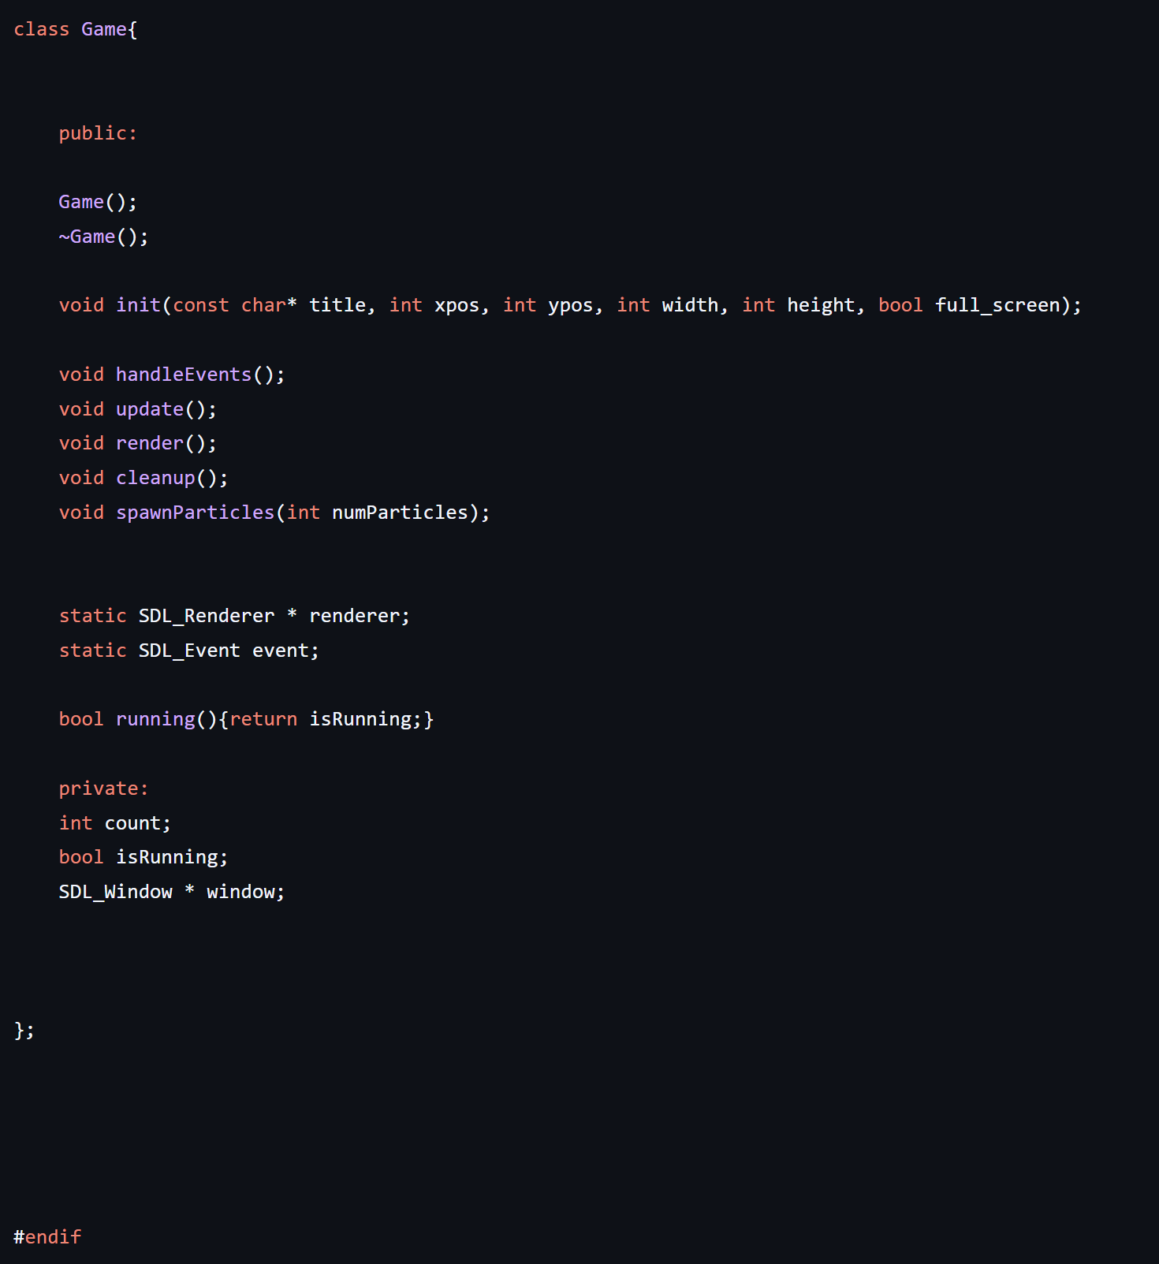

This header file allows me to declare the functions I will be using, and I will be implementing them inside my source file. To keep my project streamlined for my stakeholders and clients, I have stuck to the minimum functions and variables needed. I have my handle events function, which is called in my main while loop, and creates and sdl poll events listener to listen for inputs. My update function is called every frame inside my game.cpp, cleanup is called when the program closes and clears all entities in the heap, and spawn particles spawns' particles to the screen with an algorithm which will be covered din more detail below. Alternatively, I could have added more functionality however I believe this is sufficient and any more features would be redundant for this project.

I have my static renderer and event. I have made this design choice to make them globally accessible across all my files, as all my program will be using the same renderer and event listener. While I could have made them non static, this makes my code much easier to read and program for.

My running method I have implemented in my header file instead of just declaring due to how simplistic it is. While it is generally advised to keep your declaration and implementation separate, it is one getter function and therefore I decided would be easier to just to implement in my header file.

### Main file

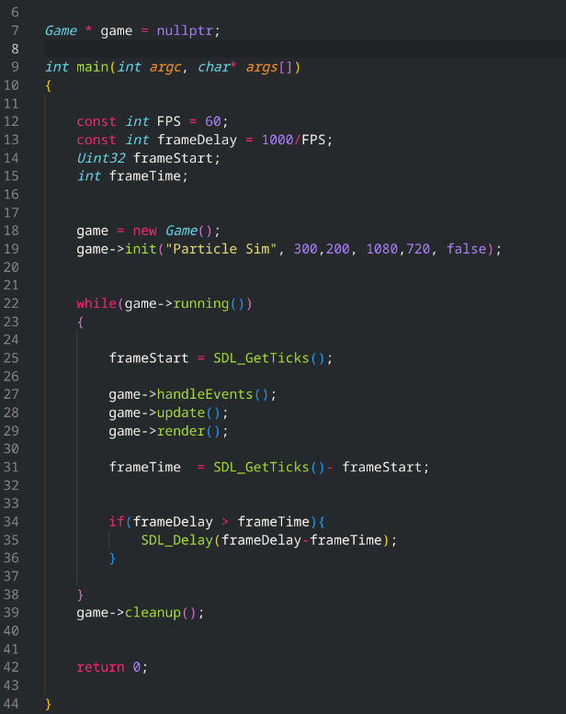

This is the file that is run when my project is compiled and executed. It is the “motherboard” of my code, using all of the other header and source files. While the actual code is not great in size, it has designed to be modular and is offloading onto other functions and classes in other files, such as the game class. It is able to calculate frames per second, handle input events, updates and rendering, and when the application is closed cleans up any memory left on the heap. I could have had my main and game run in the same file, however, to maintain modularity and ease of readability I thought this was a better suited approach.

## My game.cpp global variables and header inclusions:

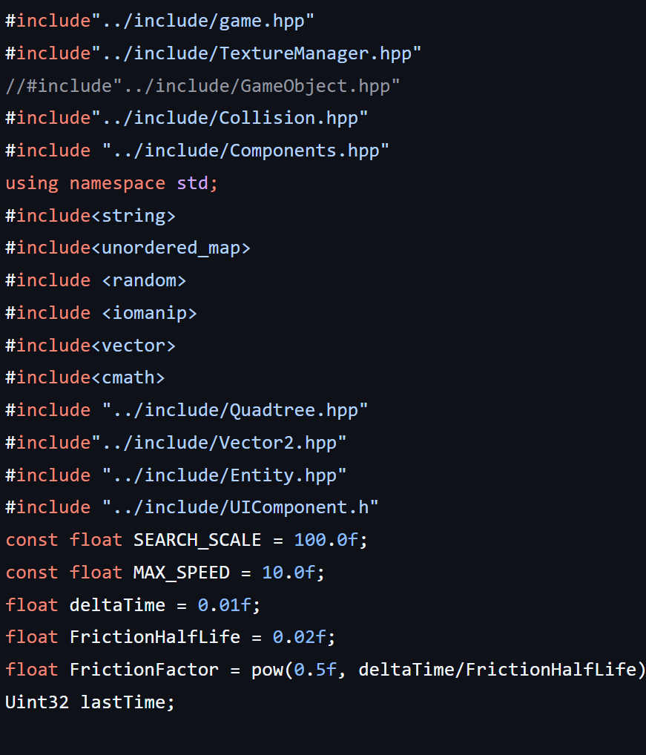



Here is the top of my game.cpp file. I have included all the necessary headers for my ECS to function, as well as game.hpp as this is the implementation for it. Alternatively, I could have not included everything and it might have still worked due to the fact most of these included header files include the other header files themselves, however I wanted to be on the safe side and because I have used pragma once in all my header files, this ensures each header file is only used once during compilation anyway and reduces risk of circular dependencies.

### Initialising the game and SDL systems:

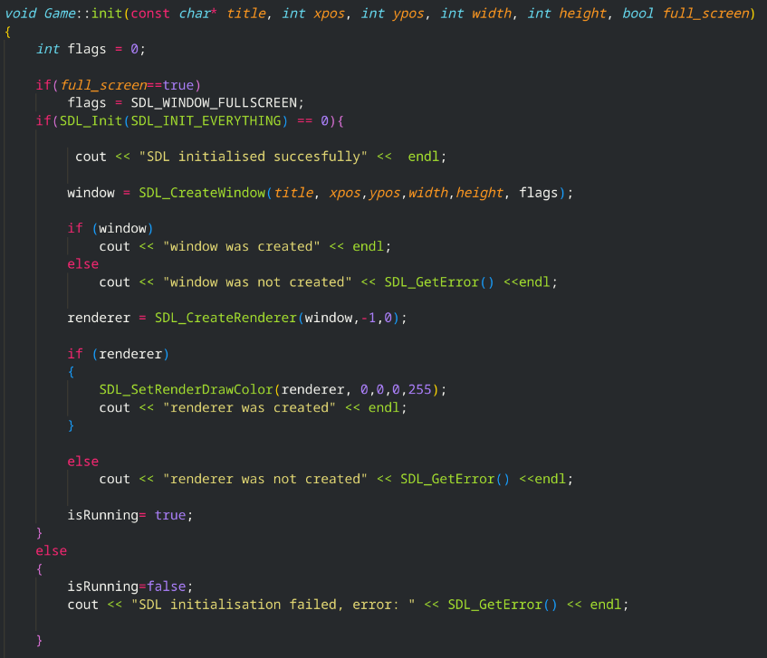

To ensure my application is reliable for my users, I need a robust initialisation system. Using flags and a series of checks, such as checking to see if the window and renderer were initiated properly, I have managed to ensure not only reliability and decreased risk of some subsystems running when other do not, but also a robust framework for debugging for future development if necessary. I could have performed more checks, however as mentioned previously due to time constraints and scope of project is felt unneeded

### Particle Initialisation

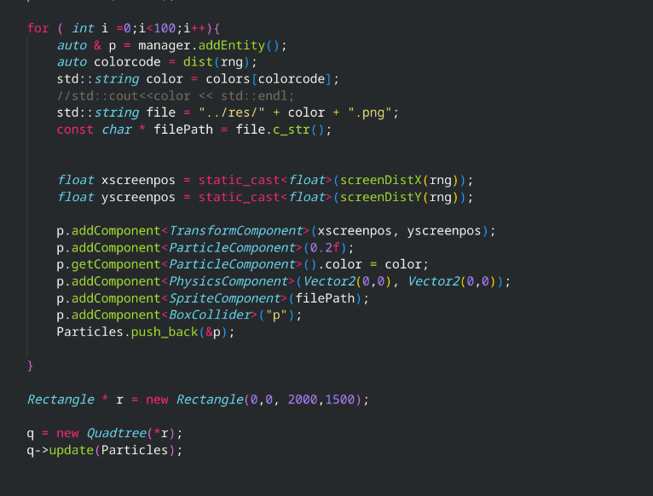

To be able to access the particles at any point in my program, I am using my ECS entity manager to create and handle these particles, as well as adding them to my Particles vector, so I can search through a vector of one datatype, instead of through my manager vector which might have other unwanted entities in.

After randomly generating their x and y positions on the screens, we can then pass those as parameters into creating our transform component for each particle, as well as our particle component, physics, sprite and box collider component to our particles, giving them the necessary behaviours to interact together. At the end of this, we will then pass our Particles vector into our quadtree where it can be inserted. There may have been a nicer more efficient way of doing this, however after thinking for a while nothing came to mind. This is not inefficient, and it would only affect performance at the start of the simulation anyway

Upon creating my interface for my stakeholders, I have had to make this code more modular by implementing it as a method in my game class. This allows me to more efficiently respawn particles without needing to rewrite the code in my handle events method.

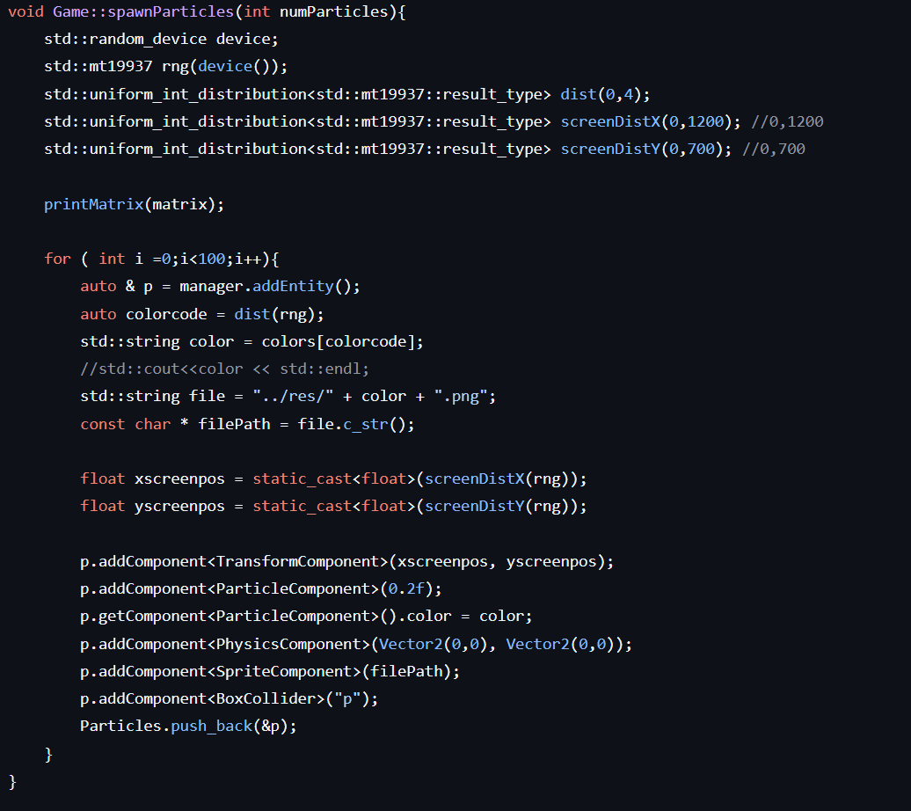

This code is then called in my handle events method:



### Update function:

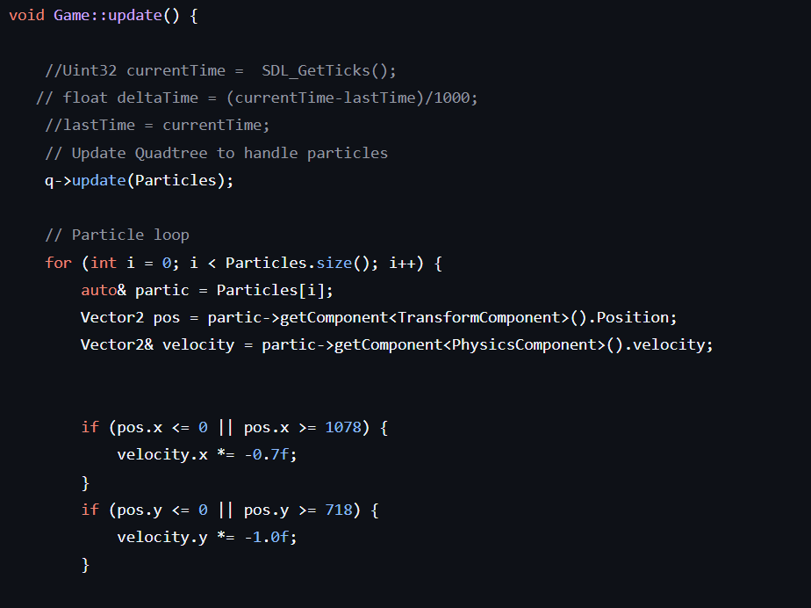

I first start my update function by updating my quadtree, feeding in my updated Particle vector to reinsert my particles into the tree. I then loop through my Particle vector and obtain their velocity and position attributes from their Physics and transform component respectively.

I have some conditions below to stop my particles going off screen, where their velocities are just reversed to be going in the opposite direction, creating a bouncing off effect.

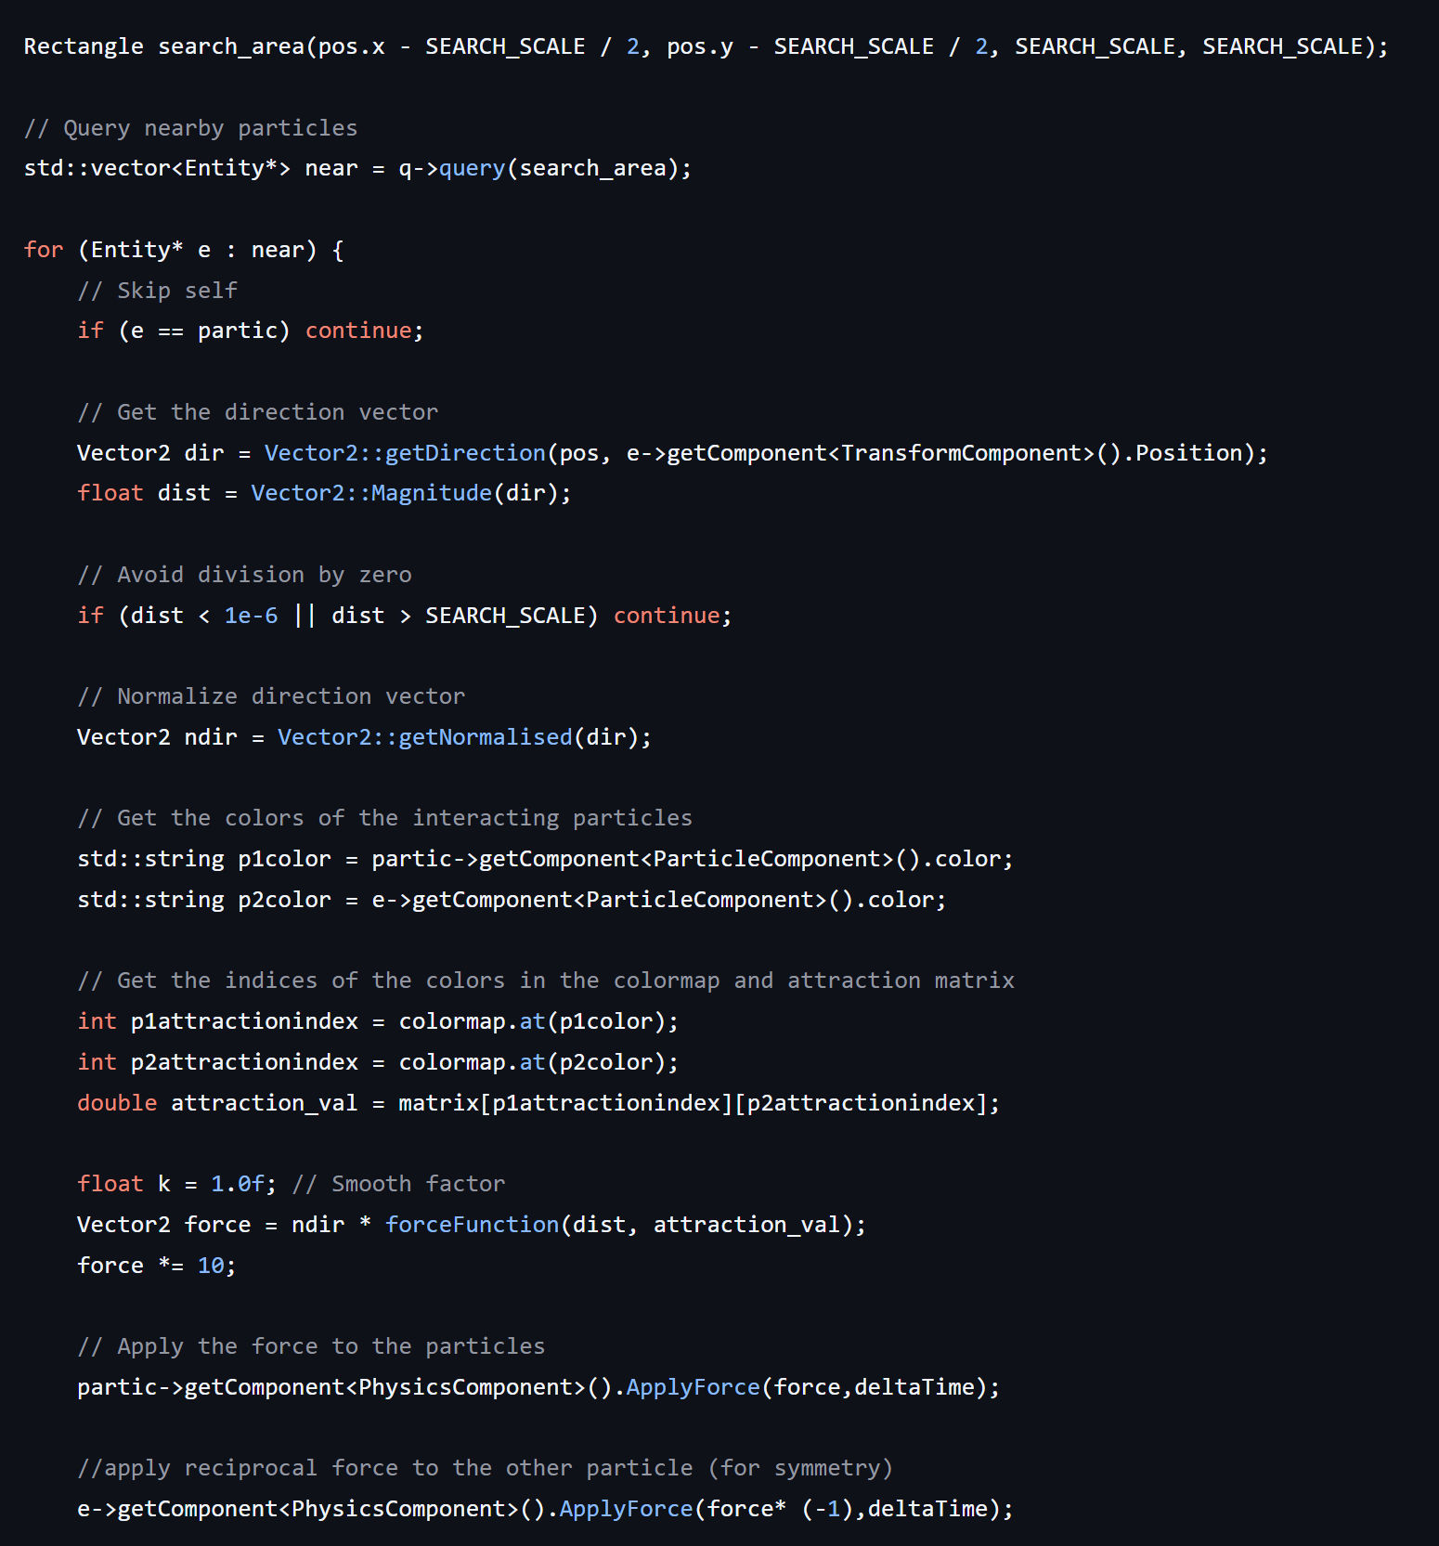

I then create my search area based off my constant search scale and the particles position obtained from its transform component. I then create an entity vector called near which then uses the quadtree to query that section of the screen and returns all the entities in that region to the vector. What is happening here is I am creating a searchable square region around my particle for my quadtree to search through, and then anything found in that square is deemed close enough to be interactable with my particle.

I loop through all my near particles in O(n) time thanks to my quadtree, and first make some checks such as, is the particle being checked itself? If this is the case, we can skip. Or is the particle too close to the particle to the point where it is on top of it and could cause a division by 0 error? Once these checks have been made, I then implement my Vector maths I discussed in my design section, where I get the direction of the particle to the particle being searched. After doing so I then normalise the vector2 by dividing the x and y components by the magnitude of the vector. I then get the colour codes for both particles by using my unordered map colormap and then use the values as an index for my attraction matrix to get the attraction value. I then calculate the force through my force function which returns a scalar quantity and then multiply this by my normalised unit vector. I then apply a force modifier which will later be changed to a variable for my users to control. I then obtain the physics components of each of my particles and apply the force I calculated to one, and the opposite force the other using my physics component method.

I use my collision method from my collision code to then check for a collision, and if so to resolve the collision. I then finally multiply the velocity by my frcition factor to ensure the particles do not infinitely gain speed.

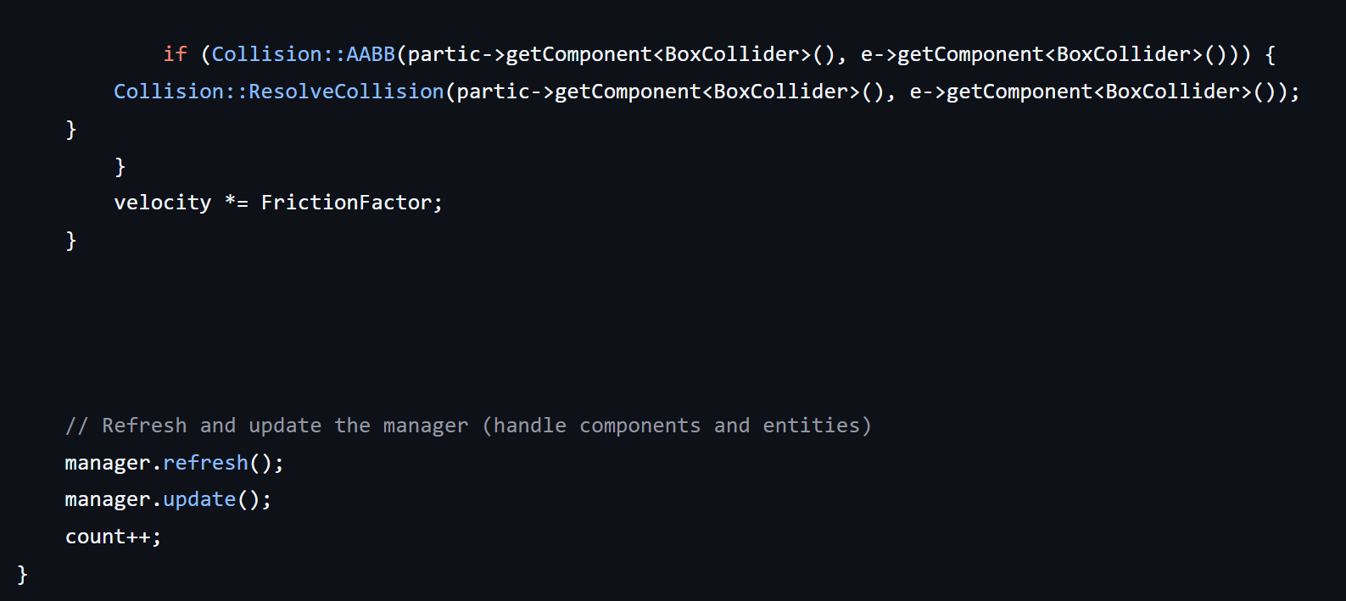

I call my manager refresh to get ready for the next frame, then call my update function again from inside my update function.

### Render function:

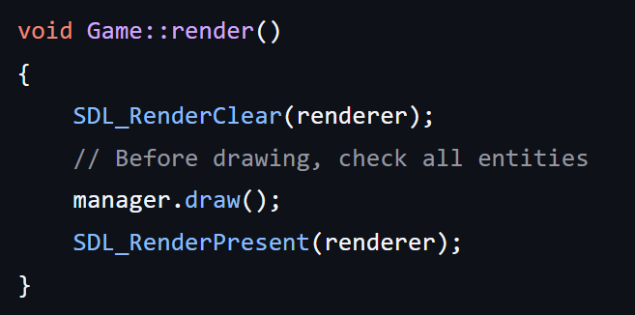

I clear my renderer of any surfaces currently on the screen, then use my managers draw method to enable all my entities to call their draw methods, then present them onto the screen. As you can see using an ECS paid off as now I just have to call the manager functions to do all this, whereas if I had gone for a different, less modular approach I would have likely needed to call all my entities draw functions separately.

### Cleanup function:

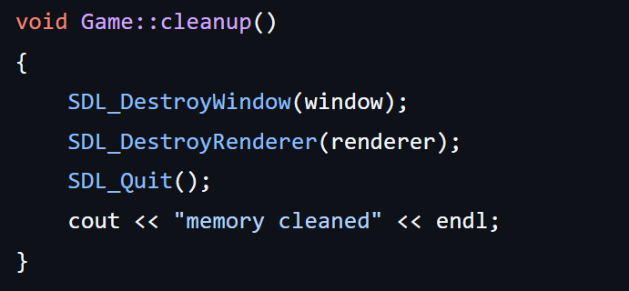

This just uses the sdl framework to clear up anything on the heap, destroying and removing my window and renderer, and then quitting the application and outputting a cleaned message into the terminal. Alternatively I could have added more flags and logs to have a better idea of what was going on, however since it was the end of the program, I deemed it unnecessary and not very user friendly to have several logs considering the terminal will be how the users are interfacing with the application.

Physics interaction

## Components

### Entity Component system (ECS)

This system allows for flexible, efficient and robust object management for my game, which is vital for optimal performance for my stakeholders on lower end devices. In my header file, I have declared and implemented a manager, component and entity class for my setup. The manager will manage entities, which through composition will each have components added to them, such as the Transform Component or the Sprite Component. I have used C++ templates to allow for flexible data handling of different types, allowing the program to specify which component it is searching for when accessing an entity. This modular structure ensures user readability and good maintenance for my stakeholders, in case of errors or bugs being found. There were other ways I could have structured this, such as a tree structure for my objects, however I felt this was easier and more familiar to deal with and create.

#### Component class:

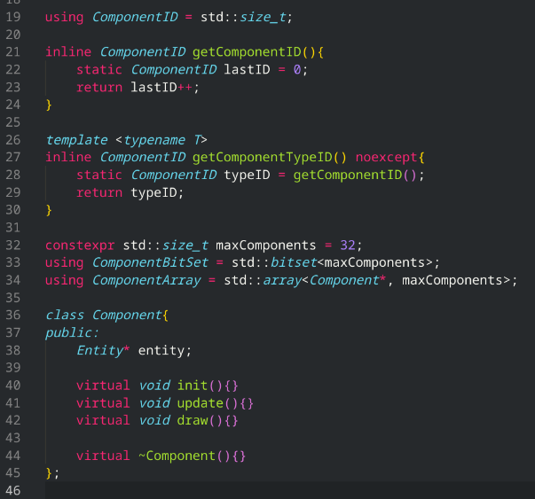

I have declared and implemented some inline functions nearing the top of the file for some base functionality, and have made my component class abstract (as denoted from making its methods virtual). This means I can easily add in new components with a homogeneous structure. I have also used a constant expression to define how many components I want any given entity to be able to have, which while is not an issue currently, may help prevents crashes given that there is a bug where components are added more than once. Aside from these virtual functions meant to be overridden, there is also a pointer to the Entity the component will belong to.

#### Manager class:

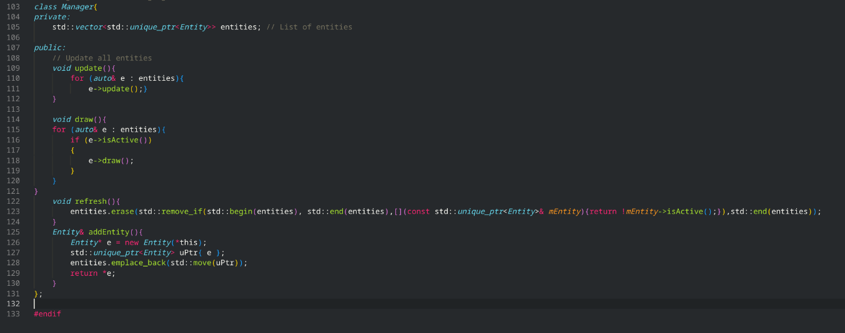

This class is dedicated to managing the entity objects, and is responsible for updating each entity, drawing, refreshing and adding Entities into the game.

The draw and update functions are not implemented here, but instead as each entity is unique with different components and attributes, calls the entity to call its own draw and update functions.

When the entity is being added to the unique pointer entity array, it is placed at the back to maintain a queue data structure, so important entities spawned on game initialisation are not de prioritised.

The refresh function removes inactive entities from the manager object’s entity array. This is needed so I can take out inactive entities and stop memory leaks at the end of each frame.

Later, in my development stage I also added this function in:

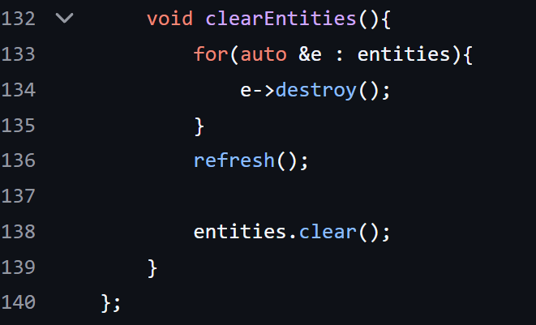

This loops through all the entities belonging to the Manager object and destroys them using the entities destroy function and then calls the refresh function to remove the inactive entities from the manage, then clears the entity array. This is needed for my restart simulation shortcut so I can safely remove all the current particles on screen.

#### Entity class:

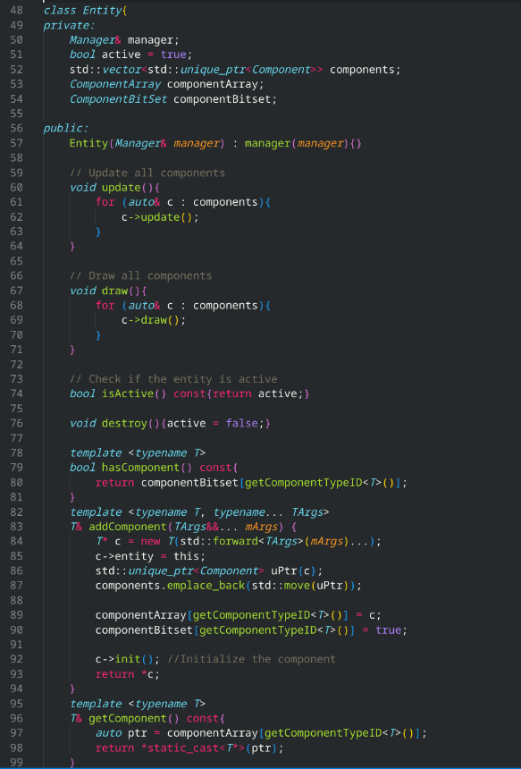

The entity class is essentially a template for a container object, which will be accessed to get its transform components. It has some maintenance functions such as isActive() to ascertain if the entity is active and needs updating/refreshing or not, and destroy to remove itself from the heap. AddComponent() again places a new pointer to a component with a specified type and parameters to the back of the components queue. GetComponent<T> returns the specified type component from the components array, allowing for secure and easy accessibility.

Its update method is similar to the manager class however unlike the manager update function which calls each entity to update itself, the entity updates method calls each component it contains to update itself.

### Particle Component

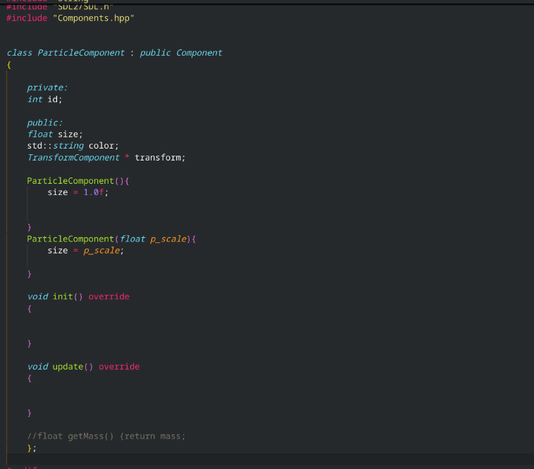

A very small component, this is mainly to be able to add futures in the feature if necessary. So far it is only used to determine the size and mass of an entity, however I am sure it could be used for much more in the future.

Edit: This code has been made redundant I have decided to put it in my physics component instead

### Transform Component

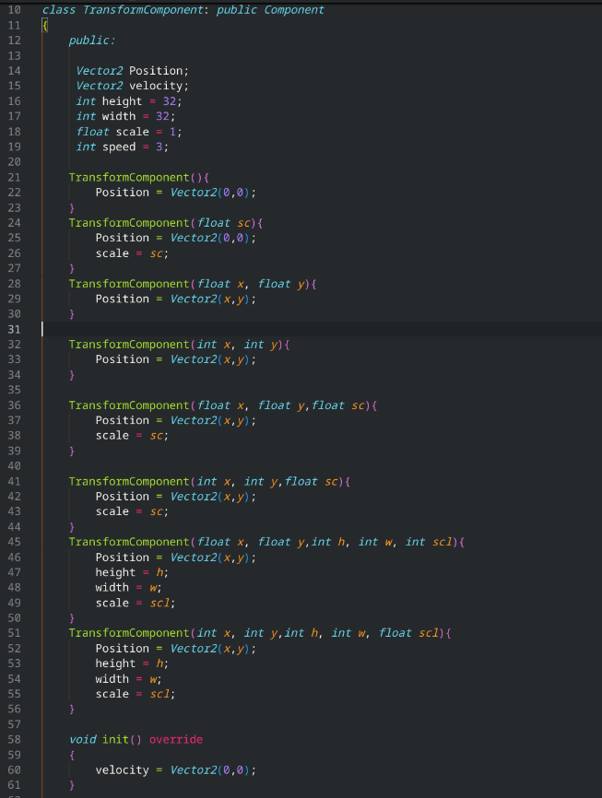

One of the more ‘primitive’ components, this will be used by the likes of other components such as Physics and Sprite. While not the neatest implementation, this allows for several different parameter types and instantiation options. The main features of this component is to be able to give basic attributes, such as height, width, position and scale. As mentioned in my design section, I could have kept a uniform constructor though this seemed more appeasing to my stakeholders who are programmers who might want to modify the project for themselves.

### Physics Component

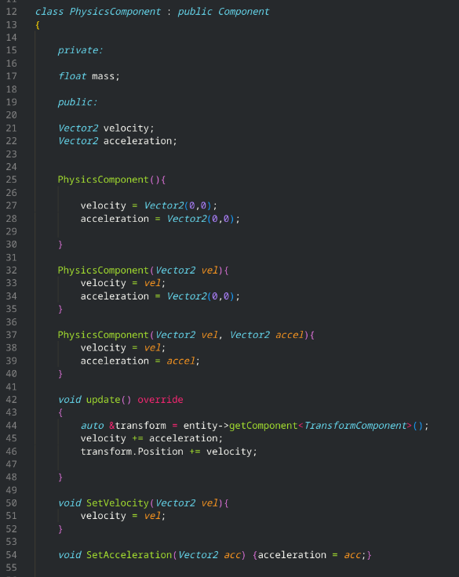

This interfaces with the transform component, and processes the velocity and acceleration of the entity, then adjusts its position via the transform component. It is fairly rudimentary, having basic functionality to set velocity and acceleration, and I have overloaded its constructor to allow for more flexibility when adding this component.

EDIT: changed up my physics component slightly, it now actually handles the physics and forces.

A very simple function, as you can see it now accounts for mass in a particle as well, giving more variation for my stakeholders to play around with to get the desired results.

Updated physics component:

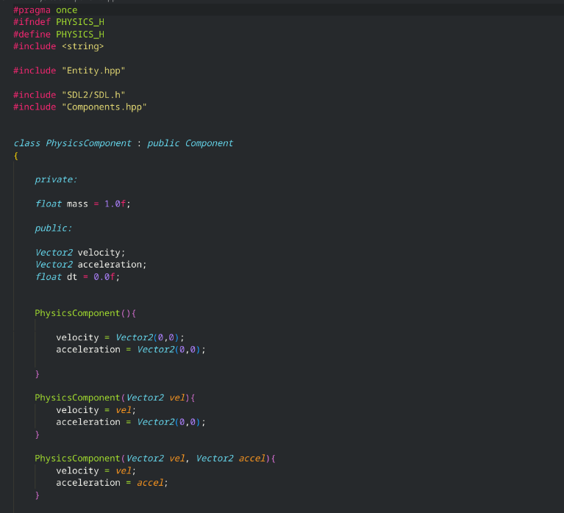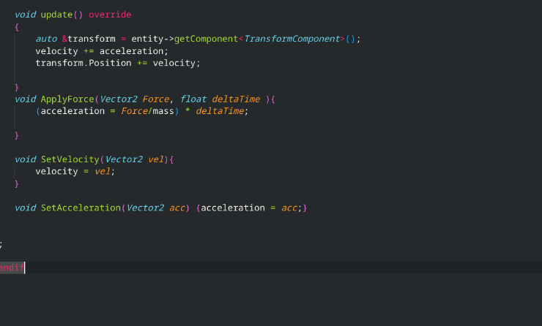

How it is used in code:

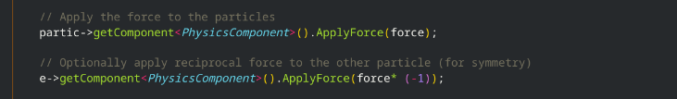

### Box Collider

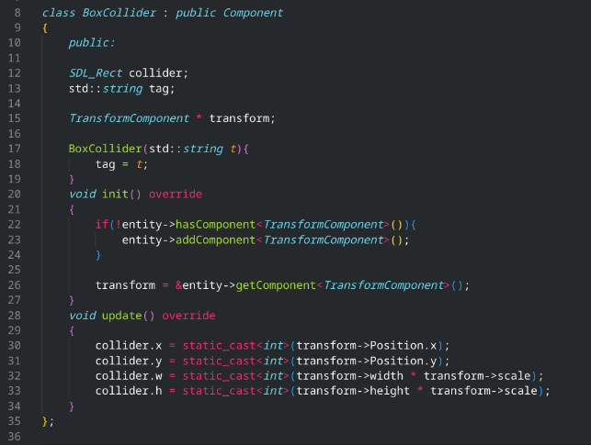

My box collider component's purpose is to give my entities detectable collision, and an added tag attribute to be able to identify which entity is which. It uses my collision code to calculate if two entities have overlapped box colliders on screen:  
Header file:  
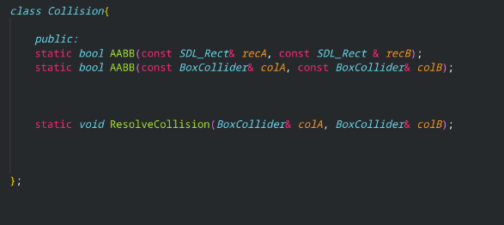

Source file:

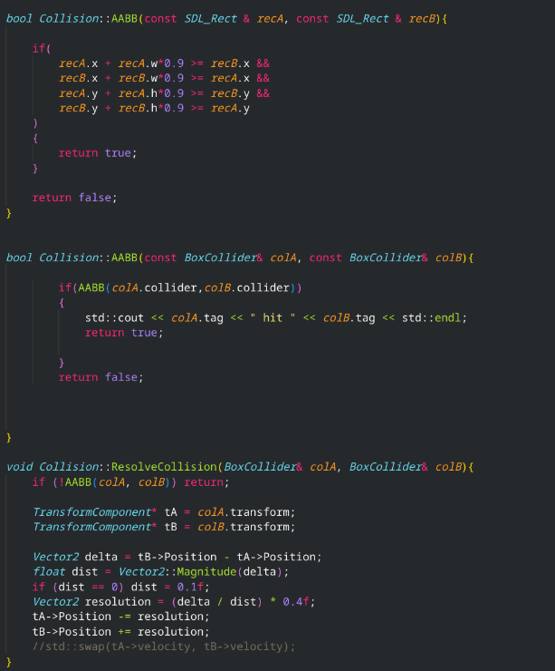

Pseudo code:

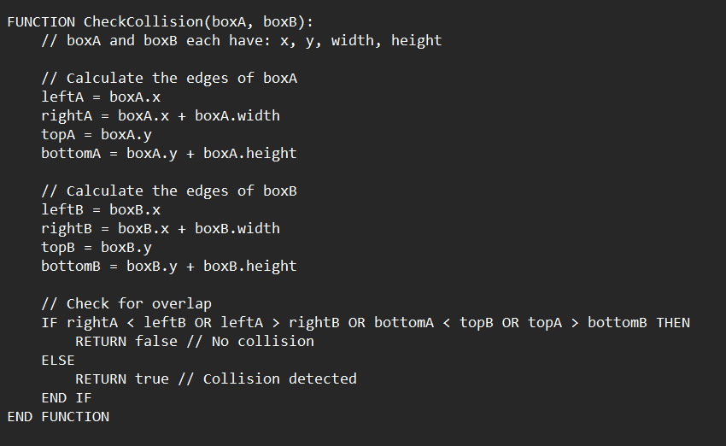

Axis Aligned Bounding Box Collision (AABB) is a series of mathematical inequalities using an entities position and dimensions to determine if an overlap has occurred between two entities.

If there is a collision, the resolve collision function will then manually separate the entities apart using their transform components based on their collision resolution, which determines how far they are moved away from each other. This works the same as the logic I have used for my particle's attraction mechanics.

### Sprite Component

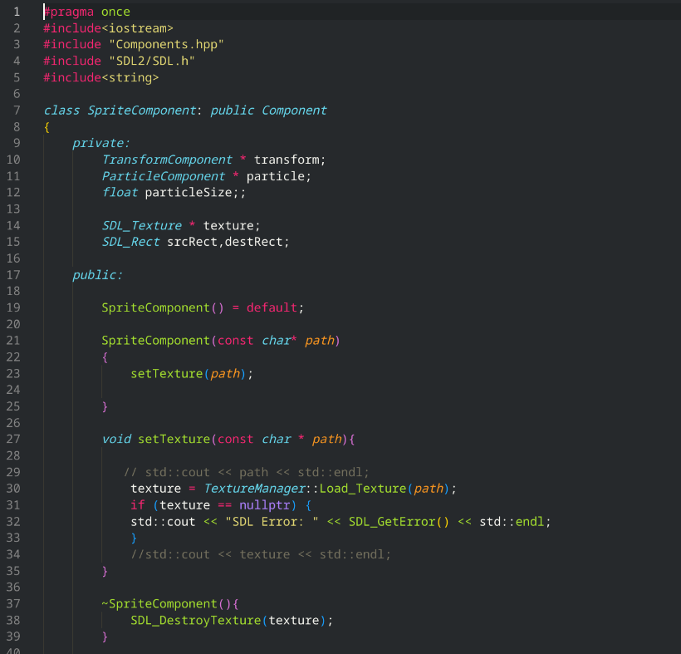

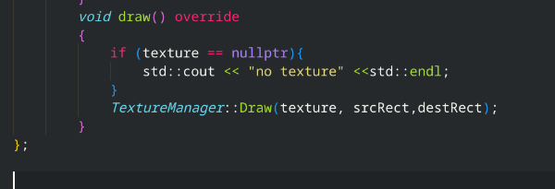

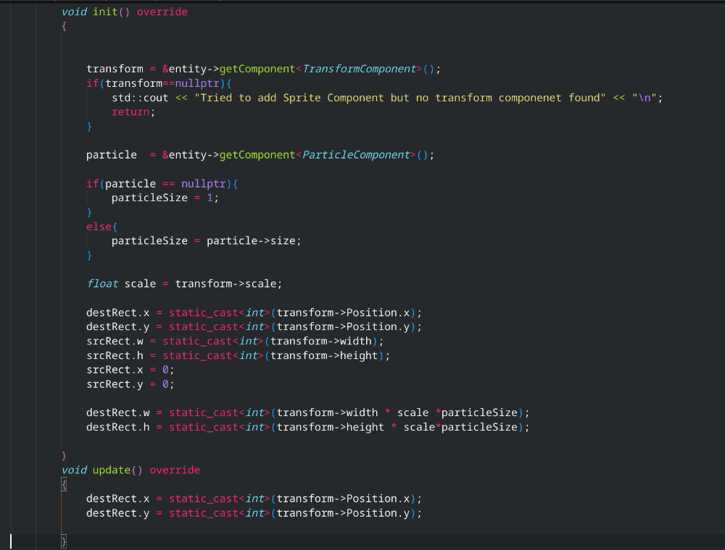Sprite component uses transform component and the texture manager, to be able to draw entities to the screen. More functionality could have been added, such as capabilities for rotating entity sprites, or different levels of opacity, however I felt that it was outside the scope of the project, due to the fact the particles are already circular and there is no need to change the opacity levels of the entities for the use cases of my stakeholders. I have implemented some error catching, such as verifying if the entity has a transform component, which is needed to be able to handle the source and destination rectangle region to load the texture to through sdl2.

The set texture method calls on the texture manager I have made to load in a texture, which is called on the initialisation of the sprite component.

The update method has been overridden to be able to update the position of the texture drawn based on the entities new position by getting the current transform position of the entity.

The draw method just uses the texture managers draw method to render the texture onto the screen with the specified texture and source/destination rectangle.

Overall, this solution is much more elegant than my first prototype, and I personally feel it is a big improvement in respect to efficiency. While on the surface it may not look that different to the first prototype, the modular nature and robust code in this project makes it easy to be developed on further, and gives it a much less rigid, fixed potential as a simulator, which will be useful for my stakeholders, in case they would like to add anything to the project which they would feel would benefit them.

### Usability features:

As mentioned in my design I will first create a non-GUI using keyboard shortcuts due to time constraints. I could straight away create a GUI for this however I think that this method has the added benefit of not being in the user's way, nd does not block anything on the screen at all.

My logic for this input system is put in my update function for my game.cpp:

### Handle Events Function:

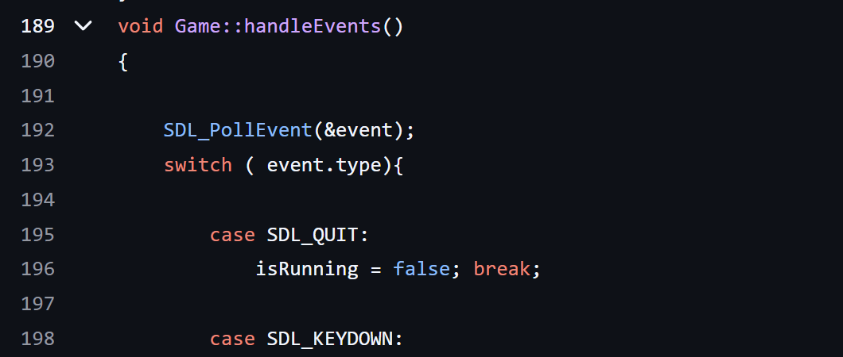

I first poll my sdl event listener and use a switch statement to test between two event types, QUIT and key down. Alternatively, I could have used an else if statement, however due to the fact inside my switch statement there will be another else if statement nested inside to check which key has been pressed, so it will be easier to read and maintain if I keep it broken up as two separate types of conditionals.

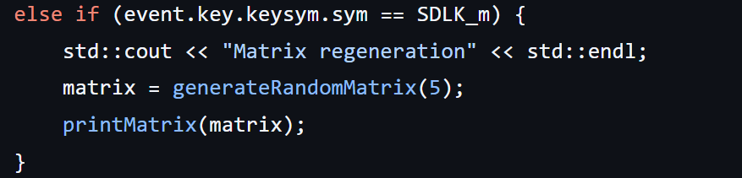My first check is if the event key symbol is” m”. If so, I generate a new matrix and output it to the terminal, so the user can see what matrix is being used.

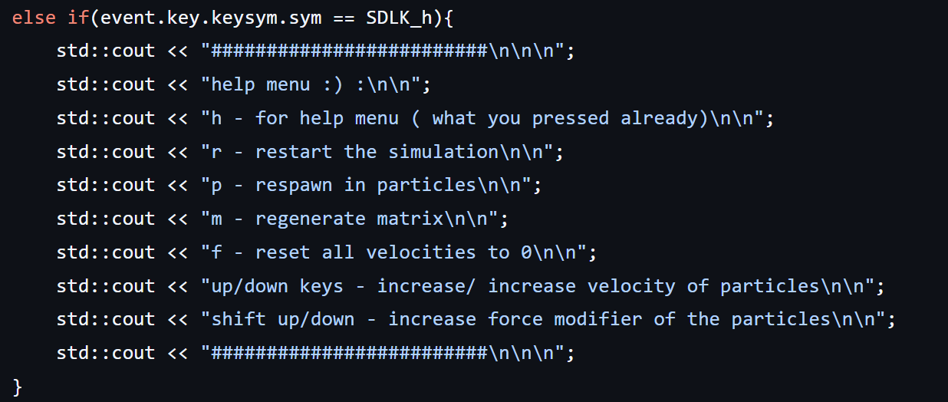

My second check is to see if the help shortcut has been pressed, or “h”. It outputs the list of commands that can be used, including itself. I could have made it slightly more comprehensive however the shortcuts are all simple, and given the simplicity of my interface I did not want to make it harder to navigate and use than needed.

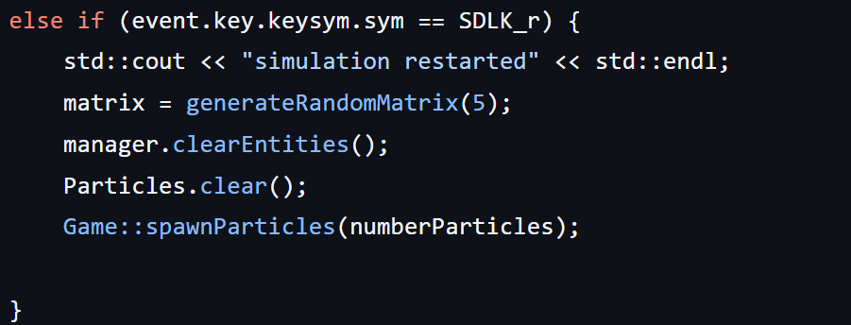My third check is to see if the restart shortcut has been pressed, or” r”. This generates a new matrix, calls the manager clear entities function to clear the entities form its array, and Particles to clear its Vector. Then the spawn particle's function is called to respawn in the new particles.

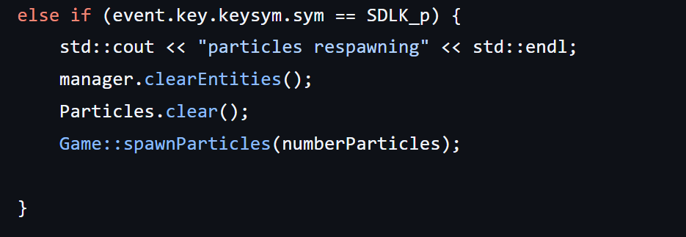

Clears particles, similarly to the restart shortcut however the matrix stays the same. While not completely necessary I felt that this was a good option to have for users who may want to experience the same behaviour several times in case they needed to recaptivate it.

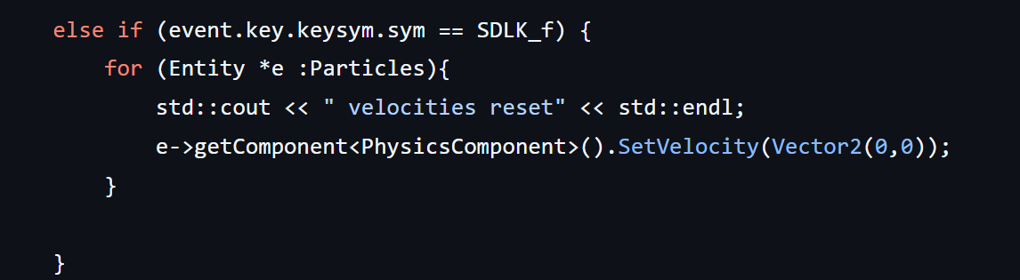The freeze shortcut is necessary as it is a control for the simulator. Without it the particles could potentially gain too much energy and cause unwanted results. I could have alternatively looped through each particle and applied the negative force to cancel out its velocity, which would have given a more smoothed natural effect, however due to time constraints I left it at this to work on the rest of my interface features.

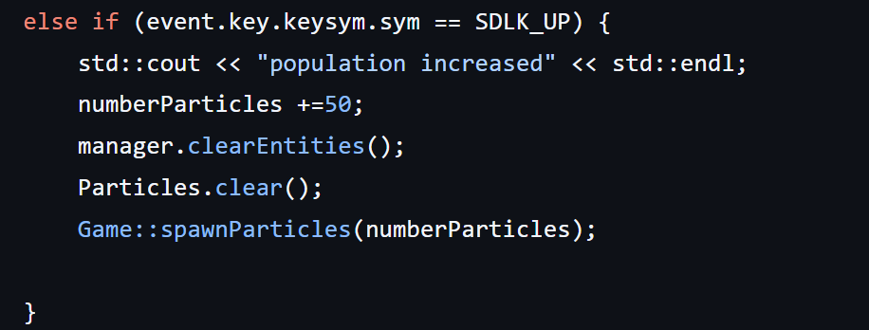

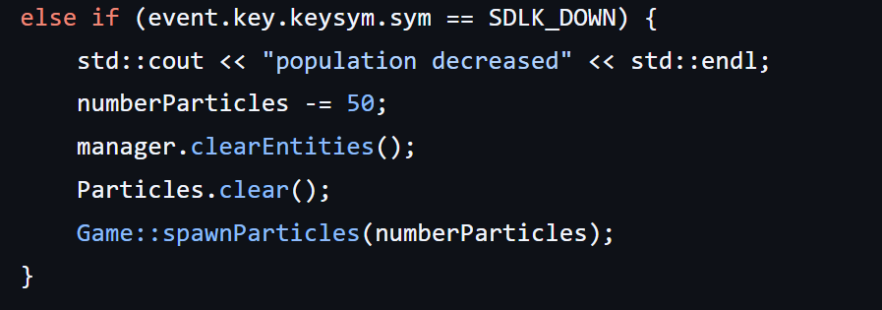Checks to see if the up or down keys are pressed and outputs if the population has increased or decreased. The number Particles variable is then increased/decreased and used as a new parameter for the spawn particle's function. I could have also outputted the new population number to the terminal, however unlike the matrix values, the population number is quite visible to the naked eye, and you can clearly see the difference, so I made the decision to not output it so the terminal is not cluttered up further.

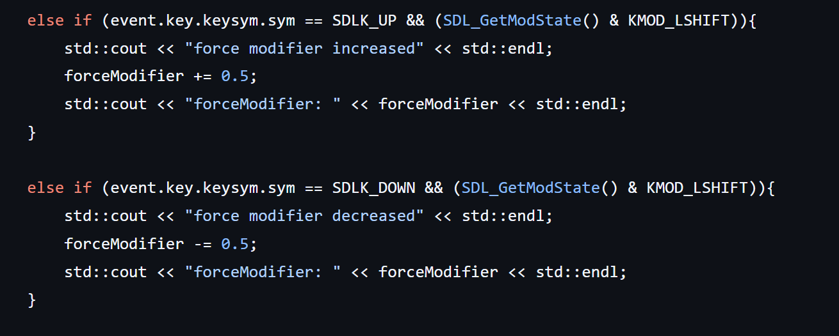In order to test for two keys simultaneously I needed to use SDls mod state to perform a simultaneous check of the keyboard state due to me having only set the event listener up for one event at a time. I then increase/ decrease the force modifier which is then used in my update function. I also output the current value of the force modifier for my user. I alternatively could have gone for a smaller interval in increases however after playing around it concluded that 0.5 was a nice, sweet spot and much lower did not really cause noticeable differences and became a chore to traverse up and down between values.

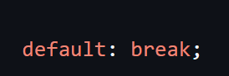

If none of the above occurs, the switch statement returns to its default case and breaks, moving on with the code.

I have introduced new variables, numberParticles and forceModifier into my game.cpp file. I have chosen to do this, so I am able to adjust the values accordingly instead of being fixed values which gives my users more flexibility around use of the application.

New variables:



while numberParticles has been shown in usage above, this is how forceModifier is being used now:

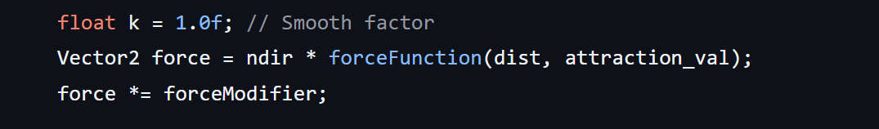As you can see it now uses a variable instead of a constant 10.

## Review of second solution:

What have I accomplished?

For my second solution I have managed to curate a much more optimised and well-structured project. There is a useable interface available and a robust physics engine.

The program performs much better and on the recommended hardware and software requirements can run upwards of 3000 particles at once on the default screen size. The particles and their behaviours are much more varied and complex now, with the ability to perform several different formations.

I have focused on the features I got from my user feedback of my first solution and have worked heavily on the physics system. While setting up the ECS was not that difficult, getting my particles to behave correctly was a long process. Several things in my game.cpp and physics component script were changed and amended several times, only to be changed back again after realising the initial issue was not that part of the code but instead something else.

One big problem I was experiencing towards the end of this development stage was as I had changed the physics component to have smoother and more realistic physics, I had accidentally forgot to reset thew acceleration each frame. This may not seem like a big issue on the surface as I was still maintaining the velocity, however this was causing issues when I was trying to reset velocities of particles and for keeping my particles in bounds. By not resetting the acceleration each frame, the next frame the velocity was calculated with the same acceleration, overriding the effect of resetting it. This was causing my particles to be pushed through the border, and my “f” velocity reset key to not function as intended. I fixed this issue by first setting acceleration to (0,0) each update function and incrementing the acceleration using += instead of =, which fixed the issues mentioned above.

Another issue that I had was the force function I was trying to copy from a similar project that was referenced in my analysis. I had not correctly implemented it as my distance was not scaled correctly. For example, in the force function I was trying to replicate, the distance was presumed to have a max of 1. However, my distance has a max of 150. This was causing way too much movement on the screen as the force being applied was being calculated with a scaled-up distance variable. I resolved this issue by dividing the distance by half of the search scale.

Another difficult challenge was the adjustment of the values themselves. As will been in the iterative testing section, there was almost as much testing and changing of values as there was programming. While the bulk of the code from my second solution took around a week to program, the adjustments to the values and the force functions took several weeks of testing and experimenting and reevaluating how this system was supposed to work.

An important lesson I learnt and what I would do differently given the chance would be to develop the user interface much sooner in the development stage as it would have saved a lot of time testing. The system I was using up until near the end of the development stage was manually changing values and then recompiling every time. When I finally got round to developing the UI, the testing sped up tenfold due to the ease and accessibility of modifying the variables.

Another lesson I have learnt is evaluating the components of a system before making them. Both my particle and UI component code ended up being redundant, with the particle component being merged into the physics component, and the UI component being discarded all together. If I were building this project with a larger scope in mind, such as not just being a particle simulator, I would have included the particle component as a derived component of the particle component, as they follow all the same base functionality.

By far the hardest part of developing this project was coming back to my code after several weeks and being completely unfamiliar with the framework I had created for myself, leading to me neglecting certain functions I had already programmed and trying to insert new ones. One dire example of this was me forgetting I had a handle events function and trying to fit my keyboard input into my update function, only to realise the next day that it would be much better suited inside the function dedicated to handling keyboard events.

Before I get to the overall review of the stage, I wanted to gather some feedback from my stakeholders as to get a better idea of how much this project has met the success criteria that I had put in place for my initial analysis of the project.

My initial success criteria:

* Usability and Accessibility features
* Good performance
* Realistic simulation mechanics
* Visually interesting

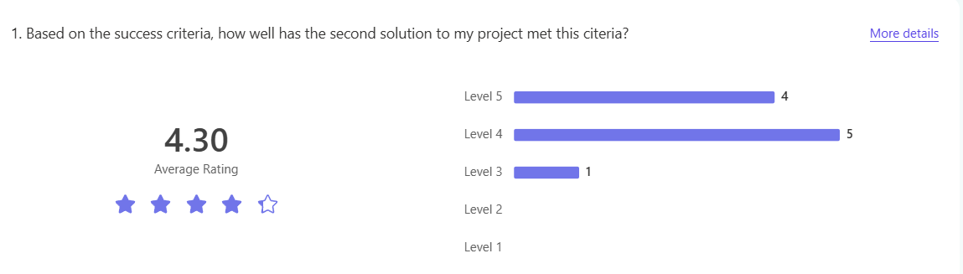

Overall, I am fairly happy with this rating. It is a lot higher than my first prototype and as can be seen from comparing my second solution to my success criteria, a lot more of it has been met compared to the first solution. An average of 4.30 stars puts my project in a good place to work on from in the future. While it is not perfect, I am again going to mention that this rating is not based off the actual experience of the application, but instead how it meets my set-out criteria.

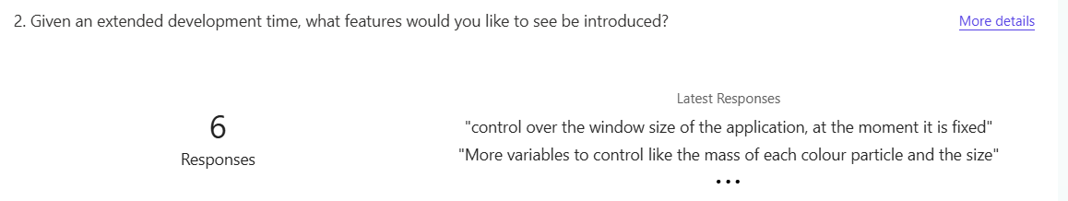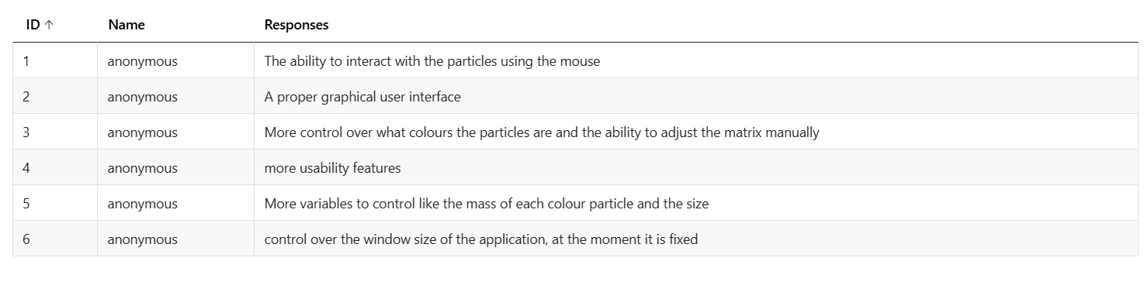

After this second solution, which is going to be the final solution I will be submitting, I wanted to know what features could be added given an extended development period for me to discuss in my evaluation. Unlike the survey for my review of the first solution, I left this Question text based instead of multiple choice, and therefore more open ended. the reasoning for this was that for my second solution I wanted to focus on the key mechanics that would be used the most, whereas this survey was supposed to be more creative in suggesting new features they would like to see added. Not features that my end users want/need.

An interesting response that I got was implementing the ability to use the mouse to interact with the particles. I have gotten some verbal feedback beforehand about this, though it was not officially recorded. Given an extended development time, this would certainly be near the higher end of my priorities as I feel this would be a very unique and experimental feature, which is the point of this project.

The second response seen was to include a proper graphical interface, however I believe based on the research conducted and the consensus of my end users I made the right decision given the time constraints. Another added benefit to having it keyboard based is most of my end users will have experience with their own software's already using keyboard shortcuts, which is why I believe the Feeback on how easy the program to use was so positive.

There is capability for the 5th response to be met, as it has been implemented into my physics system, just not executed in my program. The reason for this is I did not have time to add any relevant usability features into the project for these mechanics, and did not want to force this feature on my end users. However, since this project is open source, this issue can be easily rectified by changing the spawn Particles function to generate random masses for each colour type.

The 6th response is something I admittedly heavily overlooked. I had not touched the actual window proportions much since I originally started this second solution and got SDL up and running. This issue is slightly harder to fix as I have used hard coded values for the screen size, and these same hardcoded values have been used for my border control, my quadtree region and my particle collisions. If I were programming this from the start, I would make sure to not hardcode these values in to give me a bit more flexibility (pun not intended) with the window size.

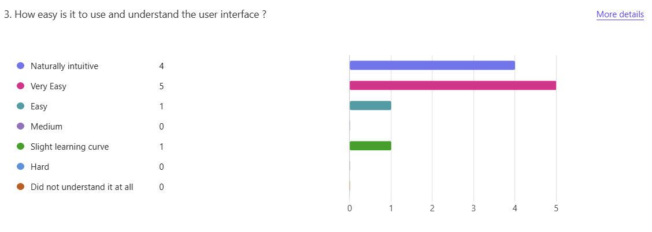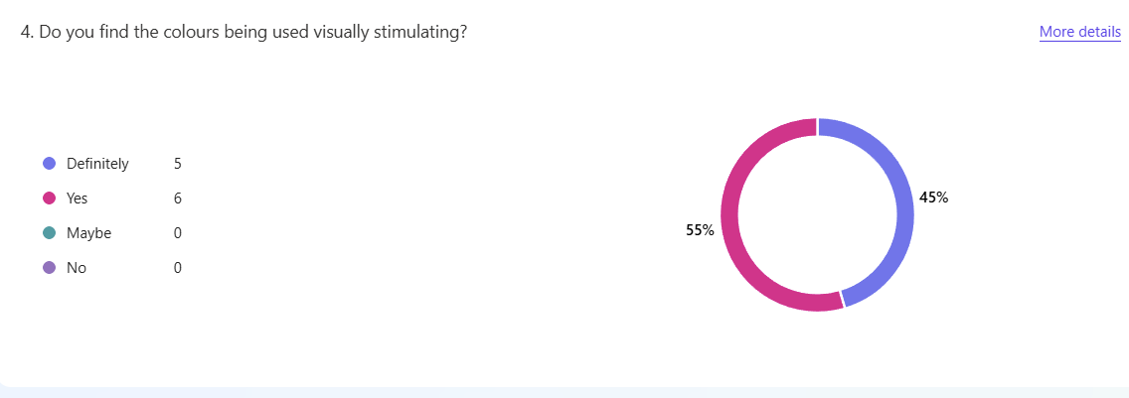

Overall, how was this second solution was a big success. I amanged to hit all the criteria I set out in my analysis and the overall Feeback has been positive. The simulation is visually interesting to observe as shown above from my survey and the controls appear to be easy to understand and use. Given further development time I would add in a lot of the features mentioned above, including creating a GUI for my end users.

# Iterative test data:

## Testing of second solution:

#### Testing Quad Tree regions:

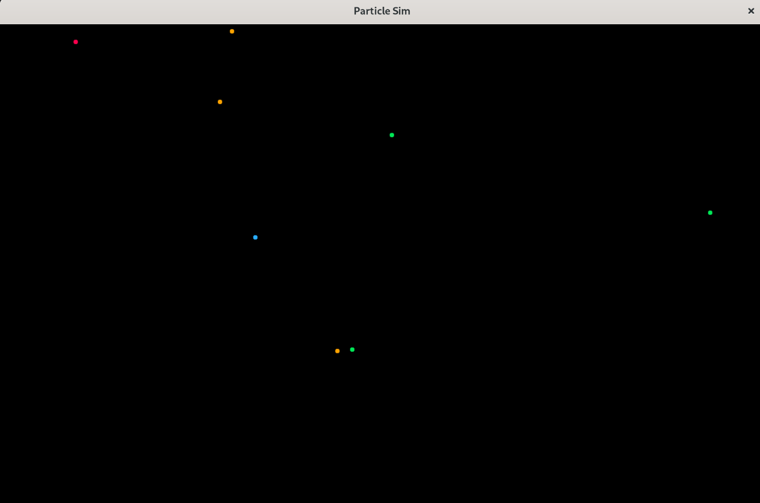

I have limited the population of particles to 8, and have kept them static, and am going to use my Quadtree class to determine if they have been inserted correctly into the tree depending on their position and region. Here is my test table:

|  |  |
| --- | --- |
| particle | Tree Location |
| 0 | NorthWest |
| 1 | NorthEast |
| 2 | SouthWest |
| 3 | SouthWest |
| 4 | NorthWest |
| 5 | NorthWest |
| 6 | NorthWest |
| 7 | NorthWest |

As can be seen, my quadtree is managing to correctly insert the positions of my particles into its tree.

qFor my iterative testing stage of this project, due to the unique nature of my application (being a simulator), instead of using methods of input testing for validation, my testing will mainly be comparing observed behaviours to the expected behaviours from my particles:

Inverse application of forces:

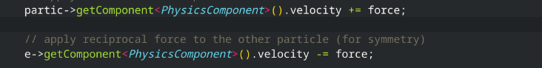One of the first stages of my testing was using random configurations of randomly generated attraction matrices to input into my simulation. Despite each matrix being different, I found I was obtaining homogeneous results each time, no matter the matrix. After looking into my code, a little further I tried adjusting some values, which had minimal effect. Finally, after looking through my further mechanics textbook, I realised I had neglected the idea of applying a resultant force to the reciprocate particle, which greatly fixed this issue, and stopped the particle propagating to one side of the screen.

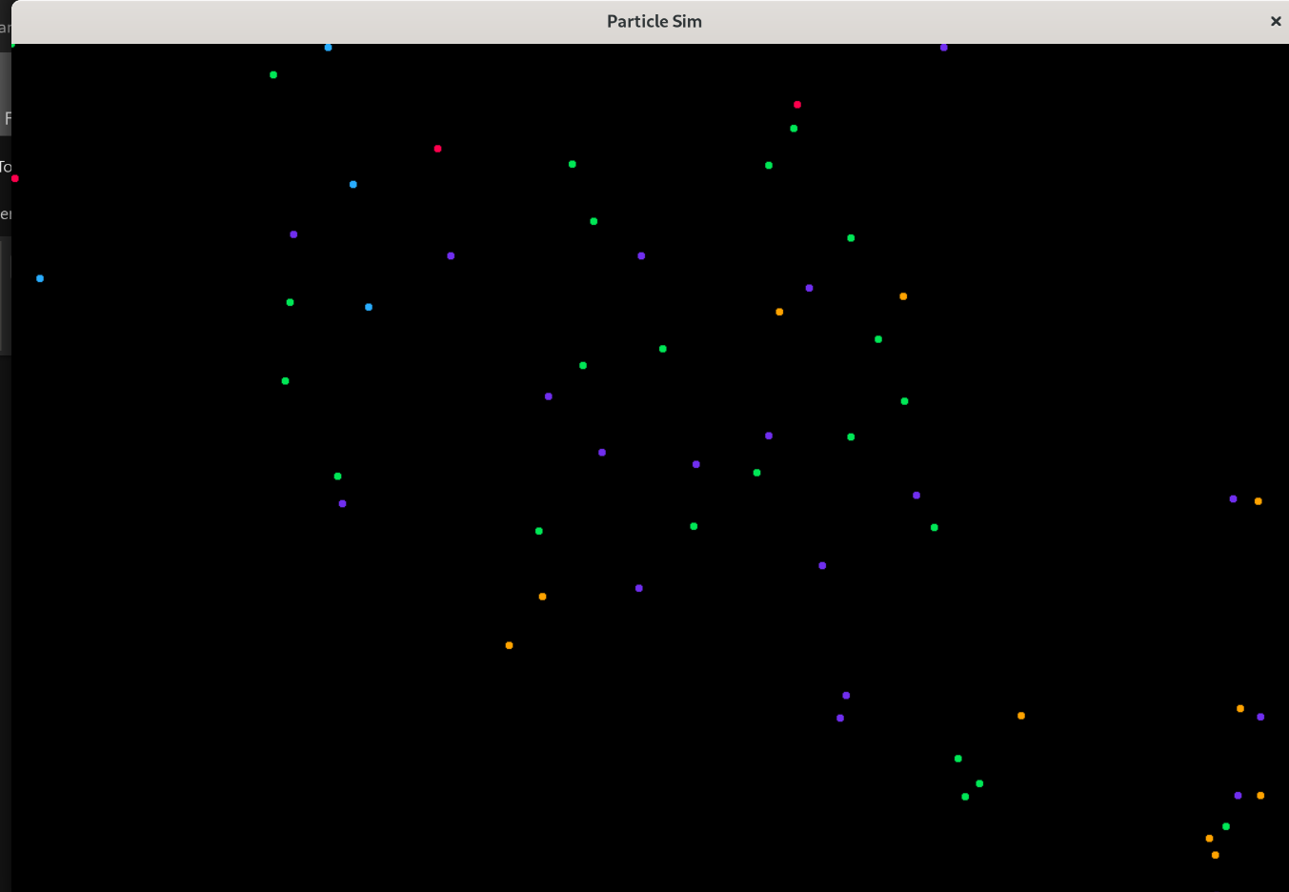

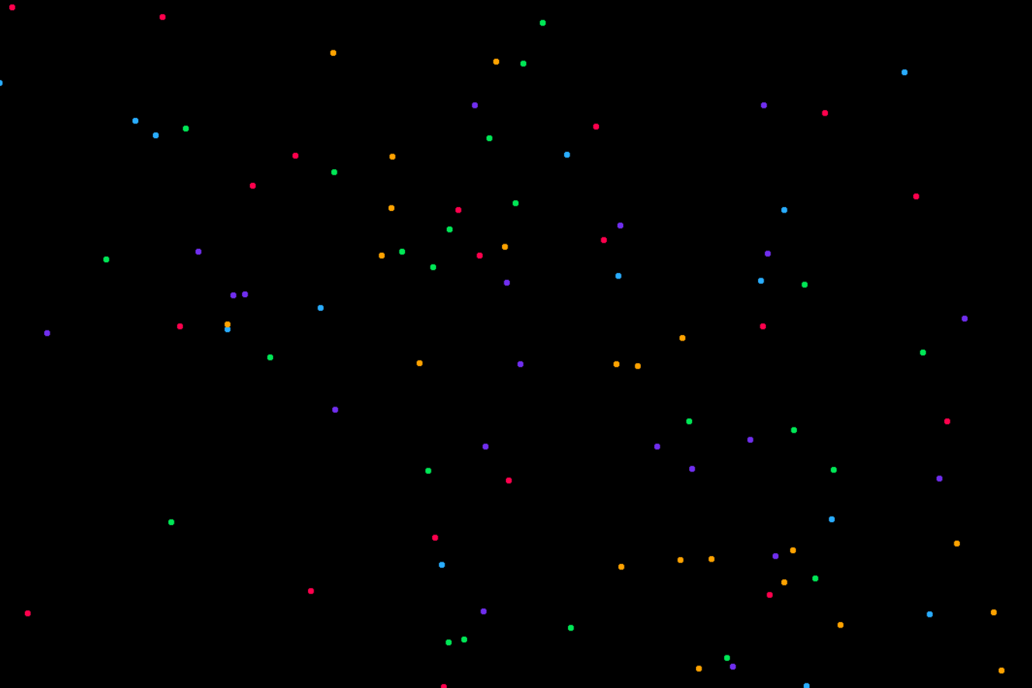

## Adding in Friction:

Another issue that was occurring was the widespread of particles, and the apparent increase in velocity from which I was able to confirm from my console logs. This infinite increase in velocity caused the particles to be able to overcome the attraction forces of each other and break apart, acting as a gas like model. This is not what this project is for as it prevents structures and behaviours forming. To amend this, I added in a dampening factor into my code, which at first was too great and caused all of the particles to become at rest after a few seconds, however after some further testing, I found that the value 0.995 works quite well.



|  |  |
| --- | --- |
| Dampening multiple factor (float) | Time taken to get to rest (seconds) |
| 0.5 | 2 seconds |
| 0.6 | 3 seconds |
| 0.7 | 4 seconds |
| 0.8 | 8 seconds |
| 0.9 | 10 seconds |
| 0.95 | 30 seconds |
| 0.995 | n/a (equilibrium has been reached) |

Unexpected crashes:  
  
  
After a minute of run time, I noticed that the game continued to crash. After cleaning up some of my code, and this issue still persisting I looked to my manager class in my ECS to see if anything was not being taken care of properly. While at first nothing seemed out of the ordinary, after scouring across my code I realised that my texture manager was not cleaning up the temp surfaces to render my textures for my particles to. After fixing this issue, I have had no more crashes since. This bug was fairly early on in the project so I do not have the original code to show for causing this.

## Interactions in only one part of the screen:

I noticed that my particles were only interacting in one specific area of the screen and suspected that my regions for my quadtree (as mentioned above) may be off. After reviewing my code and running some tests separately on my quadtree, it appeared to functioning normally, however after going back to my project and checking my sdl resolution size for my window, I realised I had only set a 400x400 region, when he screen is actually, 1200x700. After rectifying this in my code I found the results to be much better as shown below:

Before:

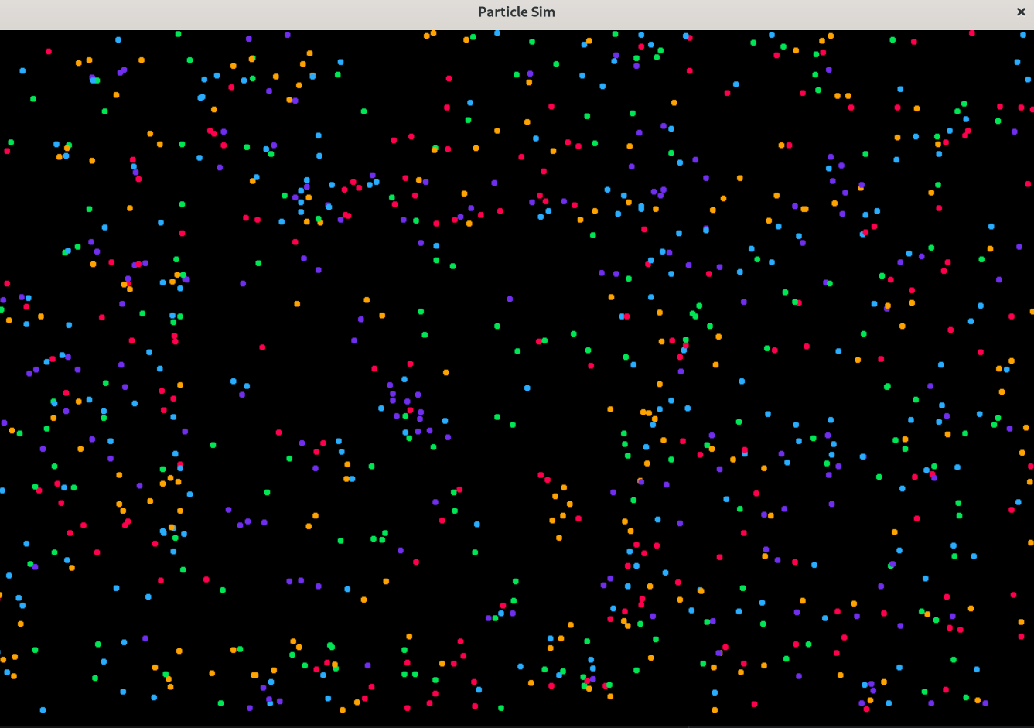

After:

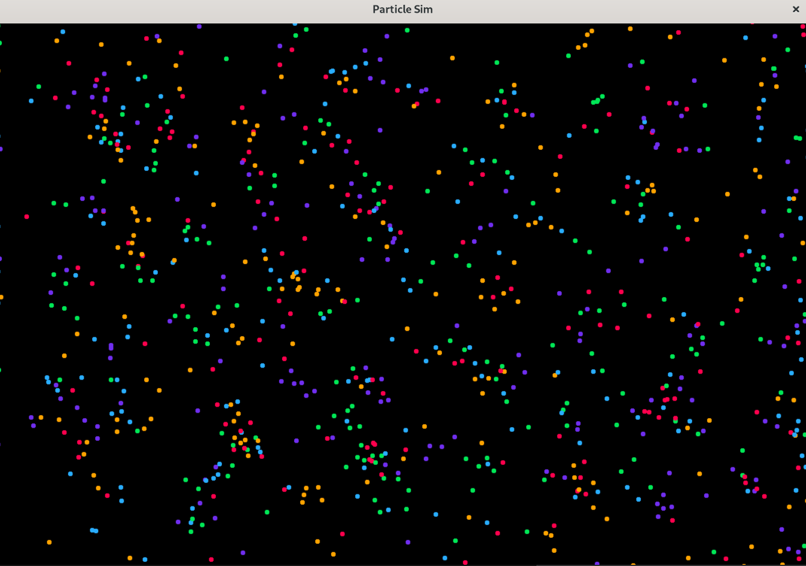  
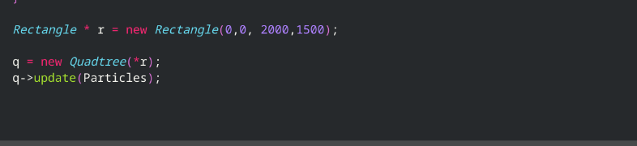  
  
Testing to try obtain more complex behaviours:

While I am getting movement, and some behaviours showing, I am struggling to obtain less rudimentary behaviours from my particles, so I will be running some tests to try narrow down the issue. I believe it is either my interaction logic in my update loop or my attraction matrix generation. I will be hashing together some altered game.cpp files to test this.

I first tried combing through my physics logic, however everything seemed to be in order there. I adapted my matrix generation function to try get a spread of different distributions but nothing major changed. I then got the idea to iteratively test my key variables responsible for the interactions taking place. Keep in mind that this is not a perfect test as each attraction matrix is different from each other as it is being procedurally generated, however beforehand the results were all the same no matter the matrix. I will be taking the best case from each parameter of these tets.

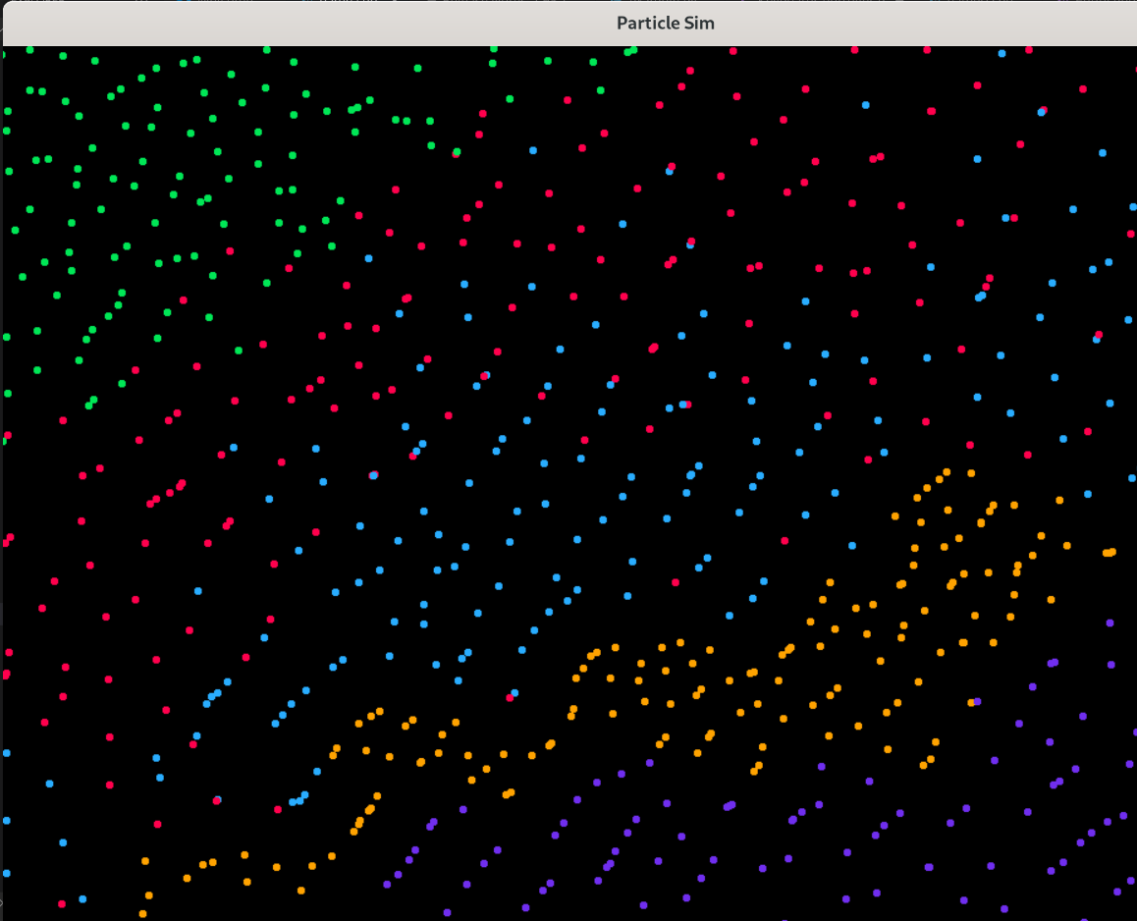

|  |  |
| --- | --- |
| population | 1000 |
| Force_multiple | 9 |
| friction/dampening | 0.9 |
| SEARCH_SCALE | 50 |

Results produced quite nice patterns; however, the force causes the particles to constantly push or pull apart, and when being pulled, ends up with too much force and rebounds past the particle.

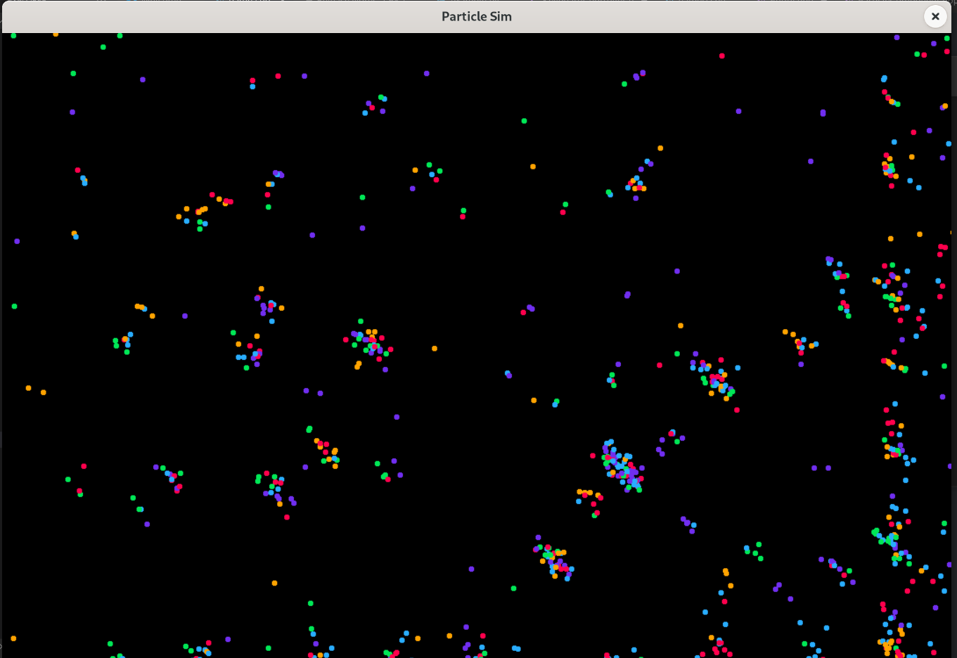

|  |  |
| --- | --- |
| population | 1000 |
| Force_multiple | 10 |
| friction/dampening | 0.7 |
| SEARCH_SCALE | 50 |

Most of these results using these settings were fairly similar, which is problematic because that indicates the forces are overriding the attraction matrix. I am still having the issues of particles pulling together and apart too much, however the increased dampening from the friction value helps keep them not too far apart, which in turn creates an almost free for all between clumps of particles, where some consume each other.

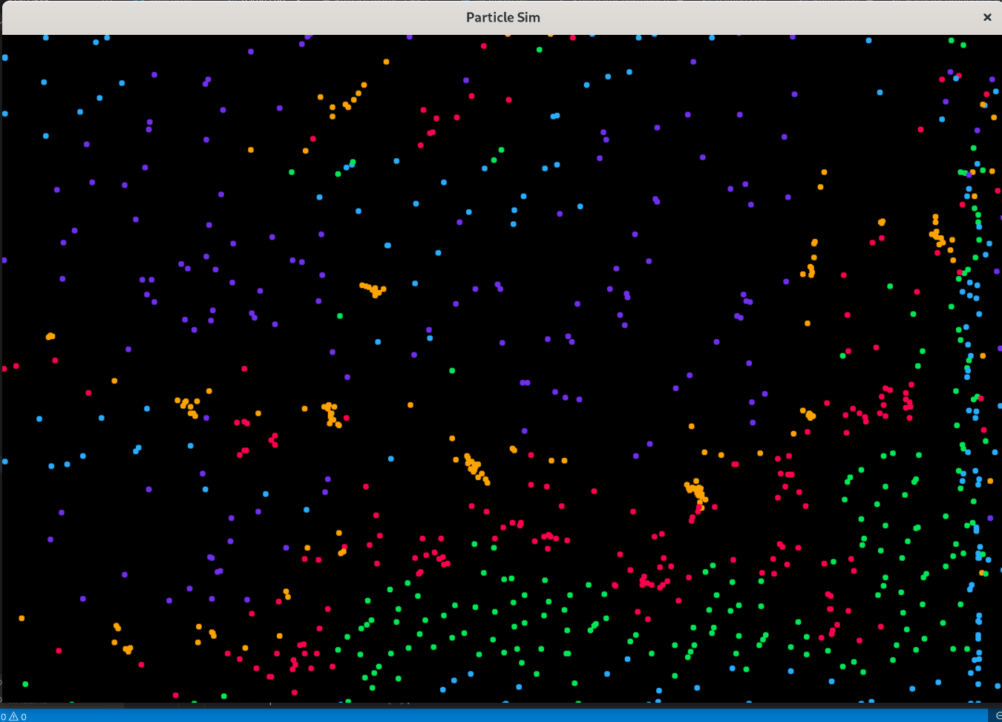

|  |  |
| --- | --- |
| population | 1000 |
| Force_multiple | 10 |
| friction/dampening | 0.95 |
| SEARCH_SCALE | 50 |

I believe there is not enough friction for these settings, as the fluidity of the particles stops any solid structures being formed. I will try increasing the friction but it seems that 0.95 is not enough friction for the desired behaviours.

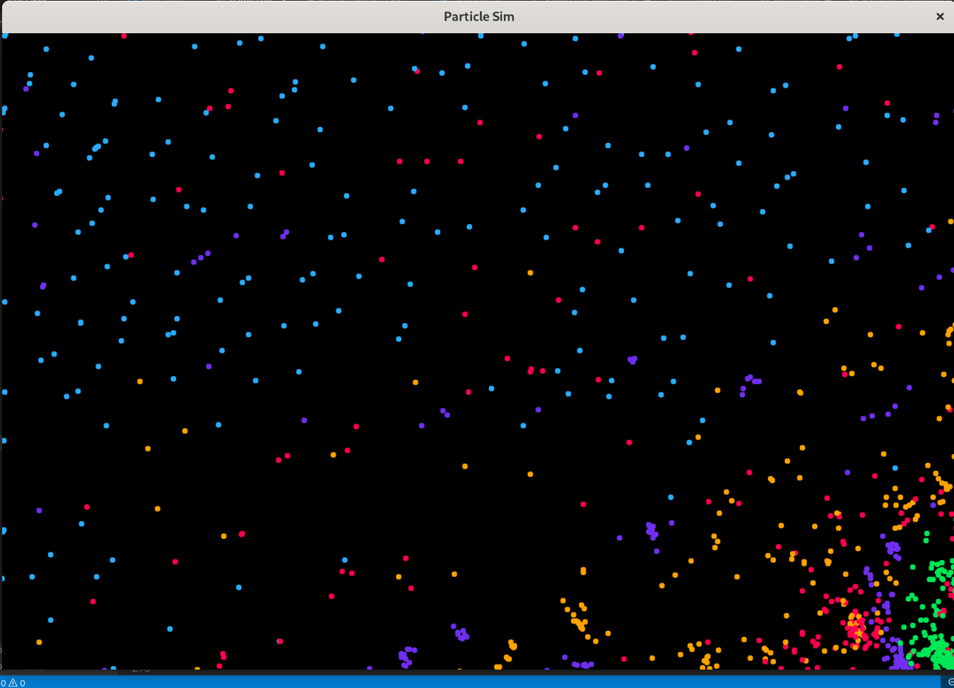

|  |  |
| --- | --- |
| population | 1000 |
| Force_multiple | 10 |
| friction/dampening | 0.8 |
| SEARCH_SCALE | 50 |

It appears that in this scene blue was fairly inert, and red, orange, and purple all corned the green particles into one corner. These settings produced the most variable results, however the particles are still not forming together as I would hope, so I am going to take a deeper dive into the force function I am using.

## Altering the force function

My force function is used to determine the magnitude of a force between two particles, so I can then use it as a scalar to multiply in the direction my particle should be going. I plan on improving from this to see if better results can be obtained.

How I am handling application of forces at the moment:

I am treating the force function as one function/ equation, which has worked up until now, however this is potentially bottle necking my project, so it needs to be changed.

How I plan to change this:

I will use conditional if statements to replicate a “piece wise” function, where the function changes at different points. An example can be seen from below which I will be trying to replicate.

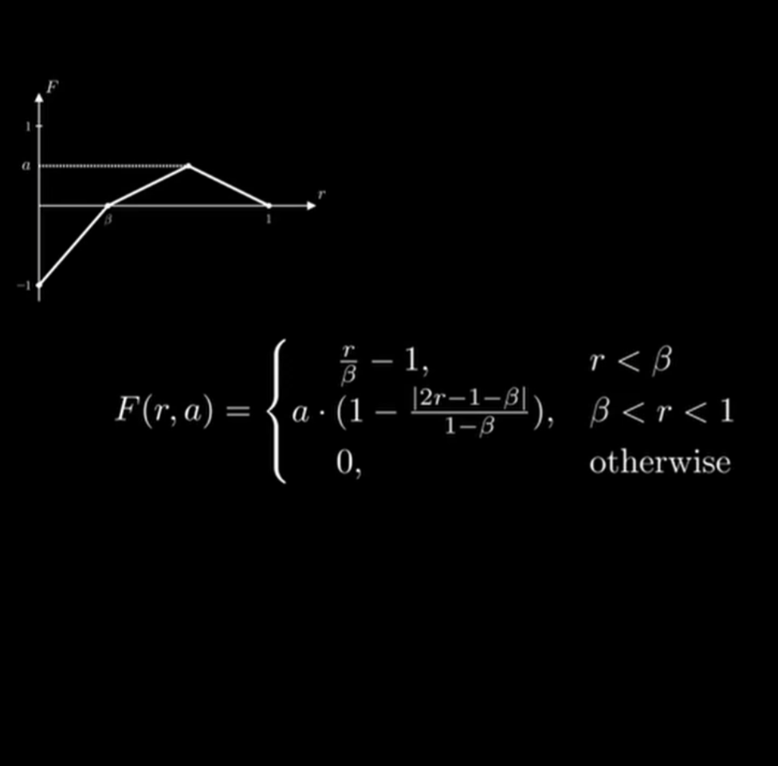

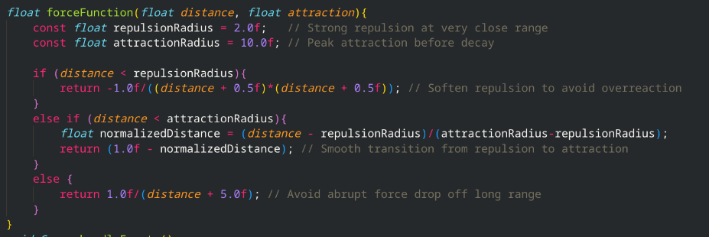

After some adjusting to make sure particles are not repulsed too much to the point where they bounce off each other I settled on this force function. It can be changed later however as mentioned several times before I do have time constraints, and this function gives semi satisfactory results. It is split up into 3 parts, the repulsion, the attraction, and the decreasing attraction as shown up above. I have managed to create this graph by splitting it into 3 conditional statements, and as you can see below by adjusting values such as repulsionRadius the particles form closer or smaller together.

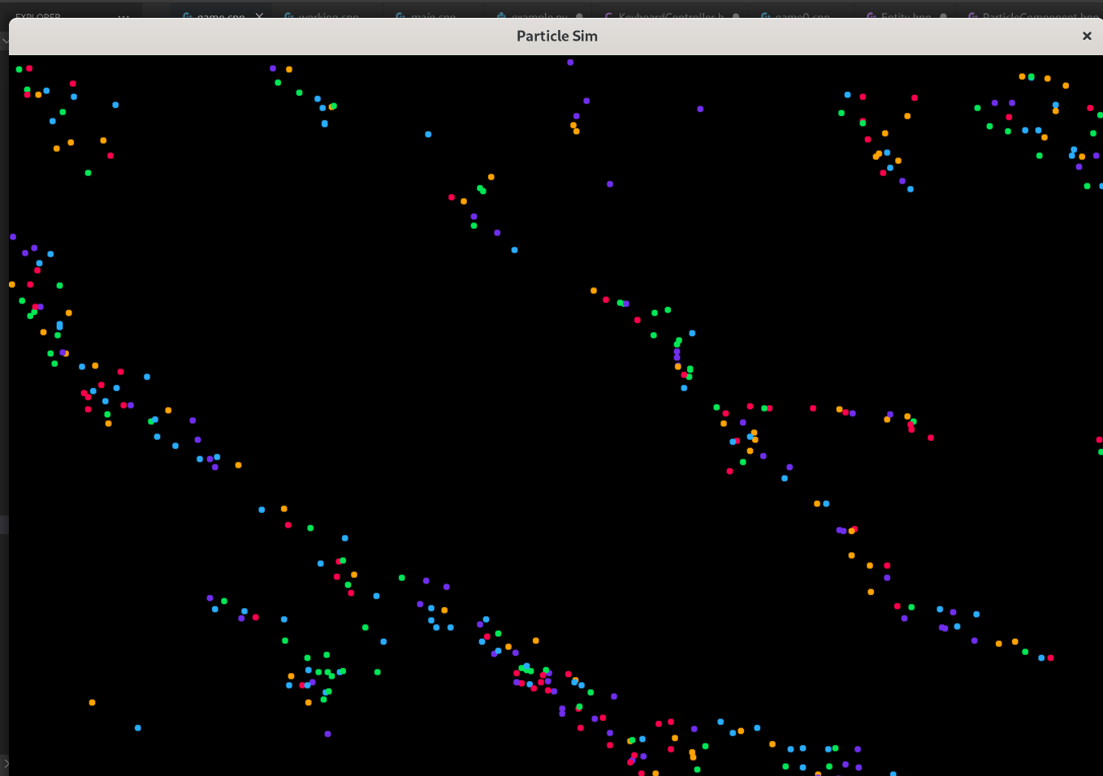

### 

### Testing User Interface:

|  |  |  |
| --- | --- | --- |
| Input | Expected Outcome | Observed Outcome |
| “h” | Output help menu | Outputs help menu |
| “r” | Restart simulation | Clears particles, generates new matrix and respawns particles |
| “p” | Respawn particles | Clears particles and respawns particles |
| “m” | Generate new matrix | Generates new attraction matrix |
| “f” | Freeze particles | Temporarily cancels out velocities of particles |
| up/down | Increase/decrease population | Increases and decreases numberParticles variable, clears Particles and spawns Particles with numberParticles as parameter |
| Shift up/down | Increase/decrease force modifier | Increases/decreases forceModifier variable |

Evidence of testing:

My help:

Restart Simulation:

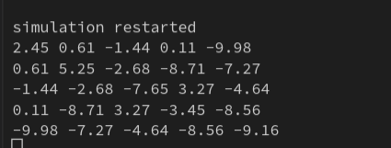

Matrix generation:

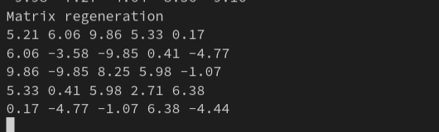

Population and particle respawning:

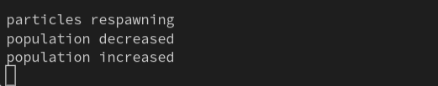

Freeze/ velocity reset:

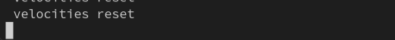

### Section 5 post-development test data: - does it meet criteria

### Test #1:

Description:

Does the application start and run?

Test data:

The application itself

Expected Outcome:

The application runs and the particles are displayed and behave with each other

Actual Outcome:

The application starts and the particles are rendered to the screen and visible, they behave and interact with each other

Evidence:

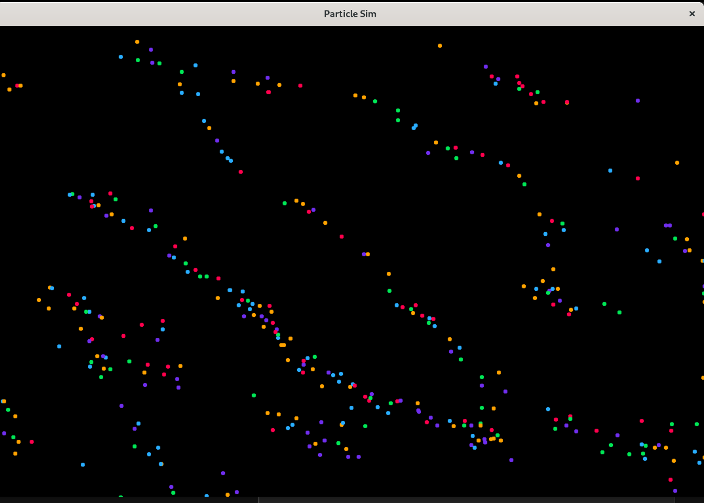

Commentary:

This works as intended, and no issues arise upon starting the application

### Test #2:

Description:

Does the program crash after an extended period? This will be observed by leaving the application running for 10 minutes and then seeing if the application i still active and running

Test data:

Seeing if the program is still running as intended after an extended period

Expected Outcome:

The program stays running and does not crash or slow down

Actual Outcome:

The program does stay running, and does not slow down at all, however the population can decrease slightly over time if they get pushed through the border of the screen by clustering together

Evidence:

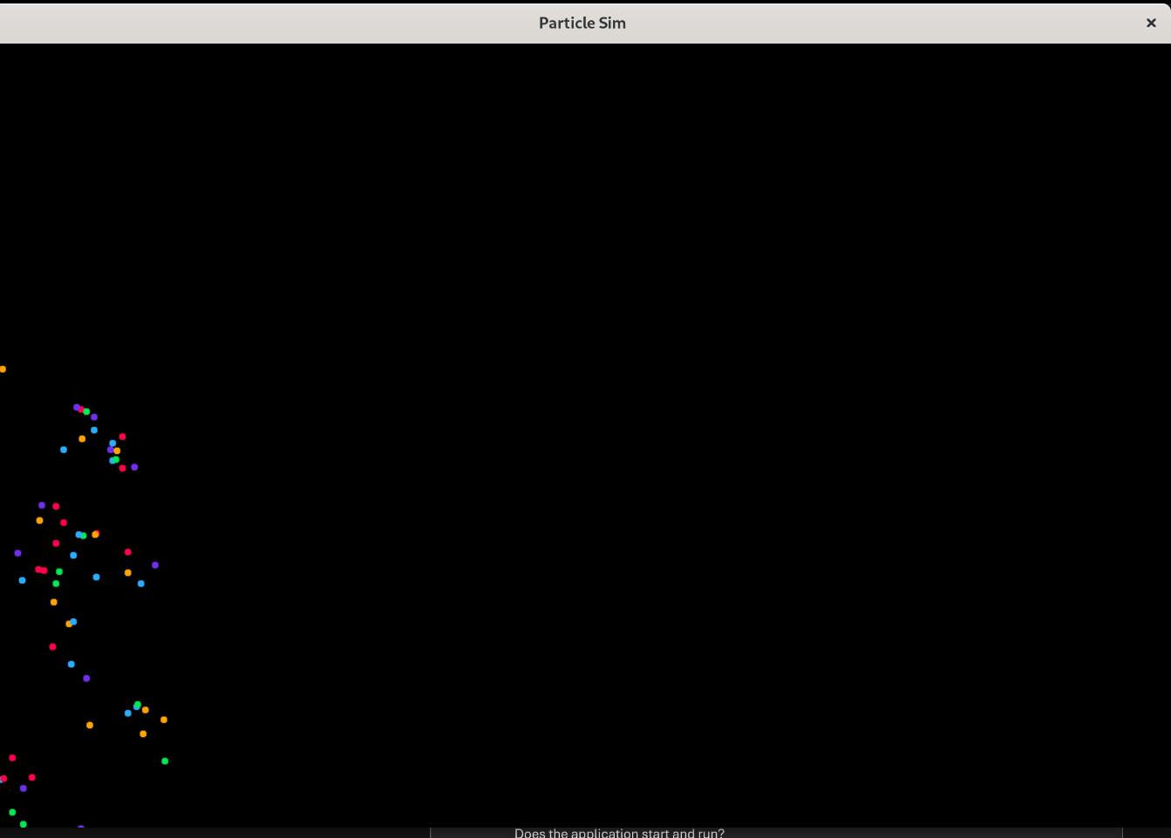

Commentary:

While I am glad that the application stays running, I found it hard to find a robust fix for keeping the particles inside the screen border. Due to time constraints, I will have to move on to other stages of the testing. I finally resolved this issue by fixing my physics component to reset the acceleration every frame, which stopped the velocity being overridden when set allowing the particles to bounce off the borders.

### Test #3:

Description:

Do the particles form and create complex behaviours with each other?

Test data:

Observation of the particles and seeing how they behave

Expected Outcome:

Form structures with each other, and gives off a semi organic look

Actual Outcome:

The particles do form together and stay that way, and depending on the attraction matrix they form different behaviours

Evidence:

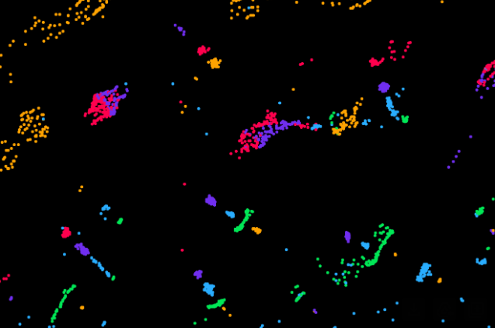

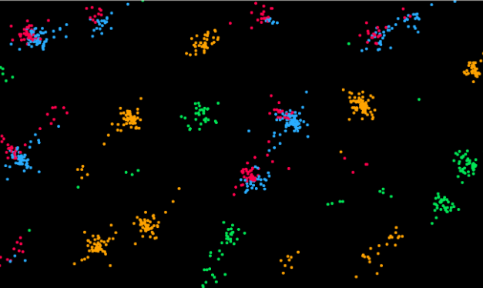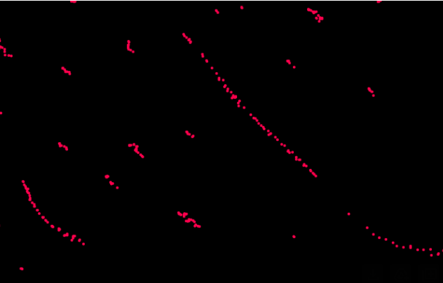

Commentary:

Not quite how I intended them to form and behave together however after much testing as seen in my iterative development section, I can conclude that it must be my force function that is having this effect. After editing the physics component as mentioned in the test above the results improved significantly.

### Test #4:

Description:

Testing to see if the program crashes or not when there are missing resources

Test data:

The removal of my particle sprites

Expected Outcome:

The texture manager catches this error and logs null texture message to the terminal

Actual Outcome:

“No texture” is outputted to the terminal for each particle which shows that the Texture manager is correctly catching the errors and missing resources

Evidence:

Commentary:

This problem could be bypassed completely by not using images and instead creating the circles using SDls built in draw lines, however there is no optimised way to draw a circle without drawing several lines at angles to simulate a circle shape, and concluded that using a sprite would actually be more data efficient long term given the number of particles that would be used. Alternatively, I could have used SDl rectangles, though I decided for simplicity and the fact I had created a sprite and texture manager to go with the approach.

### Test #5:

Description:

Testing to see if any other keyboard shortcuts have unwanted side effects.

Test data:

All the keys on keyboard

Expected Outcome:

Only when designated keys are pressed do actions take place

Actual Outcome:

Same as Expected Outcome

Evidence:

Hard to provide with static images however will be seen in the final submission containing the screen recording

Commentary:

Very happy with how robust this turned out

### Test #6:

Description:

Testing to see if the application can handle larger population sizes

Test data:

Number of particle entities being spawned

Expected Outcome:

Application can handle a minimum of 2000 particles on the designated screen size with the recommended requirements, and with a larger screen size (resulting in less collisions), can handle a minimum of 3000 particles with the recommended requirements

Actual Outcome:

Same as Expected Outcome

Evidence:

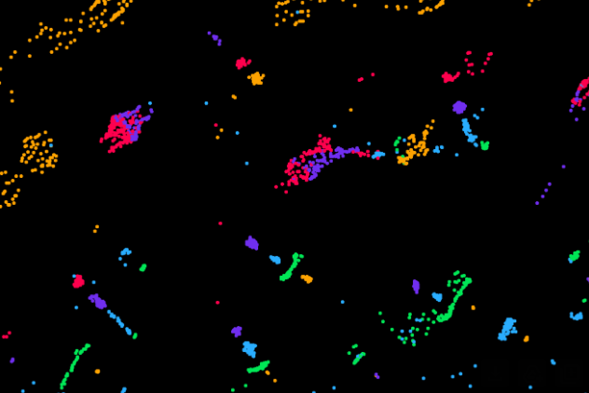

Commentary:

While there are ways to improve performance such as multi-threading considering this is one single thread, I am quite impressed with the level of efficiency that has been achieved, given that similar projects that have been looked at all make use of multithreading in their respective projects.

### Test #7:

Description:

Testing to see if all my entities are being cleared from memory properly when I restart the simulation of respawn the particles.

Test data:

This will be tested by restarting the simulation consecutively to see if the program crashes due to a segmentation fault or memory leak.

Expected Outcome:

Application handles memory effectively and does not crash or slow down when the simulation is restarted consecutively

Actual Outcome:

The application is prone to crashing. This has been fixed by clearing the Particles vector as well. I had cleared the entities array in my manager clear Entities method; however, I had not cleared the particle vector array which was causing dangling pointers

Evidence:

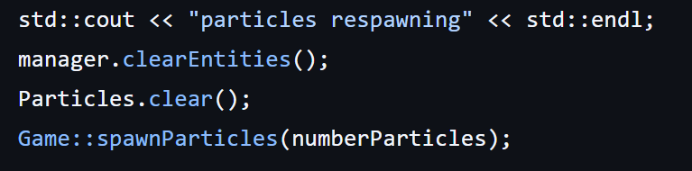

Commentary:

Glad this bug has been caught as would have been quite detrimental to the usability of the project for my stakeholders.

### Test #8:

Description:

Can I achieve replicating several phenomena and obtain varied results?

Test data:

The behaviour of the particles and what formations they make

Expected Outcome:

Several different phenomena can be replicated

Actual Outcome:

Some phenomena can be replicated however not all that were tested.

Evidence:

Simulating atoms:

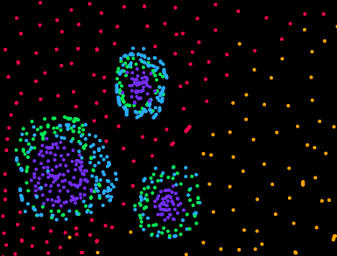

Simulating mitosis:

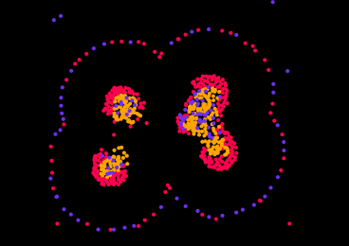

Field effect:

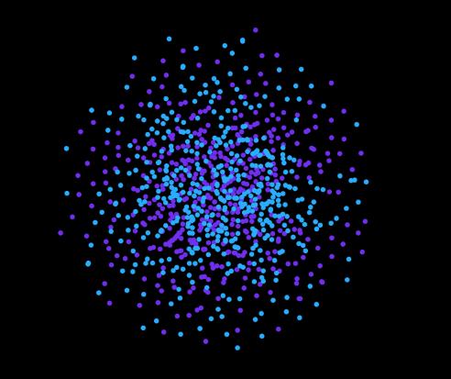

Commentary:

While some formations did not come together given the limited time frame, I am sure with some adjustments they could easily be replicated such as the figure shown below

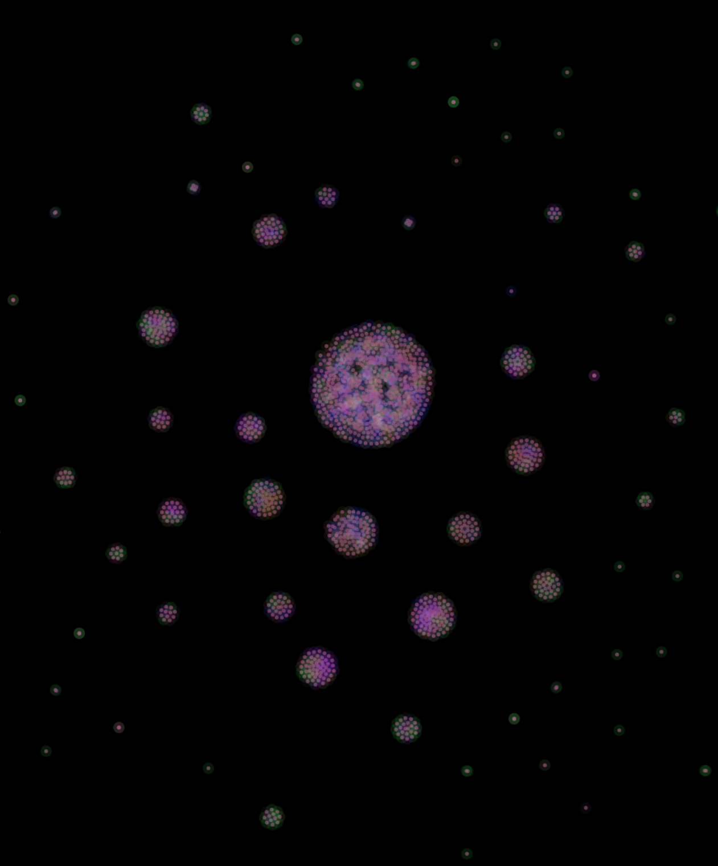

## Evaluation:

How well have I met my success criteria?

Recalling my success criteria:

|  |
| --- |
| Criterion: |
| Simulation Mechanics - partial success |
| Visually interesting – partial success |
| Smooth framerate and performance – partial success |
| Usability and Accessibility of features – partial success |
| Curated feedback based on end users - success |

### Did I produce an adequate physics system which can handle collisions and interactions between particles?

As can be seen from my evaluation testing stage (Test #8), my application starts and runs perfectly fine ( test #1) and has an adequately robust and stable physics system which allows my particles to form structures together ( test #3) and was able to replicate several real-world phenomena such as simulating atoms, mitosis and even the field effect without crashing after a prolonged period of time (Test #2) While not perfect and some behaviours were not able to be achieved due to the short time frame, I believe given a slight extension this could easily be rectified.

My particles do not speed up indefinitely as I have kept the law of conservation of energy of a system in play (iterative test data – adding in friction), and my particles stay inside the screen borders (Iterative test data – altering the force function). I have also used newton’s 3rd law and applied opposite forces whenever a force acts on an entity (iterative test data – inverse application of forces).

I have also ensured my particles interact with each other and there are no “dead zones” on the screen (iterative test data – interactions in only one part of the screen), by making sure my regions are set properly. As discussed in the review of my second solution, this is mainly from the mistake of using hard coded values for my window size and forgetting to re-adjust the other hard coded values to compensate.

Overall, I have met this criterion very well though given the chance to improve on it I would incorporate different sized particles with different masses to create more complex behaviours, as whilst the atomic behaviours could be replicated it would work much better having denser particles as the neutrons and lighter particles as the electrons, demonstrating much more accurate interactions, which would be much more beneficial for my end users.

Alternatively, I could create a variety of force functions for my end user to use, which would also create much more flexibility around use of the software. While this would have been a good solution to increase the usability of the project, I had to make sure all my other success criteria were met and seeing how the current system was functional and worked I decided to move onto the other criterion.

For all these reasons above, I believe this criterion has been met a very strong partial success, as I feel it can still be improved.

### Is my project visually interesting to observe and watch for my end users?

As can be seen from the review of my second solution, all the end users who took part in the survey thought that my project was visually interesting to observe. While not perfect and can get stale after a while I think I hit a good balance of colours to include. If given an extended development time I would improve how I have completed this criterion by a few methods:

* Added shaders for more advanced visuals. Using shaders, I could create alternative effects such as distortions or adding in bloom/glow into my simulation. This was not done due to not only time restraints, but also complete lack of familiarity with shaders as one of the only aspects of game development I have not touched ever.
* Procedurally generated particle colours calculated via hues and the number of types of particles being simulated. While not directly being due to time restrictions unlike many of the other features that never got added, this was not added because of the testing involved afterwards which would be limited due to time constraints. While working out the hue of a particle based on the factors mentioned above would be easily achievable, the procedural nature of the generation would make it difficult to ensure that the colours were visually interesting, so there would have to be further logic put in place to ensure that it is. I made the decision to stay with my set colour palette for my particles to ensure that the success criterion was met, however this would be something I would look at improving given more development time.
* Trails to show the trajectories and paths each particle has taken over the past few seconds to establish a more intertwined set of visuals. Yet again another feature that was not added in due to time constraints, however something I would seriously consider given the chance to.

Overall, for this criterion, given the features that were not implemented, I would class this as a partial success.

### Does the program perform well and run smoothly?

While this cannot explicitly be seen via static images inside my review of my second solution, it will be seen via the video uploaded alongside my project demonstrating how it functions.

Through review of my solution however, it performs very well, and as mentioned in my review of my second solution can compete with the other similar projects looked at in my analysis, even though it is only using one thread to run along. From Test #6 and Test #2, we can see that the simulation begins to slow down at around 4000 particles, which as can be seen in my evaluation testing is more than enough of a population to be able to replicate some complex behaviours.

If more time was given for development of this project I would consider adding in multithreading, which would significantly boost the performance of this project, however I am unfamiliar with the use of multithreading in c++ and had trouble trying to even include it as a header file due to my version control of c++.

While I could have pushed through with this feature, I felt my project already met the criterion and has been shown capable of most features that were mentioned in the success criteria.

Another thing I would do given more time to develop this project is to optimise the algorithms I have used inside of my program. While my Quadtree was a good step towards efficiency, the query function could likely be refined using a better form of tree traversal, and some of my other functions such as my particle spawning could likely be reduced in time complexity a lot by moving some of the variable out of the function that are constant and the do not need to be redeclared every time the function is called.

Continuing the topic of my Quadtree, I have ensured that it functions correctly, enhancing efficiency of my program (iterative test data – test quadtree regions). This ensures my simulation runs at peak performance, and reduces unnecessary checks, lowering the overall time complexity of the search for particles.

My program also handles memory well and efficiently (test #7), ensuring there are no memory leaks or dangling pointers which is vital to making sure a program is robust and safe to use for my end users. Thanks to some well-placed error catching, my solution also excels in handling missing resources and files (test #4) and will not crash despite these missing resources.

For this criterion, due to the lack of multi-threading hindering the projects true capabilities, I would label this as a partial success, however purely looking at efficiency I would label it as a strong success.

### Have I provided enough accessibility and usability features?

There can always be new features added in terms of interactivity and usability of this project, but looking at my end users surveys I believe I have adequately met the base requirements for this criterion.

I have managed to create a simple and easy to use interface with the following capabilities (the evidence for this can be seen in my review of my second solution):

* The ability to restart the simulation
* The ability to change the population size of the population
* The ability to reset the velocities of the particles
* The ability to respawn the particles
* The ability to generate and apply a new attraction matrix
* The ability to decrease and increase the force modifier used when calculating the particles velocities

This has provided a usable and accessible solution, as shown by the results in my survey for my second solution, which allowed me to come to this conclusion.

My solution is also robust in this regard (test #5), as only the necessary keys perform actions, and there are no unwanted side effects from pressing other key (aside from escape of course!). This provides a reliable interface for my end users.

The feedback from the user interface was mainly positive however some have said they would rather have a GUI, though the way I have developed it does not stop most of the functionality that could be achieved with a graphical interface. As mentioned, several times already, I was unable to create a graphical user interface due to time constraints, and if I was looking to improve this project it would most likely be the first thing I would try to add. If I were to add it, it would be collapsible so once the settings are configured my end users do not have to worry about the controls obstructing their view of the simulation, making the project easier to use overall.

Conceptual layout for control interface:

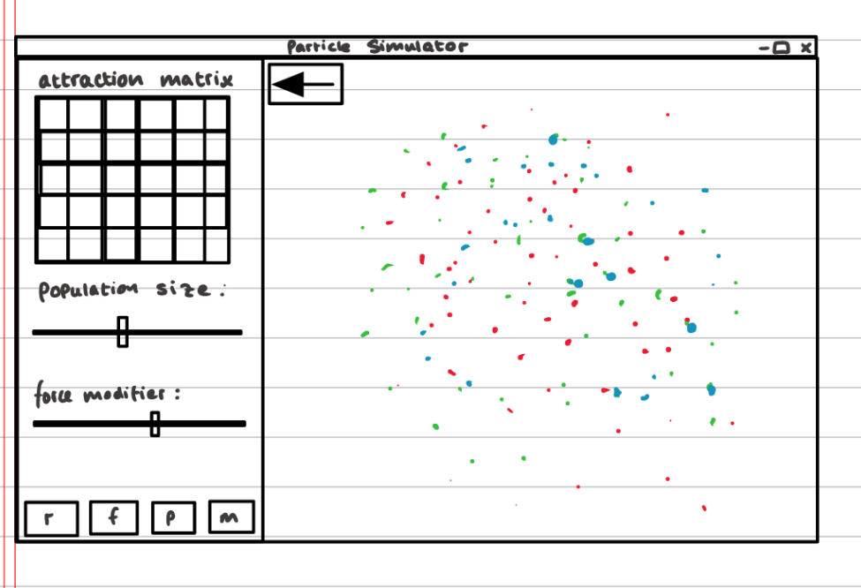

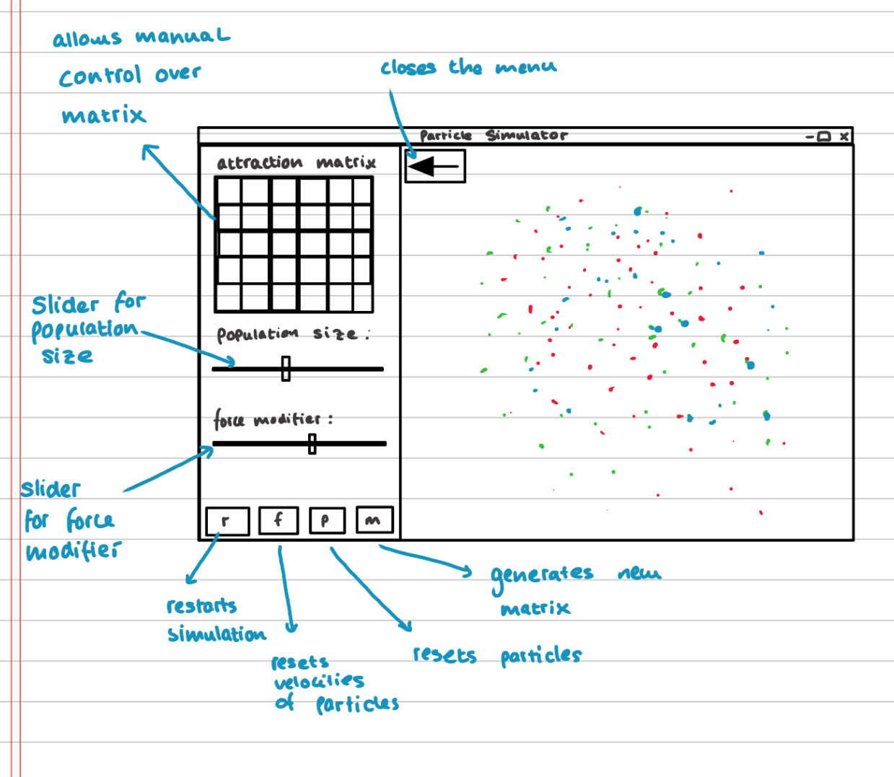

As can be seen from the annotated second figure, these changes would allow my end users overall more control of the simulation and its configurations, leading to a better and more productive experience.

Due to these reasons above, I would class this as a partial success, as my criterion has been met, just not as originally intended

### Have I taken my end users feedback into consideration when developing this project, and have I reviewed this feedback at the end of each stage in my development project?

One key strength of the solution I have made is the strong reliance on end user and stakeholder feedback. I have continuously used surveys and opinions from my end-users to help curate my project as I said I would in my initial criterion. The evidence for this can be seen from my continuous reviews of my solutions.

#### What aspects of my project did my end users have an impact on?

* Interviews to determine direction the project will take
* What features should be introduced for my second solution
* Direction to take project with respect to improving particle behaviours or creating a usable GUI.
* Getting a rating to see how well my criteria has been met
* Suggesting what usability features are necessary
* Deciding on a colour set
* How well has my second solution met the criteria?
* Features that could be introduced in the future
* Rating how usable the interface is

As can be seen, my stakeholders have had quite a large impact on how my project was developed. While not everything was directly the result of their feedback, such as implementing my quadtrees, it was introduced to complete my success criteria.

While a lot of the project was determined by my stakeholders, I feel as if I did not include enough surveys/interviews in my analysis section of the documentation. I received plenty of verbal Feeback from my classmates however this was not recorded into my project, however I believe it was sufficient to ensure my project met the requirements of my stakeholders.

Given the choice to do it differently, I would try to include more surveys for my stakeholders to give their opinions near the beginning of the project, however I feel as if I have managed to compensate for this slight lacking area by including more surveys throughout the development stage of my project.

For the reasons above, I would say this criterion has been a strong success. While there was not as many surveys in the analysis stage as already mentioned, I feel strongly this has been compensated for throughout my development stage.

## Maintenance and limitations:

While several of these limitations have already been discussed throughout the development and review stages of my project, I will cover over them again in this section.

My limitations will be categorised into 3 separate levels:

|  |  |
| --- | --- |
| Negligible | Has not affected the main end users of the project’s usability |
| Moderate | Has caused inconvenience to the project’s usability |
| Significant | Has caused harm to the project’s usability |

Limitations:

* Lack of multi-threading
* Less control over simulation due to no GUI
* Fixed colour set
* Window is not adjustable
* Visual limitations – no shaders for distortion of glow effect

The lack of multi-threading in my code made my project take a hit to its capacity. While it can safely run 3000-4000 particles on the screen at a given time (test #6), much more than that causes the program to slow down, and the frame rate starts to get choppy. As mentioned previously in my evaluation and review of my second solution, multi-threading was not included due to lack of familiarity of how it was implemented inside of c++ and due to time constraints. In the future, I would approach this differently by first having familiarised myself with a small demo project which made use of multi-threading first as to give me a better idea of how to implement it into the project. This limitation is overall negligible, as we can see from test #8 the program was able to recreate several phenomena and does not take away from the main usability of the project, instead just hindering the use of the project for further applications.

While the lack of GUI has some benefits, such as being able to access all the controls at any given time, it has some drawbacks too. There has been a loss in accuracy regarding the usability of the simulation, as specific values for the attraction matrix cannot be inserted, and the population size and force modifier can only be increased and decreased by set intervals instead of set to a specific value. As can be seen from my conceptual design of how my GUI would work earlier in my evaluation, this design would allow for much more control for my end users. If I were to do this project again in the future, I would consider how to implement my user interface earlier on in the project as it would help with testing (as discussed previously) and would also allow me to develop something more thought out, not just a feature that is added on at the end. I would class these limitations as being moderately significant.

The fixed colour set, and lack of shaders provides visual limitations, where variety in appearance of the program is non-existent currently. As mentioned in my review of my second solution, the shaders were not implemented due to the fact I was unsure of how they worked and how to implement them. The variable colour sets could have been added procedurally, however as also mentioned previously, I was not confident on how to ensure the colour sets would all be visually stimulating. Alternatively, I could have made a bunch of different colour sets manually, and added them in through code, however due to the simple nature of my UI and the time constraints involved I did not have time to program for this. In the future I would try look more at colour theory and procedurally generating complimenting sets of colours. I would say this limitation has moderate significance.

Another limitation of this project is the fixed window size, which prevents expandability and area control over the particles. This was not added in due to time constraints and poor planning, as already looked at in my review for my second solution, where I had used constants for the code, making it difficult to implement especially on my limited time frame towards the end of the project's development cycle. I would go about setting this feature up dynamically from the get-go in the future as I am more aware of it now. Overall, I would classify this limitation as moderately significant. While not detrimental to the use of the application, it certainly provides inconvenience to the end users, as shown in my survey done at the end of the review of my second solution.

How I have made my project maintainable:

* Appropriate use of variables and constants
* Modularity
* Self-documenting identifiers
* Well-designed error catching and logging implemented

To what extent is my project maintainable, what made me come to this conclusion and how would I make it more maintainable?

My project is maintainable to quite a high extent as can be seen from the modularity of my project, the error logging and the self-documenting identifiers. I have come to this conclusion as My project has been developed around my entity component system, which is modular by nature as can be seen in the figure below

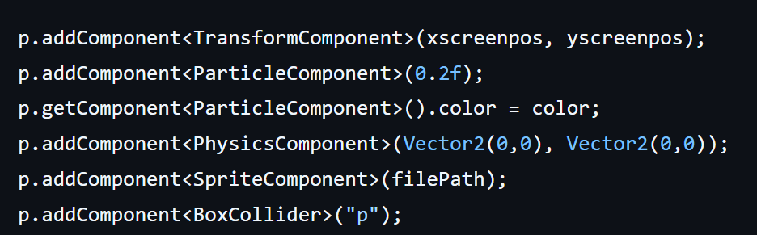 This design has allowed me throughout development and testing to isolate where errors are coming from, and the modularity of it ensures that in future development modifications and additions can be made easily to the project.

As can also be seen from the figure above, I have used adequate identifier names (besides” p” which I had previously annotated at particle, however due to how often it was used and to stop my lines getting too long I reduced it to p for short. Overall, my reasoning for this was in a for loop you use “i” as the counter variable, and this seemed like a similar case as it was only supposed to be a temporary assignment for each particle in the vector array).

Furthermore, I have implemented error logging to keep my program robust:

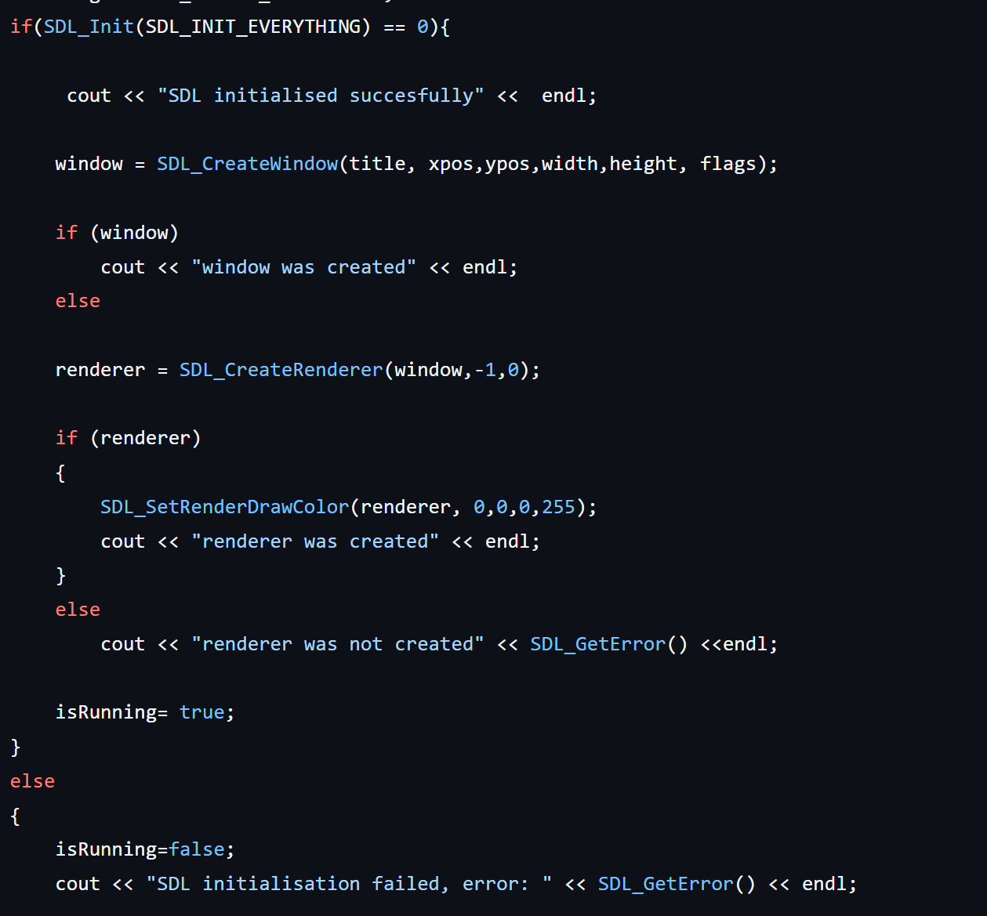  
While this feature was already covered in my development section, it was never actually discussed how this makes my project maintainable for the future. This allows me to simplify errors down to more human readable errors without the program crashing and gives me specifics of what went wrong.

#### How would I make my project more maintainable?

While I feel my second solution is very well designed, there is some room for improvement. Mainly in my game.cpp file. I have several functions that were added in such as my matrix generation, particle spawning and force function which could have been moved to other parts of my program such as my physics component for my force function, however given the need for testing and the time constraints involved I never got round to doing this, though it is something for me to consider for future development). Having these functions in their related sections would make the code easier to maintain as it would be easier to find them by association. Somebody who has not touched the project before may not expect to find the ForceFunction in my game.cpp as it would be more logical to find it in my Physics component file as mentioned above.

## Overall evaluation:

To conclude, I believe my solution adequately meets all my criteria with partial to complete success. Evidence for this can be seen from my end user surveys completed in both solutions, and my post development testing (numbered 1-8). I have managed to create an easy to use, viable particle life simulator with the necessary features to create behaviours for game developers, cool visuals for artists and overall be a fun learning tool for students of all ages. While there has been success, some things as already discussed in this evaluation have not been fulfilled to its fullest extent, that being a graphical user interface, more complex visuals and capabilities for very large particle populations. While this has not been met, thanks to my modular, maintainable solution which has been discussed above I can safely say these features can be added in future iterations with relative ease. There is always room for improvement, always a more efficient tool, algorithm or technology, however I believe my solution has met all the core features and criteria it needs to be considered a success.

# Bibliography:

Tom Mohr’s Particle Life - https://www.youtube.com/watch?v=p4YirERTVF0

The code behind Tom Mohr’s Particle Life - https://www.youtube.com/watch?v=scvuli-zcRc

Clusters by Ventrella – ventrella.com

Interactive explanation about Quadtrees - jimkang.com/quadtreevis

Quadtrees Wikipedia - https://en.wikipedia.org/wiki/Quadtree

Mechanics used – Pearson Edexcel A level physics, A level maths stats and mechanics book 1 and 2, Further Mechanics 1

Conway’s game of life: https://en.wikipedia.org/wiki/Conway%27s_Game_of_Life

Sdl 2 documentation: https://wiki.libsdl.org/SDL2/FrontPage